openCHAMBER

Building an open-source community around the development and application of automatically ventilating floating greenhouse gas flux chambers

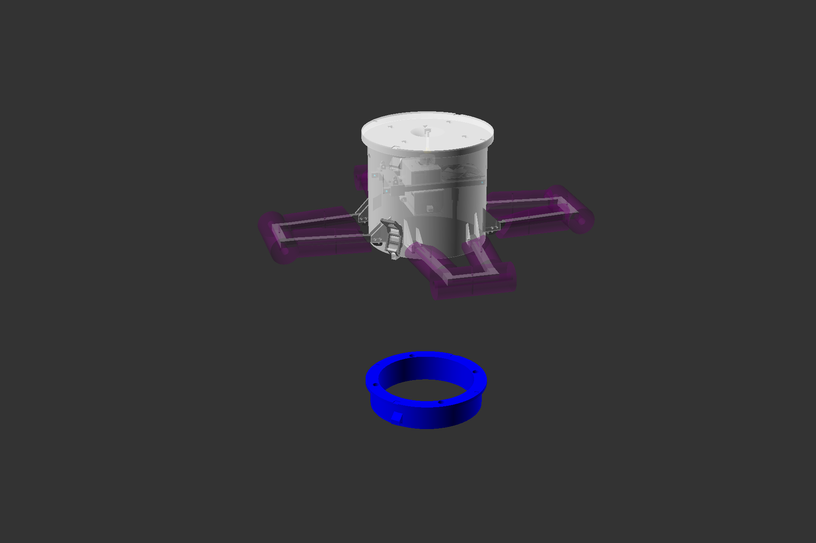

Chamber.1 Build Guide

# Disclaimer

This build guide details the construction of “Chamber.1”, the first 3d printed opensource floating chamber, designed to measure greenhouse gas (GHG) fluxes over an extended temporal resolution, through the automation of chamber headspace ventilation. This document has been created for educational and instructional purposes only. All and any resemblance to any other openCHAMBER company or automatically ventilating chamber product on the market is purely coincidental and not intentional.

Readers are free to use this resource by following its guidance to create their own Chamber.1 ventilating device. In the event that Chamber.1 devices are produced leading to publication, please respect and observe the authors intellectual property rights by correctly citing the project and or its accompanying scientific publications.

All images in this handbook have been created by the author.

All inquiries regarding this build guide should be addressed to the author at [Benjamin.archer@igb-berlin.de](mailto:Benjamin.archer@igb-berlin.de)

© Benjamin Archer | All Rights Reserved

Contents

Disclaimer 2

List of Figures (LOF) 4

List of Tables (LOT) 5

Introduction 6

Objective 6

Structure 6

Part 1 | Chamber Module 7

1.1 Parts list 8

3d printed parts 8

Non printed parts 9

Electrical parts 10

Consumable Materials 11

1.2 3d Printing 13

1.3 Post-print Processing 27

1.4 Parts Assembly 37

Part 2 | Valve Changer Module 71

2.1 Parts List 72

3d Printed Parts 72

Non Printed Parts 72

2.2 3d Printing 72

2.3 3d printing post processing 72

2.4 Parts assembly 73

Appendix 73

3.1 Chamber Module 73

3.11 Visualised Parts List 73

3.2 Valve Changer Module 73

3.21 Visualised Parts List 73

References 74

# List of Figures (LOF)

[Figure 1 - Illustration of the chamber module for the Chamber.1 system. Image a shows the CAD model of the module, while image b shows the module deployed in the field under actual conditions 7](https://d.docs.live.net/33ed0a77fd35c723/Documents/writing/methods%20paper/chamber%20build%20manual%20or%20guide%2006.01.2021.docx#_Toc92399204)

[Figure 2 - Illustration of the valve changer module for the Chamber.1 system. Image a shows the CAD model of the module, while image b shows the module deployed in the field under actual conditions. 71](https://d.docs.live.net/33ed0a77fd35c723/Documents/writing/methods%20paper/chamber%20build%20manual%20or%20guide%2006.01.2021.docx#_Toc92399205)

# List of Tables (LOT)

Table 1 - 3d printed parts list 8

Table 2 - Non printed, non-electrical parts list 9

Table 3 - Electrical parts list 10

Table 4 - List of consumable materials 12

# Introduction

## Objective

The aim of this document is to provide the reader with the relevant information required to construct the “Chamber.1” automatically ventilating floating chamber design. The document is aimed at being a build guide rather than a detailed explanation into how the chamber works and the justification behind its design. For detailed discussion about the “Chamber.1” design please see (Archer, 2022). This document will cover:

* Parts lists
* 3d printing instruction
* Physical assembly instruction (illustrated through action diagrams and GIF animation)
* Software upload and testing
* Proper storage and transport

## Structure

**Part 1** of this guide details the construction of the “Chamber Module” i.e. the automatically ventilating chamber unit, the headspace of which is sampled to determine gas flux with time (Figure 1.00).

**Part 2** of this guide details the construction of the “Valve Changer Module” i.e. the unit that controls air flow between chambers when multiple chambers are used simultaneously (Figure 2.00).

# Part 1 | Chamber Module

**Figure 1** - Illustration of the chamber module for the Chamber.1 system. Image a shows the CAD model of the module, while image b shows the module deployed in the field under actual conditions

## 1.1 Parts List

### 3d Printed Parts

The following parts are 3d printed. The names of the parts refer to the files that are available for download on the openCHAMBER github page under the project Chamber.1 in the 3d files folder (Archer B. , 2022). These files are available as STL, as well as gcode sliced for the Anycubic Chiron FDM printer (Anycubic, 2022), which was the printer used throughout the development of this project.

Table 1 lists the parts that must be 3d printed to proceed with the build process. 3d renders and actual images of the parts are available in the appendix (section 3.11).

**Table 1** 3d printed parts list

|  |  |  |
| --- | --- | --- |
| **Part Number** | **Part Name (.stl or .gcode)** | **Number of replicates** |
| 1 | Chamber Body | 1 |
| 1.b | Chamber Body Tall | 1 |
| 2 | Chamber lid | 1 |
| 3 | Chamber Float Arms | 4 |
| 3.b | Chamber Float arms Tall | 4 |
| 4 | Chamber float cutting template - left | 1 |
| 5 | Chamber float cutting template - right | 1 |
| 6 | Fan bracket | 2 |
| 7 | Lid arm curved | 2 |
| 8 | Sensor Bracket V1 | 1 |
| 8.b | Sensor Bracket V2 | 1 |
| 9 | Motor case | 1 |
| 10 | Motor case lid | 1 |
| 11 | Motor case latch - small | 4 |
| 12 | Motor case latch – large | 4 |
| 13 | Motor case optical switch | 1 |
| 14 | Aluminium bracket cut guide | 1 |
| 15 | Bottom pawl | 1 |
| 16 | Middle Pawl | 2 |
| 17 | Top Pawl | 1 |
| 18 | Ratchet | 1 |
| 19 | Servo Arm | 1 |
| 20 | Lid optical interrupter bar - template | 1 |
| 21 | Lid arm spacer | 3 |
| 22 | Lid arm straight | 7 |
| 23 | Lid arm servo side 1 | 1 |
| 24 | Lid arm servo side 2 | 1 |
| 25 | Lid arm servo side 3 | 1 |
| 26 | Lid arm servo side 4 | 1 |
| 27 | Chamber stacking clip – small | 2 |
| 28 | Chamber stacking clip – large | 2 |
| 29 | Chamber bottom cap | 1 |
| 30 | Chamber carrying handle | 1 |
| 31 | Chamber carrying handle clip | 1 |

### Non-Printed Parts

Table 2 lists the parts in the chamber module that have not been 3d-printed and are not electrical. 3d renders and actual images of the parts are available in the appendix (section 3.11). Some of these parts must be cut from larger pieces, for instance parts 48, 51, 52, 56, 61 and 62. The parts that these are made from are listed in the consumables section below, and the process of preparing these parts is covered in the build section of this document.

**Table 2** Non printed, non-electrical parts list

|  |  |  |
| --- | --- | --- |
| **Part Number** | **Part Name** | **Number of replicates** |
| 32 | M5 hex bolt 45mm | 8 |
| 32.b | M5 butterfly bolt 45mm | 8 |
| 33 | M5 hex bolt 40mm | 4 |
| 33.b | M5 hex bolt 25mm or 30mm | … |
| 34 | M5 lock nut | 16 |
| 34.b | M5 butterfly nut | 8 |
| 34.c | M5 nut normal | … |
| 35 | M5 washers | 15 |
| 35b | M5 Penny Washer | 1 |
| 36 | M4 hex bolt 45mm | … |
| 37 | M4 hex bolt 40mm | 10 |
| 37a | M4 hex bolt 35mm | 2 |
| 38 | M4 hex bolt 20mm | 4 |
| 39 | M4 lock nut | 12 |
| 40 | M4 washer | 12 |
| 41 | M3 hex bolt 50mm | 8 |
| 42 | M3 hex bolt 30 to 35mm | 10 |
| 43 | M3 hex bolt 20mm | 4 |
| 44 | M3 lock nut | 16 |
| 44.b | M3 hex nut standard | 4 |
| 45 | M3 washer | … |
| 46 | 8mm flat Mount Pillow block Bearing | 1 |
| 47 | 5mm to 8mm flexible coupling | 1 |
| 48 | 8mm diameter lead screw rod, 20cm lengt) | 1 |
| 49 | 8mm internal diameter lead screw nut (Usually brass) | 1 |
| 50 | Screws (for lead screw nut attachment) | 2 to 4 |
| 50.b | Servomotor arm bolt | 1 |
| 51 | Aluminium bracket | 2 |
| 52 | Moss gummie gasket | 1 |
| 53 | Hex mount bolt (M3 x 13) | 2 |
| 54 | M3 5mm dome head screws | 2 |
| 55 | Aluminium bracket (20x20x ….) | 2 |
| 56 | Lid optical interrupter bar - aluminium | 1 |
| 57 | spacer cylinder (21mm long, 12x1mm aluminium tube) | 1 |
| 58 | Ratchet spring (EXT 5.5 x 25.5mm) | 1 |
| 59 | Chamber carrying handle springs (dimensions) | 2 |
| 60 | (Optional) wooden board for stacking base (dimensions) | 1 |
| 61 | 1/4 inch tubing metal psuhfit connectors | 2 |
| 61.b | Push fit connector panel mount nut | 4 |
| 62 | o-ring nitrile rubber thread …mm | 1 |
| 63 | Foam float right | 4 |
| 64 | Foam float left | 4 |
| 64.b | Foam float top | 4 |

### Electrical Parts

Table 3 lists the electronic parts used in the project. 3d renders and actual images of the parts are available in the appendix (section 3.11). Part 82, the dip format Arduino uno, is required to load programs onto a DIP format atmega328p microcontroller chip (part 81). This programmed chip is then transferred to the main circuit board (part 76). Therefore part 82 is not a part of the chamber module but is required for the chamber module build process. If a different method of atmega328p programming is used, then the Arduino uno is not required. Similarly, part 83 (atmega328p bootloader burner shield) is only required when the atmega328p chip used does not already have a bootloader burnt onto the chip, or when using a chamber programme that requires a bootloader. Part 83 is required for the build process and is not a part of the finished chamber module.

Parts 77 and 78 must be constructed from the consumables list. This is covered in the build section of this document.

**Table 3** Electrical parts list

|  |  |  |
| --- | --- | --- |
| **Part number** | **Part name** | **Number of replicates** |
| 65 | Nema stepper motor | 1 |
| 66 | Servomotor | 1 |
| 67 | Optical interrupter diode and transistor | 1 |
| 68a | 5kg load cell | 1 to 2 |
| 68b | 10kg load cell (e.g.TAL220) | 1 to 2 |
| 69 | load cell HX711 module | 1 to 2 |
| 70 | RTC coin cell | 1 |
| 71 | Pressure sensor | 1 to 2 |
| 72 | HC-12 | 1 |
| 73 | 433.4-473.0MHz Antenna | 1 |
| 74 | Male antenna connector | 1 |
| 74.b | Antenna connector washer | 1 |
| 74.c | Antenna connector nut | 2 |
| 75a | Sensor circuit board version 1 | 1 |
| 75b | Sensor circuit board version 2 | 1 |
| 76 | Main Circuit board | 1 |
| 77a | Sensor board cable | 1 |
| 77b | Radio cable | 1 |
| 78a | Load cell cable 1 | 1 |
| 78b | Load cell cable 2 | 1 |
| 79a | 120mm 5v pc fan | 1 |
| 79b | Fan cable | 1 |
| 80 | Power Bank (specific information) | 2 |
| 80b | 5v to 24v 5amp boost board | 1 |
| 81 | atmega328p DIP package | 3 |
| 82 | DIP type arduino uno | 1 |
| 83 | arduino uno bootloader shield | 1 |
| 84 | USB to microusb cable short (dimensions) | 2 |
| 85 | Nema stepper motor cable | 1 |
| 86 | CO2 sensor | 1 to 2 |
| 87 | CH4 sensor | 1 to 4 |

### Consumable Materials

Table 4 lists the consumable materials used in the project. Images of these parts and materials are available in the appendix (section 3.11). These consumables are used throughout the project to build other parts (for example consumable part 94 is used to make part 52 in table 2), or to process parts before use (for example, treating 3d printed objects (Table 1) with epoxy resin (part 88, Table 4) to make these prints water and gas tight). The processing of these consumable materials is covered in the build process of this document.

**Table 4** List of consumable materials

|  |  |  |
| --- | --- | --- |
| **Part Number** | **Part Name** | **Number of Replicates** |
| 88 | Epoxy resin (approx. volume?) | 1 |
| 89 | 1kg 3d printing plastic spool | 3 |
| 90 | Flexible gel super glue | 1 |
| 91 | Standard super glue | 1 |
| 92 | UV resistant polyuerthane | 1 |
| 93 | Plastic zip ties | 14 |
| 94 | Moss gummie sheet dimensions… | 1 |
| 95 | Aluminium square tube dimensions | 1 |
| 96 | Aluminium cylindrical tube dimensions | 1 |
| 97 | Aluminium flat bar dimensions | 1 |
| 98 | Pipe insulation foam tubes dimensions | 3 |
| 99 | Hot glue | … |
| 100 | Electrical potting compound | 1 |
| 101 | JST type female connectors and crimps | … |
| 102 | …guage wire | … |

Tools:

* Needle diamond files
* Larger files (round and flat)
* Sandpaper
* Tweezers,
* Spanners / socket wrenches
* Allen keys
* Permanent markers
* Centre-mark punch ~
* Hammer ~
* Philips head and flat head screwdrivers
* Jewellers screwdrivers
* Hack saw / metal saw
* Angle grinder / Could be provided if this is too difficult
* Dremmel can be useful
* JST Crimps ~
* Wire cutters/ snips
* Drill / drill bits
* Multimeter? (unless buying kit from me)
* Ruler with mm

## 1.2 3d Printing

### 1.2.1 Introduction

This 3d printing guide provides information on how the chamber module parts were designed to be printed. The printer used throughout the development of this project was the anycubic chiron (Anycubic, 2022), and is the printer described in this manual. This printer was selected due to its large build volume (400mm x 400mm x 450mm), international availability, extensive online community and affordability (available for €315 at the time of writing (Anycubic, 2022)). Alternatively, 3d printed parts can be printed at your local maker space or ordered from a 3d printing service such as JLCpcb (JLCpcb, 2022). In the future, if there is sufficient community interest, then currently 3d printed parts could be reproduced through injection moulding and distributed to the community. Incidentally, this would also remove the need for the post-print processing steps, such as epoxy coating, described in section 1.3.

Through extensive use of the anycubic chiron 3d printer in the development process of this project, there have been commonly occurring issues across the multiple machines in our print farm. This section of the guide provides trouble shooting information for these common problems that you are likely to experience with extended use. Though it must be added that current models of the Chiron (at the time of writing) are already improved over the early forms of the Chiron used throughout this project, and that these problems are fairly simply solved with a bit of guidance.

3d models are available for download in stl form or as pre-sliced gcode for the anycubic chiron (openCHAMBER github page under the project Chamber.1 in the 3d files folder (Archer B. , 2022)). The 3d models published in this project were all developed using the opensource CAD software openscad 2019.05 (openSCAD, 2021). This software was chosen as it is truly open source and free for everybody to use (i.e. not subject to limited contracts and terms of usage that software such as fusion360 are (fusion360, 2021)), is arguably the most powerful opensource CAD software available at the time of writing (2021), and offers a large online community through which extensive information is available. The openSCAD coding files used to make the 3d models in this project are available on the openCHAMBER github page under the project Chamber.1 in the 3d files folder (Archer B. , 2022), and can be adjusted by the user of this guide if tolerances or parts need adjusting.

The printing of the parts listed in Table 1 is divided into the two nozzle sizes, 0.8mm and 0.6mm. Printing guides assume the use of PLA plastic, such as the amazon basics 1.75mm PLA () or any other well packed and dried PLA plastic (i.e. including desiccant packets, and rolled evenly onto the spool with no tangles or knots which could cause prints to fail).

Printer gcode was generated from 3d models using the opensource slicer software CURA (CURA, 2022).

### 1.2.2 0.8mm Parts

Printing at a nozzle size of 0.8mm decreases the overall printing time and is optimal for large low detail pieces that serve a structural purpose. This reduces the printing time from days to hours. Print settings must be adjusted to deal with this volume of plastic. The recommended settings are based upon the printers used in this project, however individual printers vary, and may need their own adjustment.

Table 5 details the parts that are printed at 0.8mm, their print times and PLA plastic requirements.

**Table 5** 0.8mm Part Printing Statistics (for generic pla)

|  |  |  |  |  |
| --- | --- | --- | --- | --- |
| **Part Number** | **Estimated Print Time (Minutes)** | **Estimated Material Weight (g)** | **Estimated Filament Length (m)** | **Support material** |
| 1 | 2070 | 1267 | 424.76 | YES* |
| 1.a | 2570 | 1583 | 530.85 | YES* |
| 2 | 1324 | 666 | 223.22 | NO |
| 3 | 4 x 232 | 4 x 154 | 4 x 51.6 | NO |
| 3.b | 4 x 304 | 4 x 197 | 4 x 65.97 | NO |
| 4 and 5 | 403 | 236 | 79.25 | YES |
| 6 | 14 | 10 | 3.52 | YES |
| 7 | 2 x 14 | 2 x 8 | 2 x 2.64 | NO |
| 8 | 122 | 93 | 31.26 | YES |
| 8.b | 98 | 77 | 25.83 | YES |
| 9 | 773 | 512 | 171.72 | YES |
| 10 | 228 | 133 | 44.57 | YES |
| 11 | 4 x 6 | 4 x 4 | 4 x 1.46 | NO |
| 12 | 4 x 18 | 4 x 12 | 4 x 4.09 | NO |
| 21 | 3 x 12 | 3 x 6 | 3 x 2.09 | NO |
| 22 | 7 x 9 | 7 x 5 | 7 x 1.71 | NO |
| 23 | 11 | 8 | 2.56 | NO |
| 24 | 11 | 8 | 2.58 | NO |
| 25 | 13 | 9 | 2.93 | NO |
| 26 | 11 | 8 | 2.58 | NO |
| 27 | 2 x 6 | 2 x 4 | 2 x 1.47 | NO |
| 28 | 2 x 50 | 2 x 31 | 2 x 10.46 | YES |
| 29 | 1069 | 851 | 285.42 | NO |
| 30 | 294 | 212 | 71.25 | YES |

*The Support material in Part 1 is built into the stl file rather than added later in the slicer.

Using pre-sliced files

If using the pre-sliced models and an Anycubic Chiron printer, then the next steps are straight forward:

1. Install a 0.8mm nozzle to the printer. To change the nozzle, heat up the hotend/heating block to pla printing temperature (200oC). Hold the heating block in place while you remove any existing nozzle using a spanner, and then insert a 0.8mm nozzle in the same way (Figure 1.1).
2. Carry out some pre-print checks

* Ensure that the weight of PLA filament loaded to the machine before printing is greater than that estimated for the print in Table 5. Otherwise, be prepared to change the filament spool at some point during the print, which can cause layer shifts on the Anycubic Chiron and thus a failed print.
* Ensure that the print bed has recently been levelled.
* Ensure that the grub screws on the z-axis motor coupler are tight. Failure to do so can result in catastrophic print failures.
* Inspect the filament and ensure that it has not become brittle in the storage process. Brittle filament can result in print failures as the filament runout sensor will not be triggered.
* Ensure that the filament driver screw is at the correct tension and that the Bowden tube resistance is low (i.e. the Bowden tube is not worn out or blocked by PLA particles, and that filament flows freely through the print Nozzle).

1. Wipe down the print bed with a lint free cloth and isopropyl alcohol, to ensure adhesion of the print layers to the print bed.
2. Transfer the .gcode file of the part that you would like to print from Table 5 to the printer (e.g. Part 1). This is most simply done using an SD card.
3. Once the SD card is inserted into the printer, select the file for printing and select start print.
4. Check intermittently throughout the print to ensure that there has not been a failure and that no action needs to be taken.
5. Once the print is finished, let the printing bed cool to room temperature – the print should release from the print bed by itself. In the case that it is still stuck to the print bed, carefully remove the piece using the spatula/scraper provided with the 3d printer.
6. Store the 3d print safely. Parts with support material (listed in Table 5) will need the support material to be removed. However, this step is covered in section 1.3 (3d printed part post-processing).
7. Repeat steps 1 to 8 until all the parts from Table 5 have been printed.

**Figure 2** - Demonstrating how to change the extrusion nozzle on an anycubic chiron 3d printer.

Slicing models for a different printer

If not using an anycubic chiron printer, or you would like to print groups of specific parts together, then the stl files will need to be sliced before printing. The following is guidance on part orientation and support settings, when preparing your own gcode for the parts in Table 5.

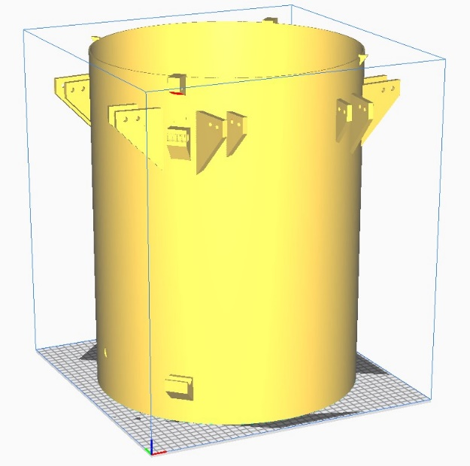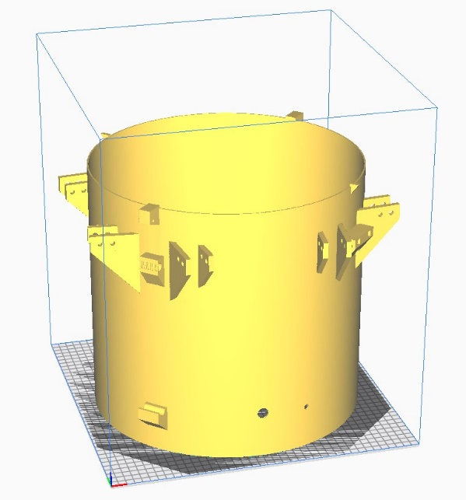

Part 1.

Print settings:

Image to show orientation.

**Figure 3**

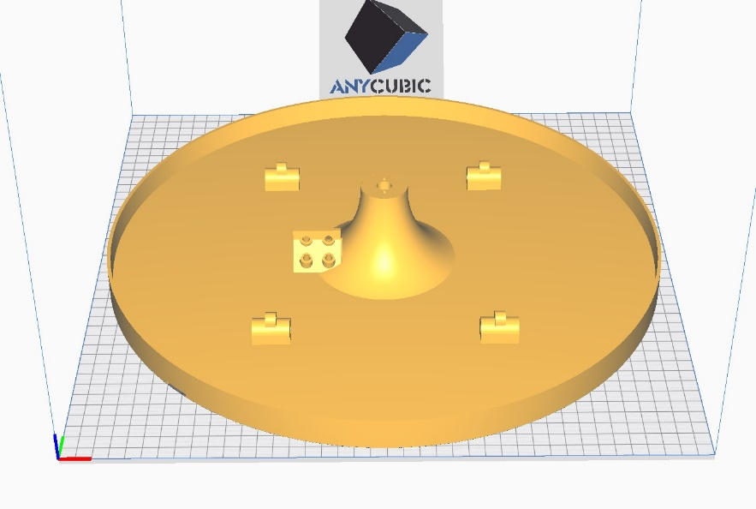Part 2.

Print settings:

Image to show orientation

**Figure 4**

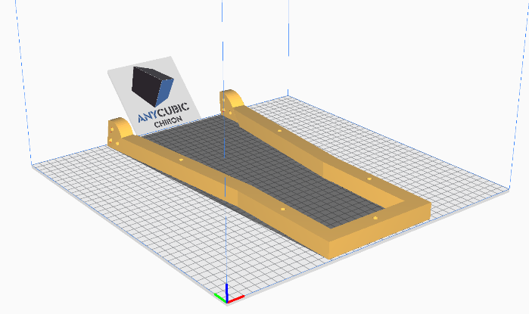

Part 3.

Print settings:

Image to show orientation

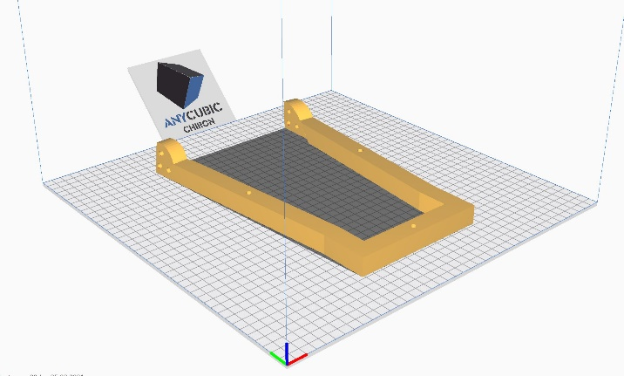

**Figure 5**

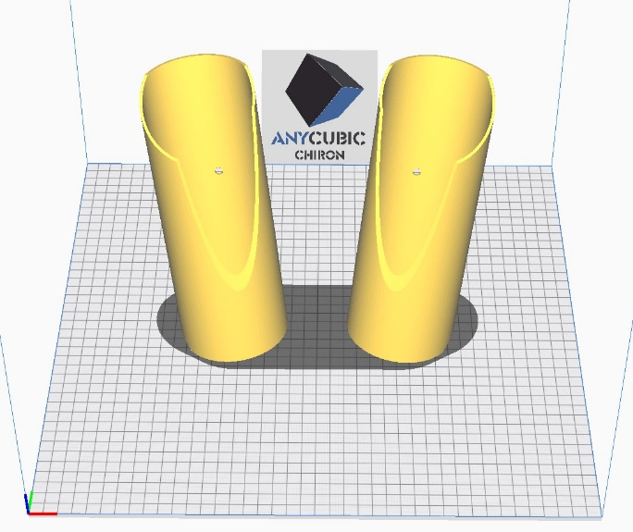Part 4 and 5.

Print settings:

Image to show orientation

**Figure 7**

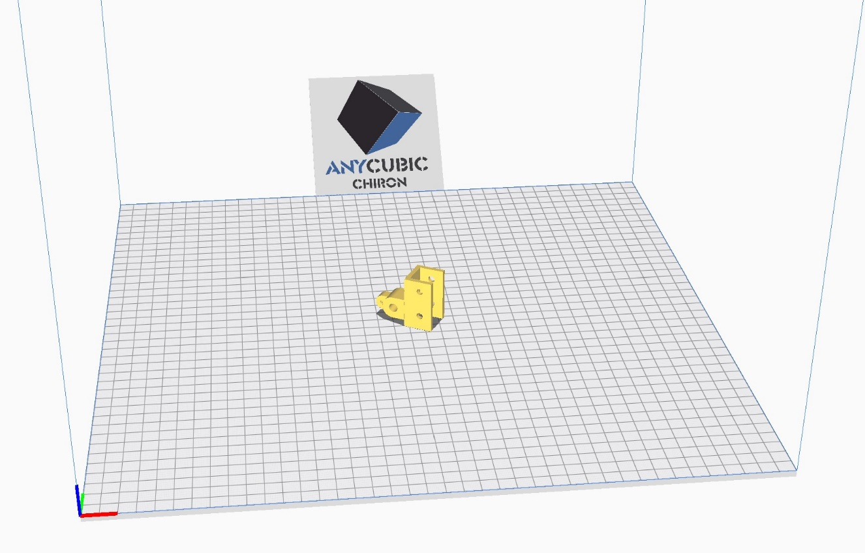

Part 6.

Print settings:

Image to show orientation

**Figure 8**

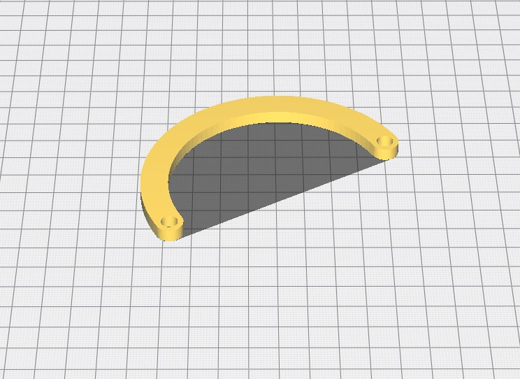Part 7.

Print settings:

Image to show orientation

**Figure 9**

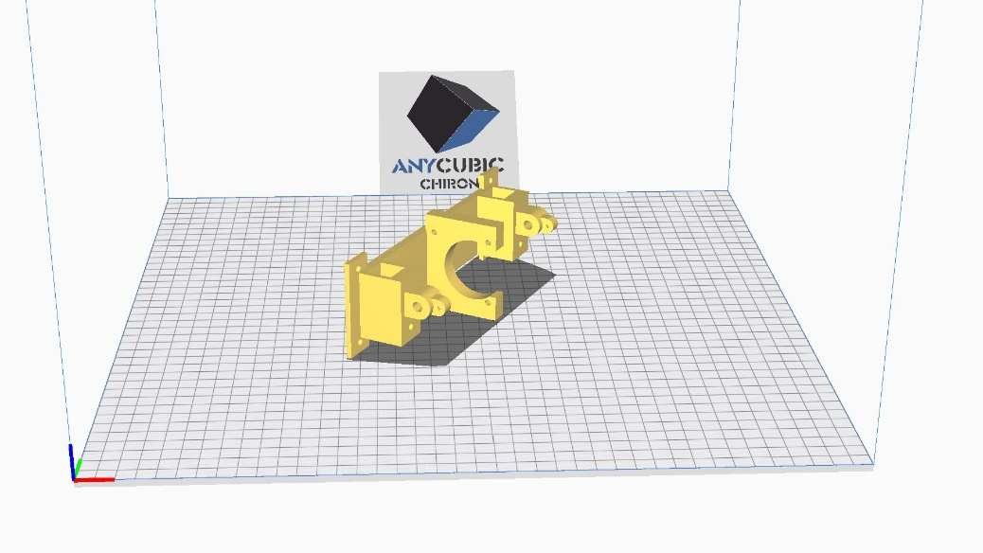Part 8.

Print settings:

Image to show orientation

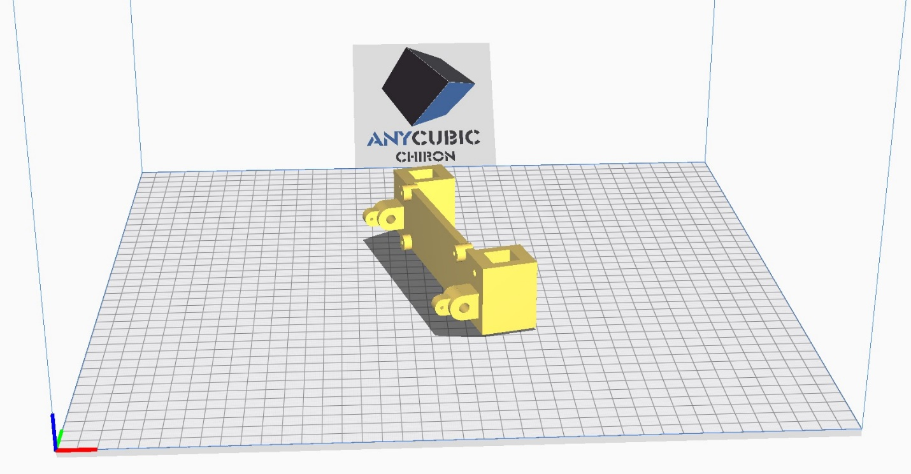

**Figure 10**

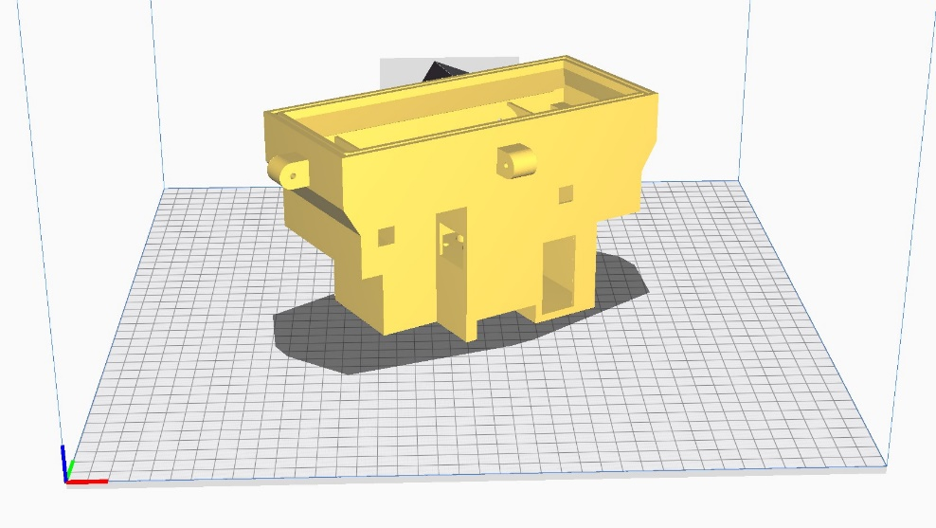

Part 9.

Print settings:

Image to show orientation

**Figure 11**

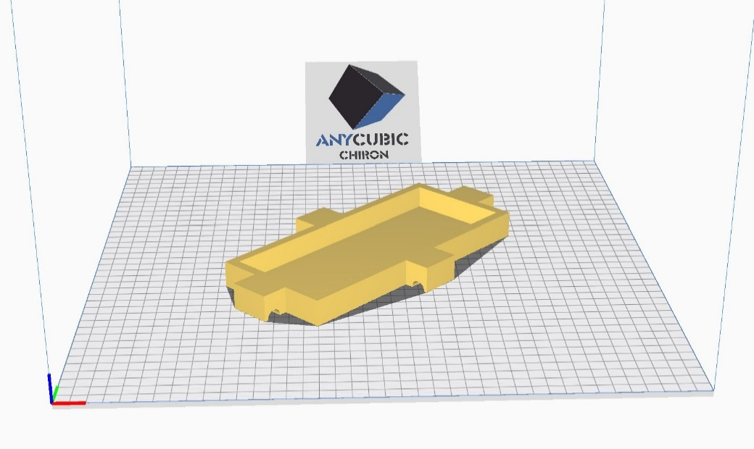

Part 10.

**Figure 12**

Print settings:

Image to show orientation

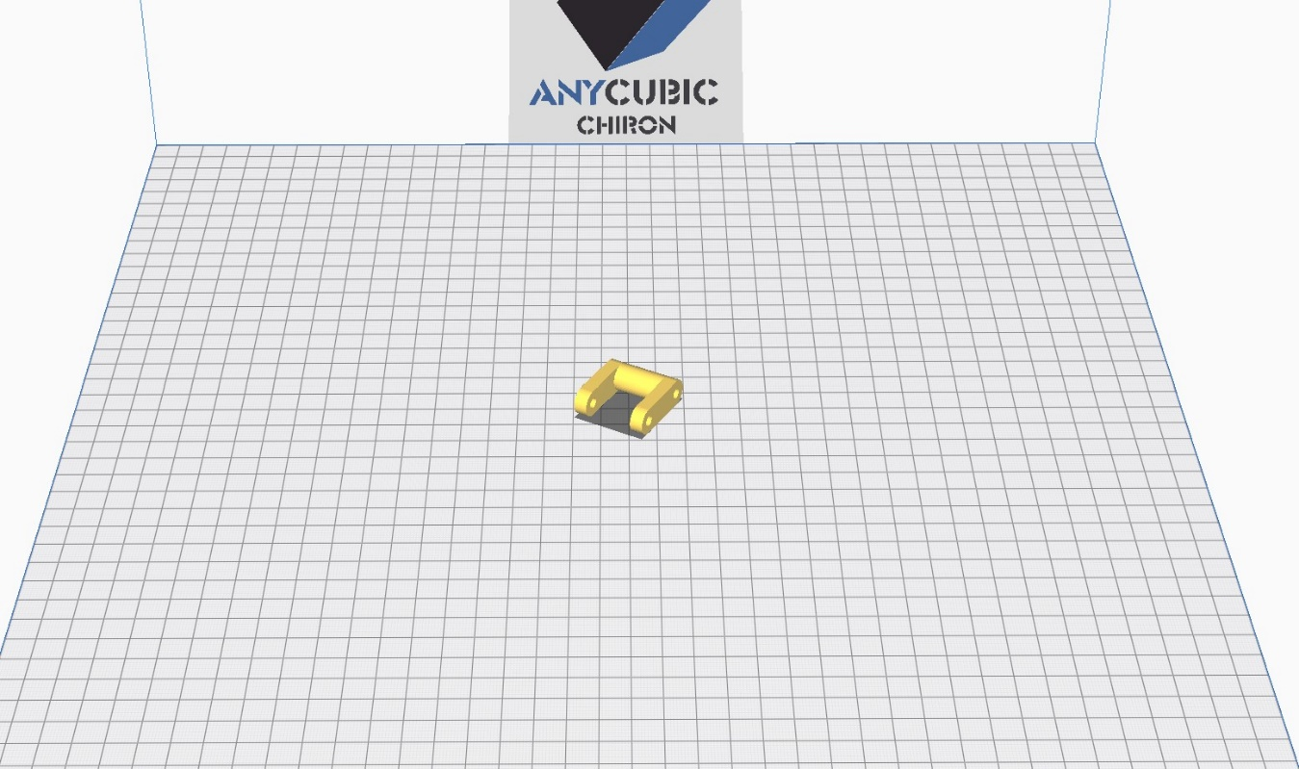

Part 11.

Print settings:

Image to show orientation

**Figure 13**

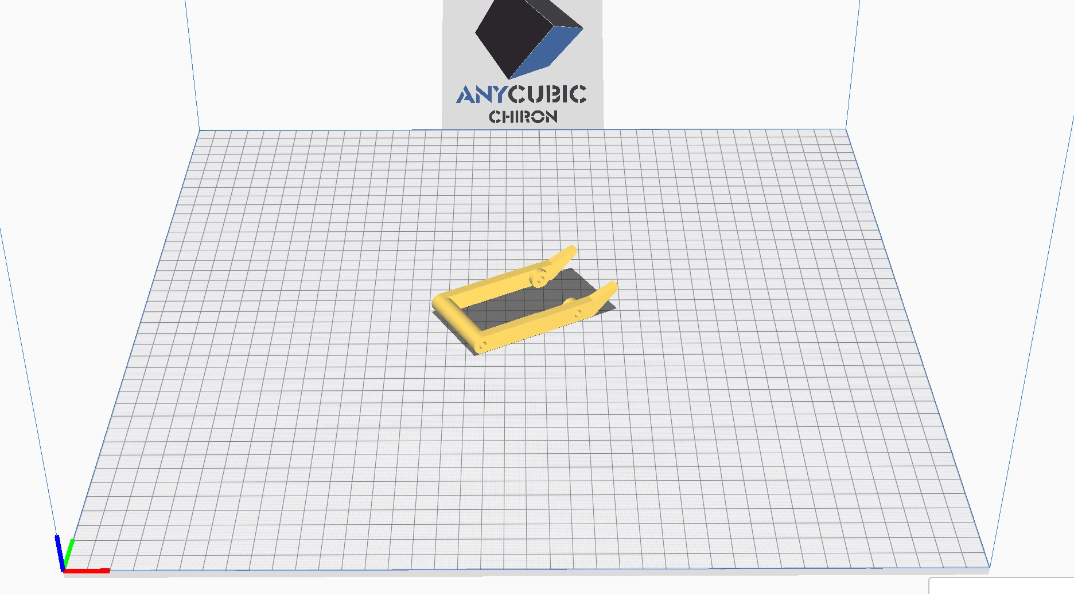

Part 12.

Print settings:

Image to show orientation

**Figure 14**

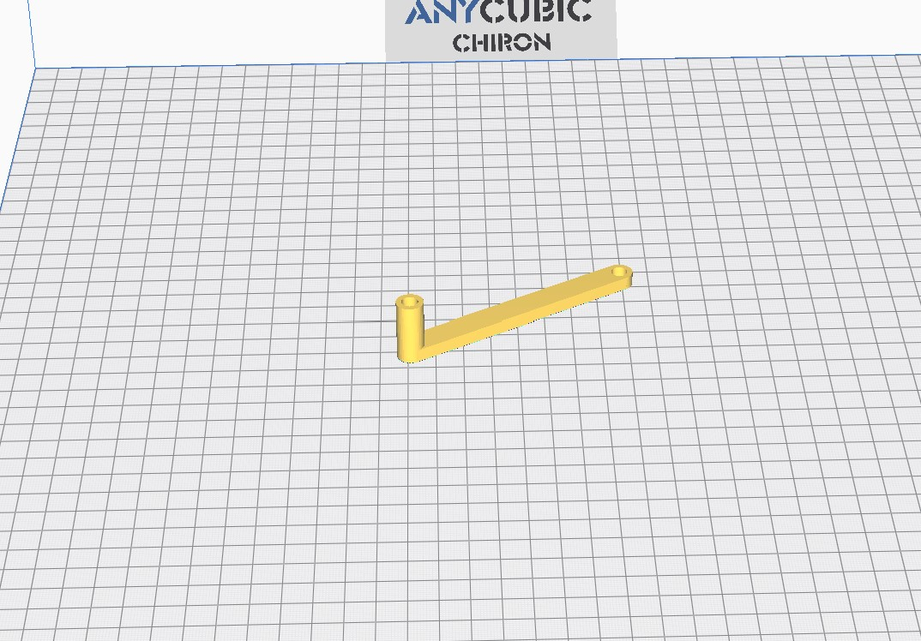

Part 21.

Print settings:

Image to show orientation

**Figure 17**

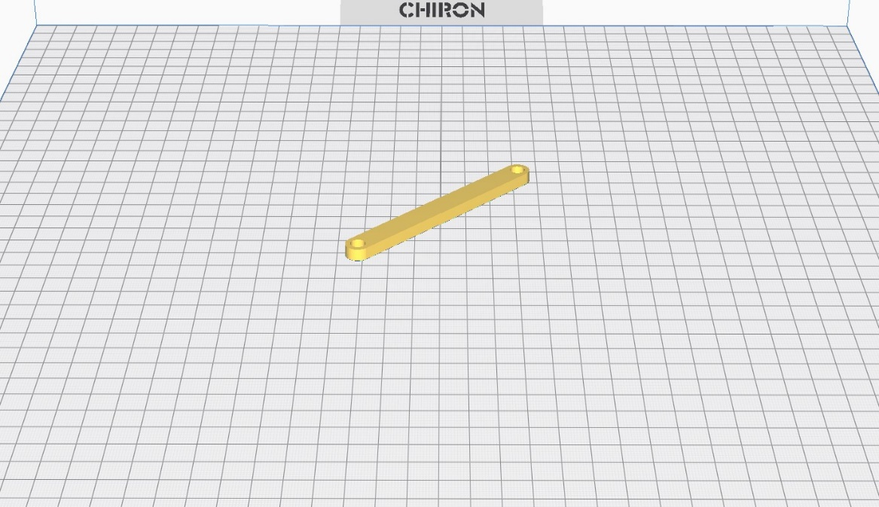Part 22.

Print settings:

Image to show orientation

**Figure 18**

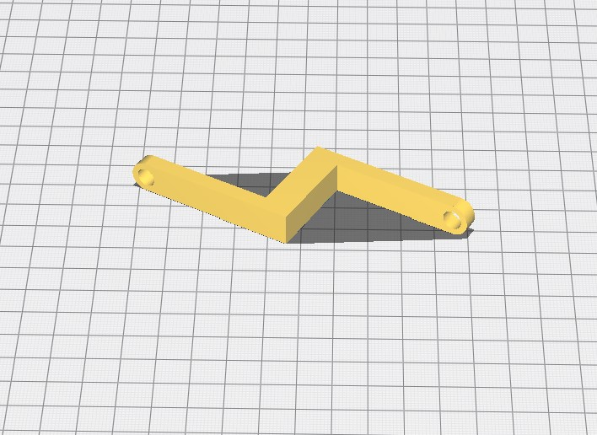

Part 23.

Print settings:

Image to show orientation

**Figure 19**

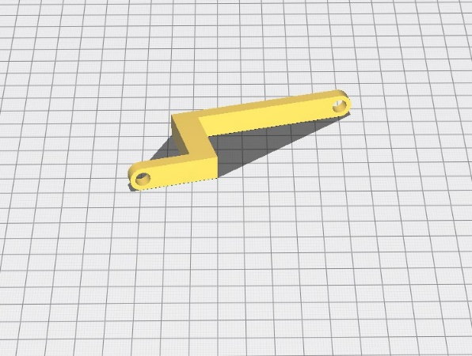

Part 24.

Print settings:

Image to show orientation

**Figure 20**

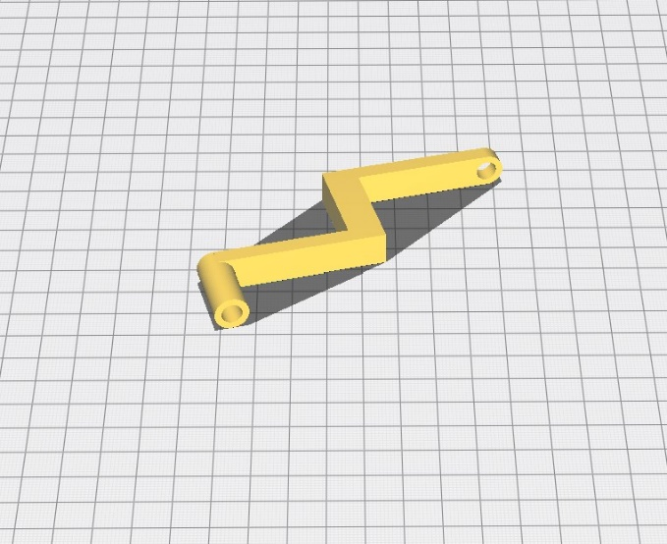

Part 25.

Print settings:

Image to show orientation

**Figure 21**

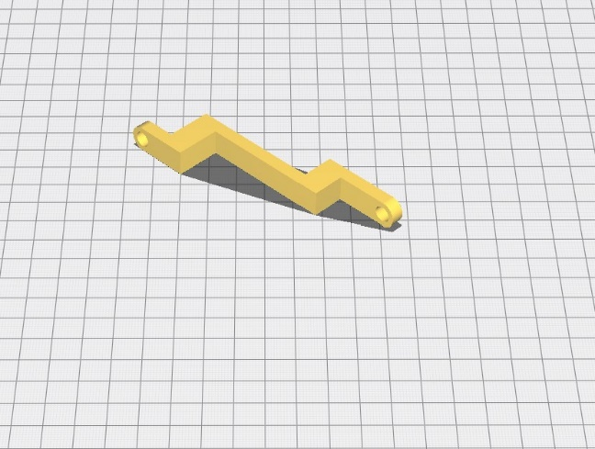

Part 26.

Print settings:

Image to show orientation

**Figure 22**

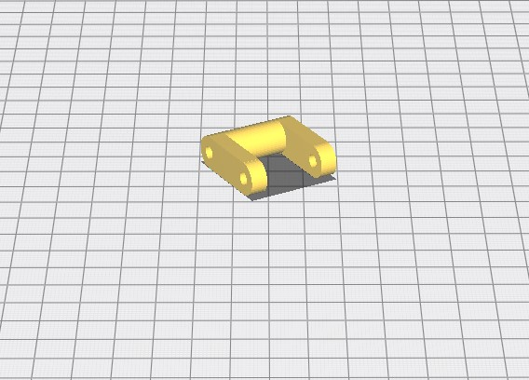

Part 27.

Print settings:

Image to show orientation

**Figure 23**

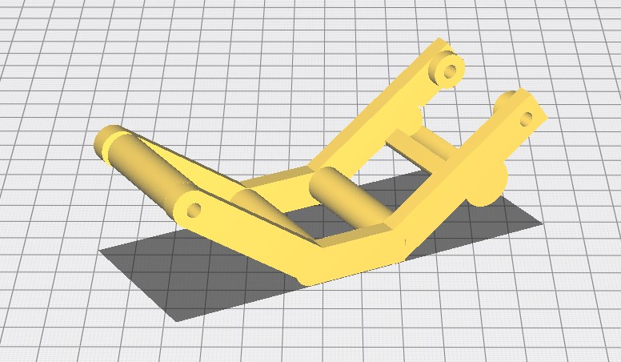Part 28.

Print settings:

Image to show orientation

**Figure 24**

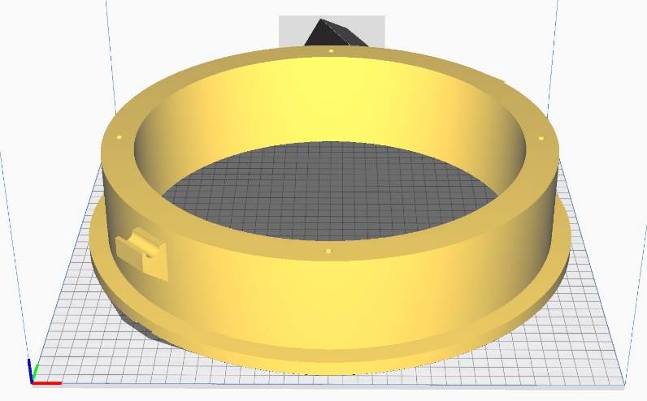

Part 29.

Print settings:

Image to show orientation

**Figure 25**

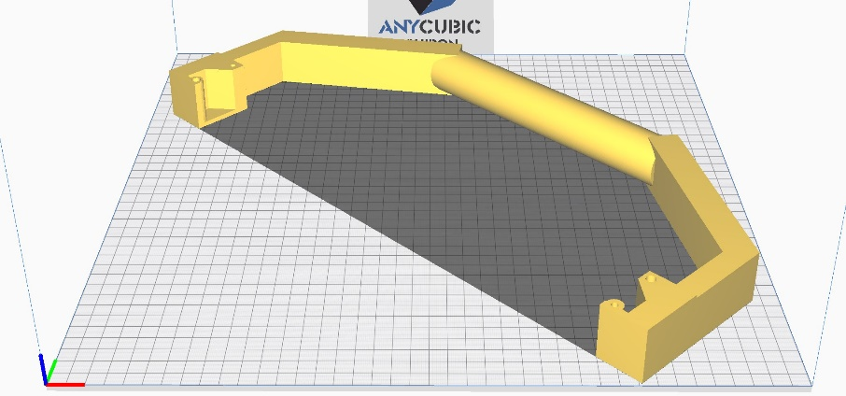

Part 30.

Print settings:

Image to show orientation

**Figure 26**

### 1.2.3 0.4mm Parts.

Printing at a nozzle size of 0.4mm increases the detail resolution of an fdm 3d print. This comes at the cost of overall print time, which is increased relative to 0.8mm resolution prints. This allows more intricate parts to be created for the chamber module. Print settings must be adjusted to deal with this lower volume of plastic. The recommended settings are based upon the printers used in this project, however individual printers vary, and may need their own adjustment.

Table 6 details the parts that are printed at 0.4mm, their print times and PLA plastic requirements.

**Table 6** – 0.4mm Part Printing Statistics

|  |  |  |  |  |
| --- | --- | --- | --- | --- |
| **Part Number** | **Estimated Print Time (Minutes)** | **Estimated Material Weight (g)** | **Estimated Filament Length (m)** | **Support material** |
| 13 | 50 | 8 | 2.59 | NO |
| 14 | 136 | 24 | 8.01 | NO |
| 15 | 40 | 6 | 2.12 | NO |
| 16 | 41 | 6 | 2.13 | YES |
| 17 | 40 | 6 | 2.12 | NO |
| 18 | 91 | 17 | 31 | NO |
| 19 | 11 | 2 | 0.62 | NO |
| 20 | 75 | 10 | 3.33 | NO |
| 31 | 7 | 1 | 0.43 | NO |

Using pre-sliced files

If using the pre-sliced models and an Anycubic Chiron printer, then the next steps are straight forward:

1. Install a 0.4mm nozzle to the printer. To change the nozzle, heat up the hotend/heating block to pla printing temperature (200oC). Hold the heating block in place while you remove any existing nozzle using a spanner, and then insert a 0.4mm nozzle in the same way (Figure 1.1).
2. Carry out some pre-print checks

* Ensure that the weight of PLA filament loaded to the machine before printing is greater than that estimated for the print in Table 5. Otherwise, be prepared to change the filament spool at some point during the print, which can cause layer shifts on the Anycubic Chiron and thus a failed print.
* Ensure that the print bed has recently been levelled.
* Ensure that the grub screws on the z-axis motor coupler are tight. Failure to do so can result in catastrophic print failures.
* Inspect the filament and ensure that it has not become brittle in the storage process. Brittle filament can result in print failures as the filament runout sensor will not be triggered.
* Ensure that the filament driver screw is at the correct tension and that the Bowden tube resistance is low (i.e. the Bowden tube is not worn out or blocked by PLA particles, and that filament flows freely through the print Nozzle).

1. Wipe down the print bed with a lint free cloth and isopropyl alcohol, to ensure adhesion of the print layers to the print bed.
2. Transfer the .gcode file of the part that you would like to print from Table 6 to the printer (e.g. Part 13). This is most simply done using an SD card.
3. Once the SD card is inserted into the printer, select the file for printing and select start print.
4. Check intermittently throughout the print to ensure that there has not been a failure and that no action needs to be taken.
5. Once the print is finished, let the printing bed cool to room temperature – the print should release from the print bed by itself. In the case that it is still stuck to the print bed, carefully remove the piece using the spatula/scraper provided with the 3d printer.
6. Store the 3d print safely. Parts with support material (listed in Table 6) will need the support material to be removed. However, this step is covered in section 1.3 (3d printed part post-processing).
7. Repeat steps 1 to 8 until all the parts from Table 6 have been printed.

Slicing models for a different printer

If not using an anycubic chiron printer, or you would like to print groups of specific parts together, then the stl files will need to be sliced before printing. The following is guidance on part orientation and support settings, when preparing your own gcode for the parts in Table 6.

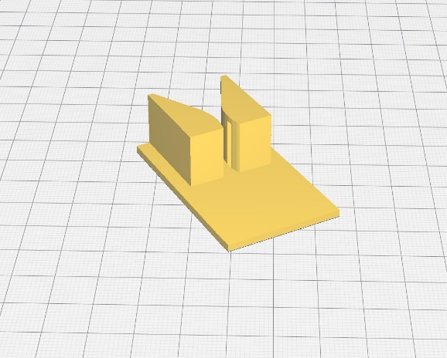

Part 13.

Print settings:

Image to show orientation.

**Figure 21**

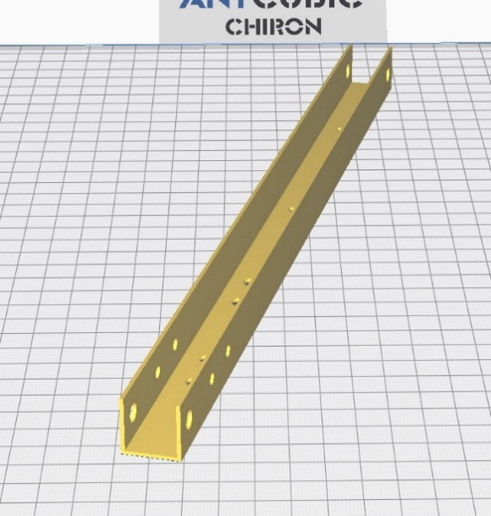

Part 14.

Print settings:

Image to show orientation

**Figure 15**

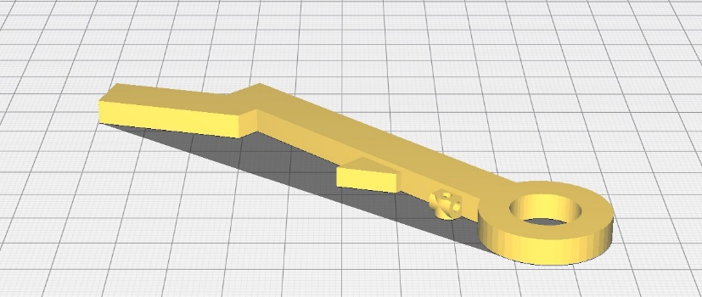Part 15.

Print settings:

Image to show orientation.

**Figure 22**

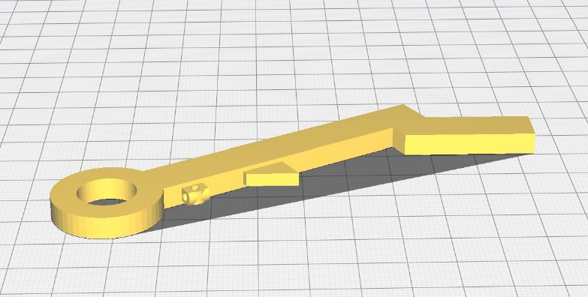Part 16.

Print settings:

Image to show orientation.

**Figure 23**

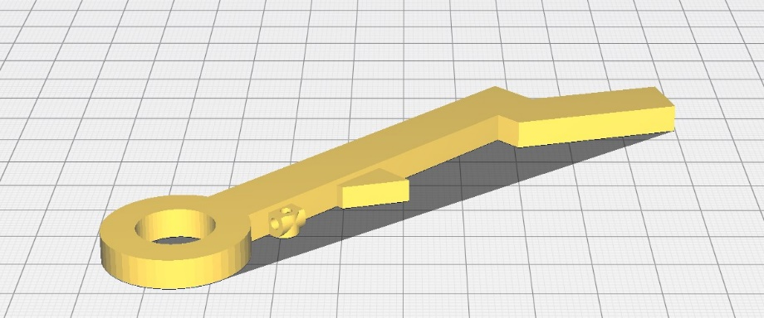Part 17.

Print settings:

Image to show orientation.

**Figure 24**

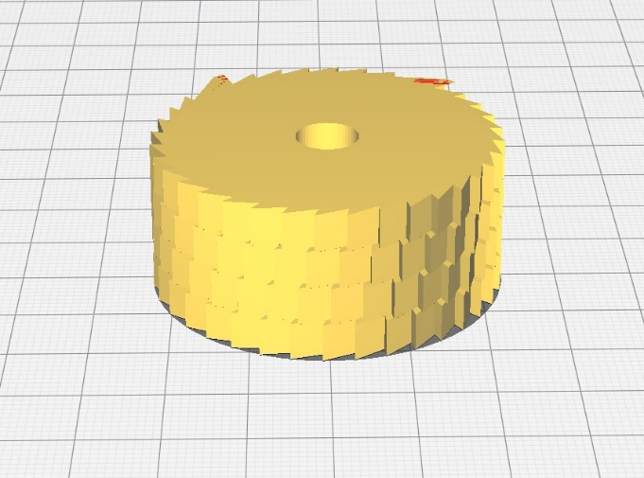Part 18.

Print settings:

Image to show orientation.

**Figure 25**

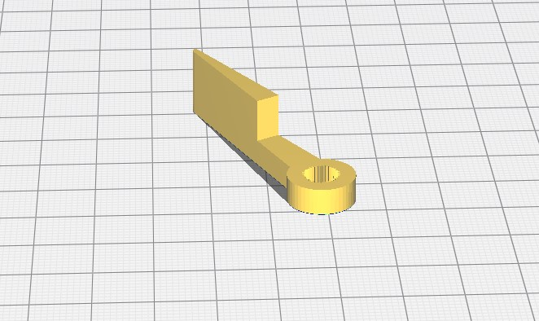Part 19.

Print settings:

Image to show orientation.

**Figure 26**

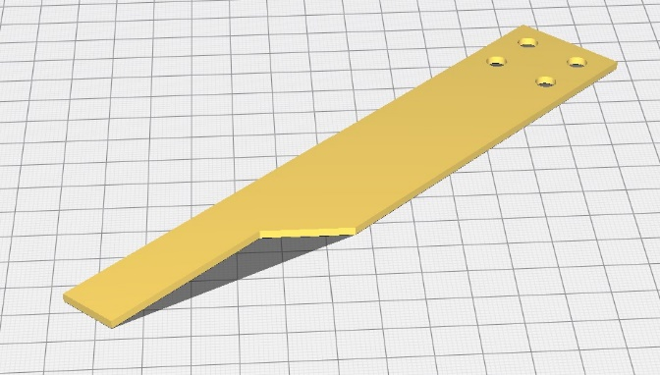

Part 20.

Print settings:

Image to show orientation

**Figure 16**

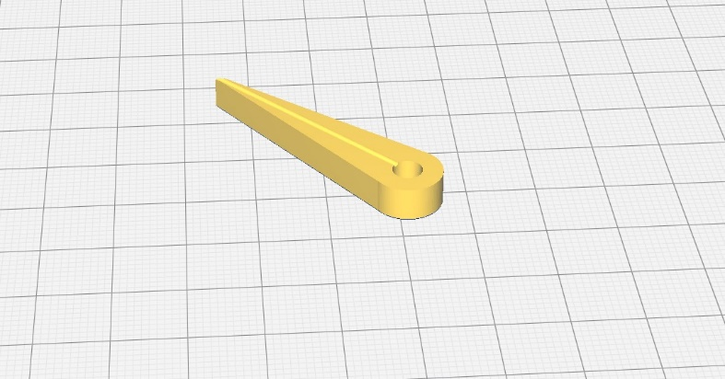Part 31.

Print settings:

Image to show orientation

**Figure 16**

## 1.3 Post-print Processing

Once the 3d printed parts in Table 1 (also listed in Tables 5 and 6) have been printed, a number of processing steps are required before the chamber assembly can begin (section 1.4). These processes are detailed below.

### 1.3.1 Support removal and clean-up

Firstly, the support material on the parts must be removed. The parts requiring support removal are listed in Tables 5 and 6 (section 1.2). Support material removal guidance for each part is given below.

Part 1. Chamber body

**Figure 27**

Part 4 and Part 5. Chamber float cutting templates

**Figure 28**

Part 8. Sensor board 1

**Figure 29**

Part 9. Motor case

**Figure 30**

Part 10. Motor case lid

**Figure 31**

Part 16. (middle pawl)

**Figure 32**

### 1.3.2 Print sealing and protection

The FDM printing method yields a part which is in essence a stack of mechanically bonded layers of plastic. As the layers are not chemically bonded (like in SLA resin printing), post processing is required to make these prints water and gas tight. For this purpose, we use epoxy resin (part 88 in Table 4) – a resin typically used for waterproofing and sealing due to its very low gas permeability and water vapor transmission properties ().

To protect the epoxy resin from UV degradation (visualised as a yellowing of the chamber), a final coat of UV resistant varnish (part 92 in Table 4) is applied over the chamber surfaces that will be exposed to sunlight. This also helps to maintain the structural integrity of the PLA plastic, which is less stable under UV exposure than other printing plastics, such as ASA or PETG.

**Table 7** – Parts requiring sealing and UV protection

|  |  |  |
| --- | --- | --- |
| **Part Number** | **Epoxy resin coating** | **UV protective coating** |
| 1 | YES | YES |
| 2 | YES | YES |
| 3 | YES | NO |
| 9 | YES | NO |
| 10 | YES | NO |
| 13 | YES* | NO |
| 63 | NO | YES |
| 64 | NO | YES |
| 64.b | NO | YES |

* Part 13 is a complicated part, requiring optical elements to be added.

Epoxy resin coating

It is advised that a longer cure time epoxy is used, a marine grade epoxy is ideal. This gives stronger results and plenty of time for application. Be carful to follow the safety guidance for the brand of epoxy you are using, however there are some basic principles to follow when working with epoxy:

* Avoid direct contact with the skin! In 10% of people contact between epoxy and skin can cause an allergic reaction called Contact Dermatitis (Westsystem, 2022). To prevent contact with the skin, it is advised that people working with the resin wear a HASMAT suit and tough use nitrile gloves designed for engineers. Nitrile gloves are recommended as other types of rubber gloves can melt when in contact with epoxy, while Nitrile does not. Tough gloves are recommended as 3dprinted parts can be quite sharp, causing tears in thin glove material.
* Ensure that the temperature of the workshop area is relatively warm. Epoxy is an exothermic reaction, and in very cold temperatures curing can be inhibited causing a sticky mess!
* Ensure that the working environment is well ventilated. Although epoxy resin off gassing is not obvious by smell, the chemicals can cause respiratory irritation when carried out in poorly ventilated areas or from prolonged exposure.

The working schedule for the epoxy process is as follows:

1. Tie and hang the part to be covered in a way that allows easy epoxy application. For this, fishing line is a good material, as regular string can become brittle after epoxy coating. Examples of how to tie the parts in Table 7 are given below.
2. Prepare your working space, ensuring that you have all the things you will need to mix and apply the epoxy. A small foam roller is an efficient way to apply epoxy, though a brush can also be used to a less aesthetic effect. Typical methods to measure the ratio of hardener to resin include using weighing scales or volumetric syringes.
3. The first layer: apply epoxy until it stops being absorbed by the 3d printed part. As a 3d printed part is in effect a mesh structure, a lot of epoxy will be absorbed in the first coating. When it appears that the print is saturated, wait 5 to 10 minutes before returning. If the print appears to be saturated then continue to the next step, otherwise apply more epoxy and repeat this step.
4. Wait until the epoxy becomes tacky/sticky – i.e. not completely cured. A tacky surface texture will chemically bond with the 2nd layer of epoxy applied. If the epoxy has completely cured then sand the surface to provide a rough texture for the second layer of epoxy to bond to.
5. Additional layers: Apply the next layer of epoxy. Less epoxy will be required for this step, as now the part is not porous. Apply like you would a layer of paint to a wall.
6. Now repeat steps 4 and 5 until the number of desired layers has been achieved. The recommended minimum number of layers is 2 to 3, however as different people apply the resin differently, 3 coats is often a safer option.
7. The last coat should be left to fully cure before removing from its hanging position, as epoxy remains soft after it is touch dry for up to 72 hours.
8. Remove all the parts from the fishing wire and check the areas that must be kept free for proper functioning (described individually for each part below). If these areas are blocked then use tools such as sandpaper, small files or a rotary tool to remove excess varnish. A common brand of rotary tool is the “Dremel”.
9. Store parts safely until you are ready to proceed with the next step in the build guide (UV protective coating).

Part 1.

A.

* Fishing line tying guide
* Number of coats
* Part specific tips i.e. areas not to block…to take care

B.

* Figures description

**Figure 33**

A.

Part 2.

* Fishing line tying guide
* Number of coats
* Part specific tips i.e. areas not to block…to take care

B.

* Figures description

**Figure 34**

A.

Part 3.

* Fishing line tying guide
* Number of coats
* Part specific tips i.e. areas not to block…to take care

B.

* Figures description

**Figure 35**

A.

Part 9.

* Fishing line tying guide
* Number of coats
* Part specific tips i.e. areas not to block…to take care

B.

* Figures description

**Figure 36**

Part 10.

A.

* Fishing line tying guide
* Number of coats
* Part specific tips i.e. areas not to block…to take care

B.

* Figures description

**Figure 37**

Part 13.

A.

* Fishing line tying guide
* Number of coats
* Part specific tips i.e. areas not to block…to take care

B.

* Figures description

**Figure 38**

UV protective Coating

After the necessary parts have been epoxy coated and allowed time to cure fully, it is time to UV coat the parts indicated in Table 7.

Ensure to follow the safety, preparation and application steps described on the UV protection coating that you use, for example polyurethane varnish (part 92 in Table 4). It is unlikely that the varnish will be cause the same irritation described in the Epoxy resin coating section above, however the same safety procedures are recommended. Similarly, temperatures can affect the varnish curing process, so excessively cold workspaces are not recommended.

The working schedule:

1. Tie and hang the part to be varnished in the manner described in the “Epoxy resin coating” section above.
2. Prepare your working space, ensuring that you have all the things you will need to mix and apply the varnish. A small foam roller is an efficient way to apply varnish, though a brush can also be used.
3. Prepare the surface to be varnished I.e., the **outside** of the part only. In most cases this will mean lightly sanding the area to be varnished. This allows a surface texture for the varnish to bind with. However, be sure to follow the specific brands advice.
4. Remove the durst with a damp cloth.
5. Apply the first layer of varnish to the **outside** of the part only, i.e. the area that will be exposed to the sun. Apply thinly like painting a wall. Take special care around areas that are likely to collect varnish and inhibit later construction processes (described in the “Epoxy resin coating” section above).
6. Wait until the varnish becomes tacky/sticky – i.e. not completely cured. A tacky surface texture will chemically bond with the 2nd layer of varnish applied. If the varnish has completely cured, repeat steps 3 and 4.
7. Apply a final coat to the part following step 5. As the purpose of this varnish is for UV protection and not aesthetics, it is likely that 2 coats will achieve this. However, is the manufacturer of your varnish suggests more coats, then follow that advise for best results.
8. Leave the parts to fully cure, following the advice of the given by the manufacturer. This is often 48 to 72 hours.
9. Remove the parts from the fishing wire and check the areas that must be kept free for proper functioning (described in the “Epoxy resin coating” section above). If these are blocked then use tools such as sandpaper, small files or a rotary tool to remove excess varnish. A common brand of rotary tool is the “Dremel”.
10. Store parts safely until you are ready to proceed with the next step in the build guide (Parts assembly).

## 1.4 Parts Assembly

This chapter details the construction of the chamber module, beginning with a group of individual parts, and ending with the constructed chamber. The assembly process is divided into a subassembly hierarchy, using the principle of 1 significant part to multiple insignificant parts such as fasteners. A combination of action diagrams, supplemented with written text and links to online animations describe this assembly process.

The main sub assembly modules are as follows: /*maybe delete the list of modules, more for planning steps*/

1. Chamber body module
2. Chamber lid module
3. Motor case module
4. Internal bracket module
5. Lid and bracket combined to one
6. Lid and bracket module connected to chamber module

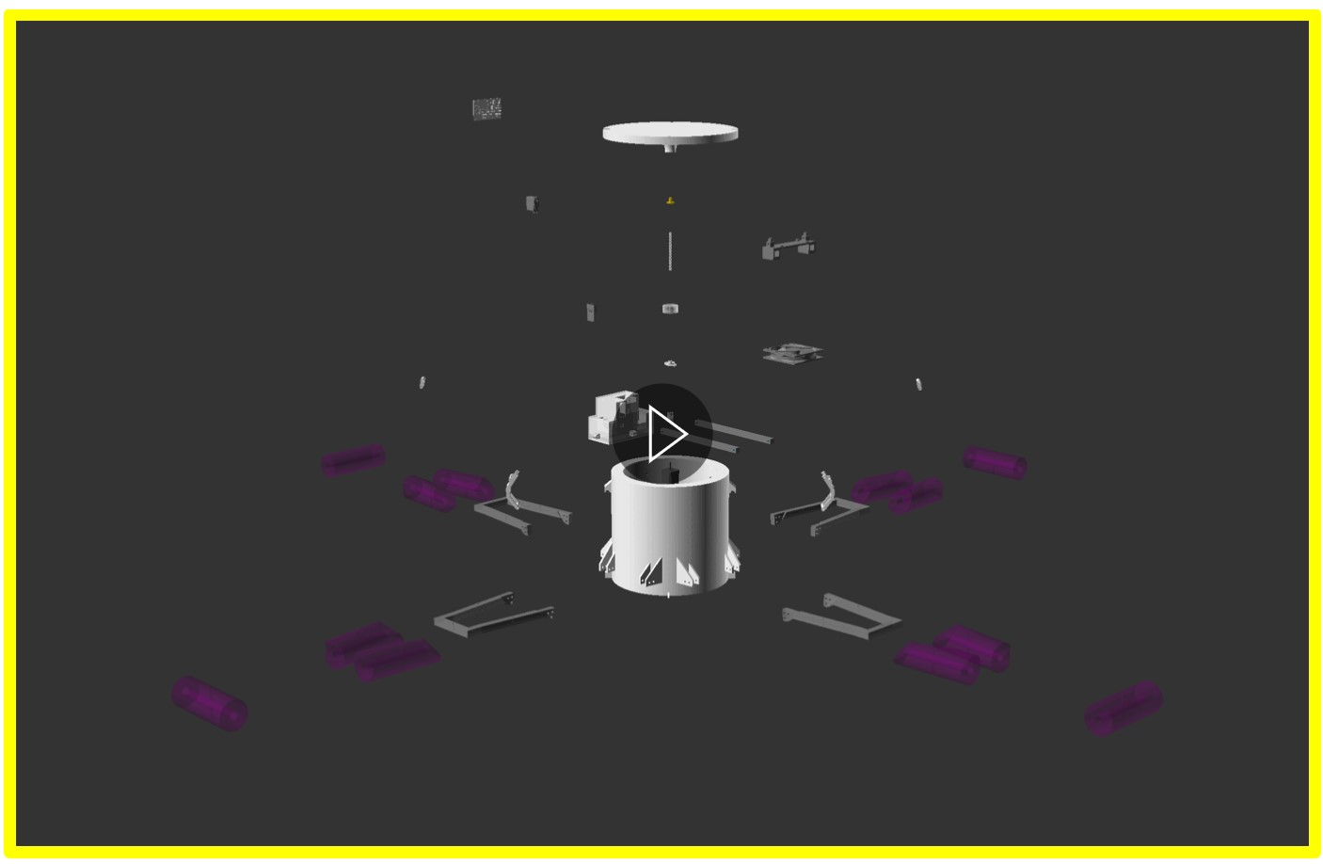

**Figure 39** GIF animation depicting the explosion of the chamber parts from their initial constructed form. Print copy will just show one frame from this animation. View online pdf for the animation. Parts and animation carried out in openSCAD.

### Step 1: Preparation

* Before beginning assembly, check that the parts listed in section 1.1 (Tables 1 to 4) have been collected, **excluding** parts 88, 89, 92 from Table 4 (only required in sections 1.2 and 1.3), **excluding** parts 48, 51, 52, 56, 61 and 62 from Table 2 and **excluding** parts 77 and 78 from Table 3, which will themselves be constructed from parts in Table 4 throughout this assembly section.
* Read this chapter before beginning construction. Familiarise yourself with the steps you are about to undertake, and make sure you have all the required tools to complete construction.

### Step 2: Chamber body

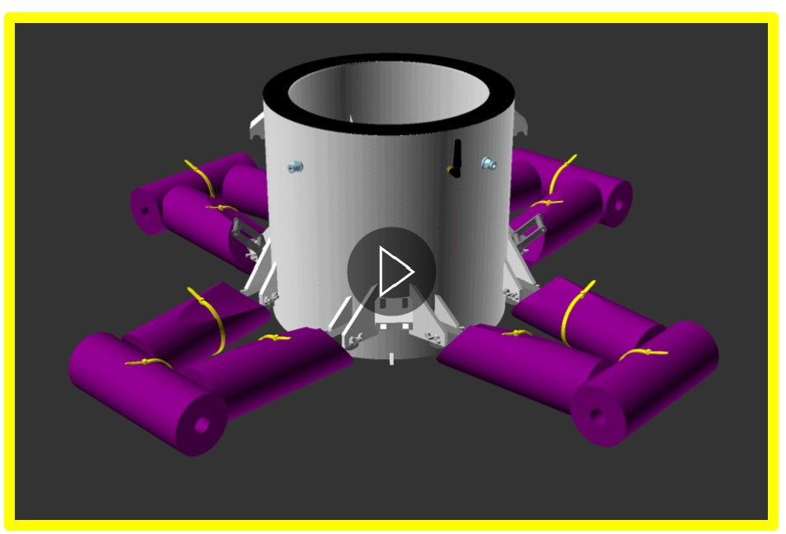

**Figure 40** 3d model illustrating the product of step 2. Before moving to step 3, your assembled piece should look like this. Print copy will just show one frame from this animation. View online pdf for the GIF animation modelled in openscad.

Step 2 focuses upon the subassembly piece “Chamber body”. The end product of this step is an open chamber, with float arms, tube connections, antenna mount, stacking chamber clips and gasket installed (illustrated by figure 40).

2.1 Gasket installation

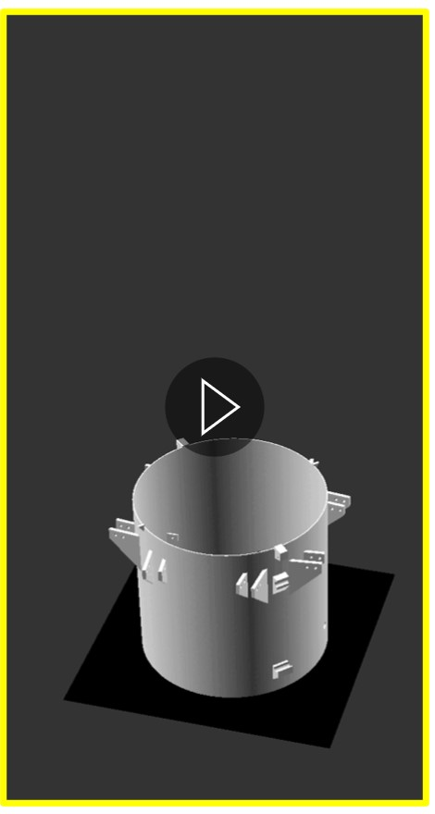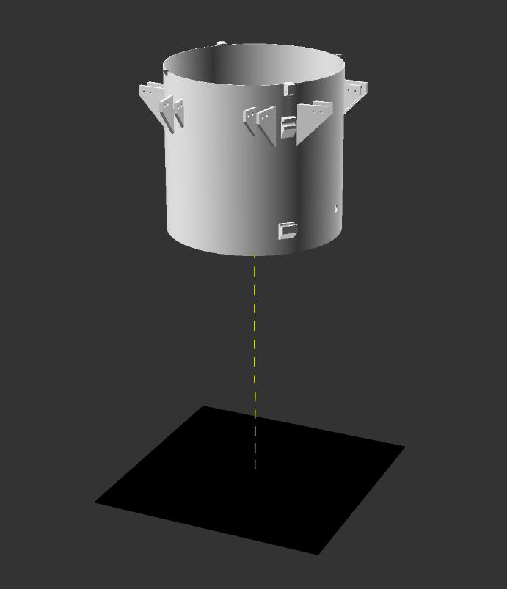

**d.)**

**a.)**

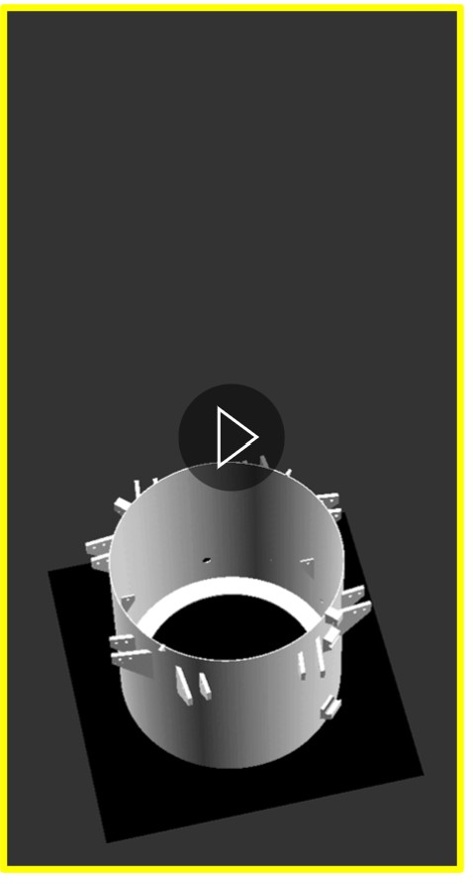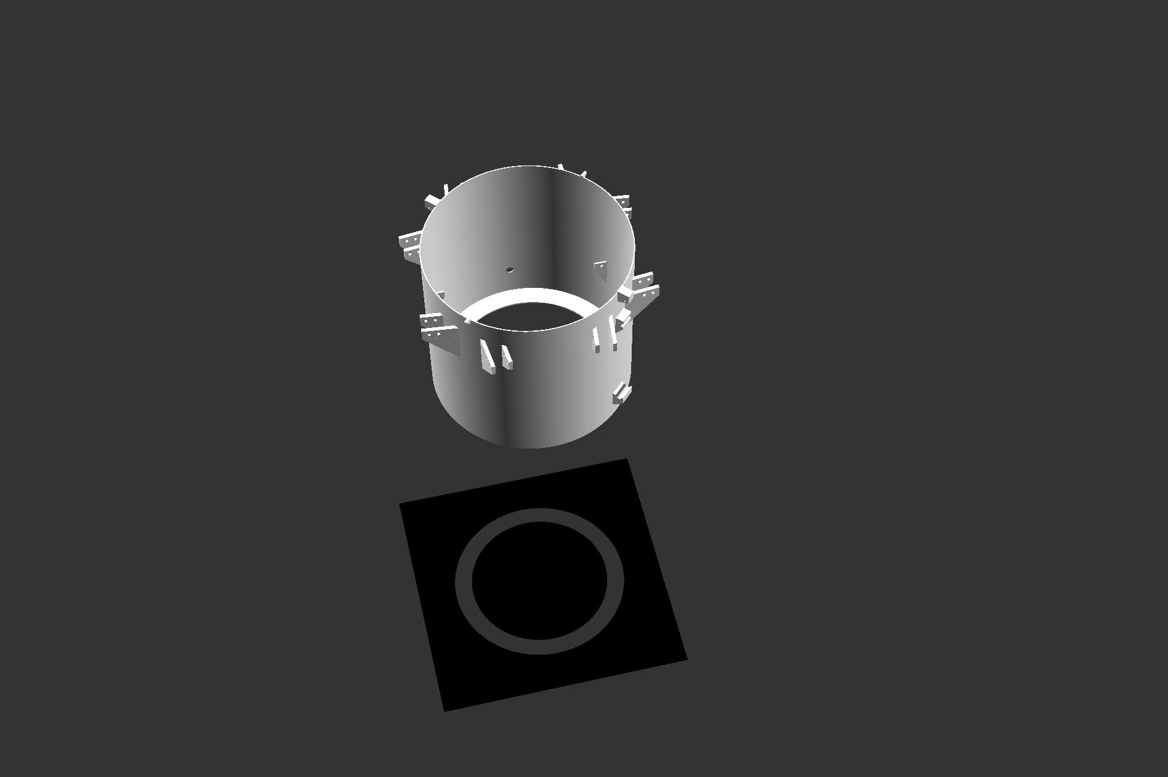

**e.)**

**b.)**

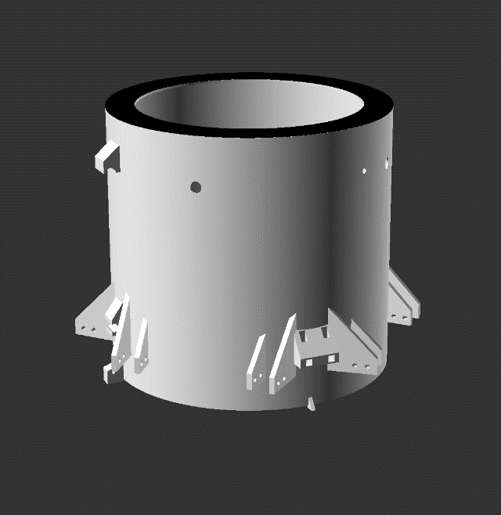

**c.)**

**Figure 41** Action diagrams (a, b and c) and animated gifs (d and e) illustrating step 2.1 gasket installation in the chamber body subassembly.

Notes:

Parts required for this section = Part 1 and Part 94 (part 94 will become part 52 after cutting).

Remove the paper protecting the glue surface of Part 94. If this is not supplied with a glued surface, then apply glue to the rubber surface now.

Lightly score the top rim of part 1 that will be face down on the glued surface of part 94. Do this in a cross-hatch pattern using a craft knife. This gives a textured surface for the glue to bind with.

Push part one (cross-hatch pattern down towards the glue) onto the glued surface of part 94 (illustrated in still figure 41 a and animated figure 41 d). Apply weight to part 1 for the curing time of the glue (usually 10 minutes).

Using a craft knife cut part 94 carefully around the outside and the inside of part 1 (this forms the rubber gasket referred to as part 52 from here on). Lift the building unit (part 1 and 52) away to leave part 94 resembling still figure 41 b or animated figure 41 e.

Flip over the building unit so that the gasket (part 52) is not in contact with the floor. Try to keep the gasket clean and damage free throughout the build process. The end product should resemble figure 41 c.

2.2 Float arm axle installation

**a.)**

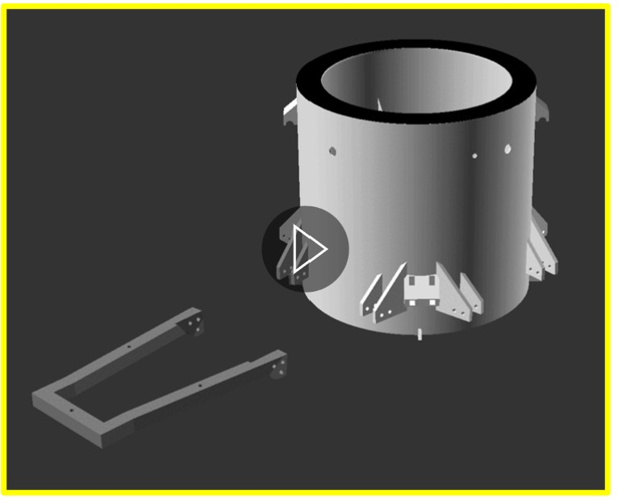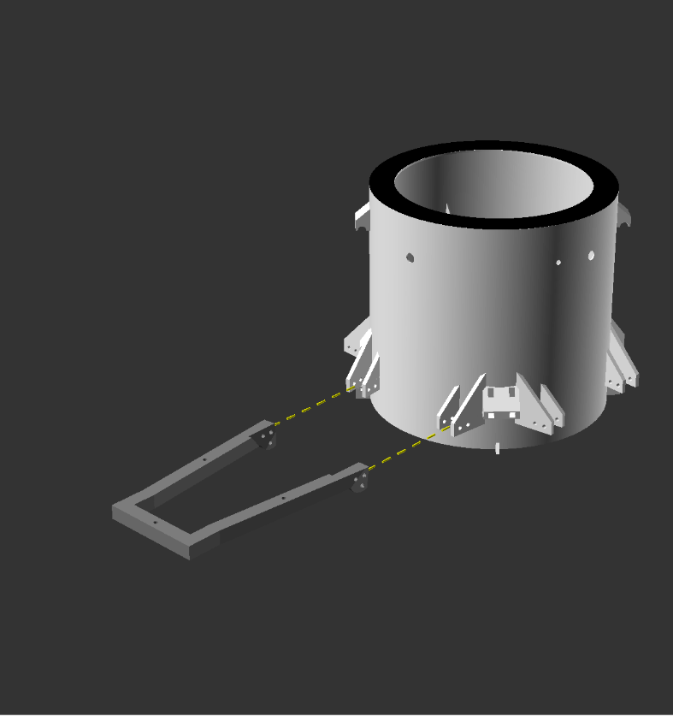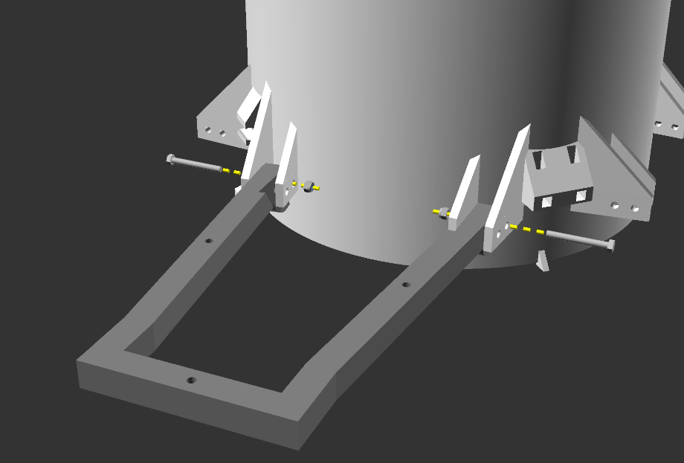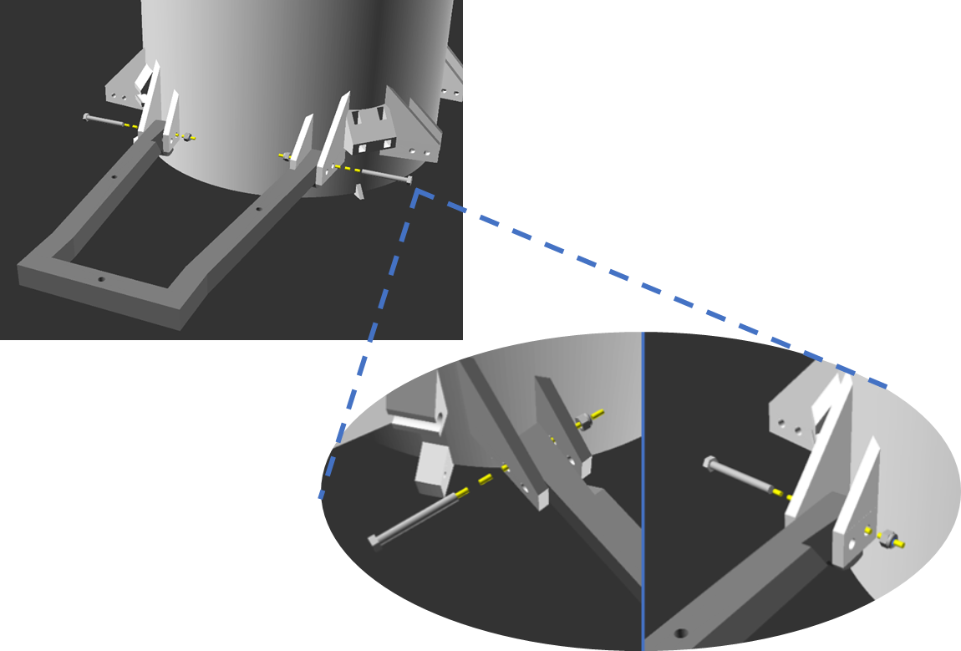

**d.)**

**e.)**

**b.)**

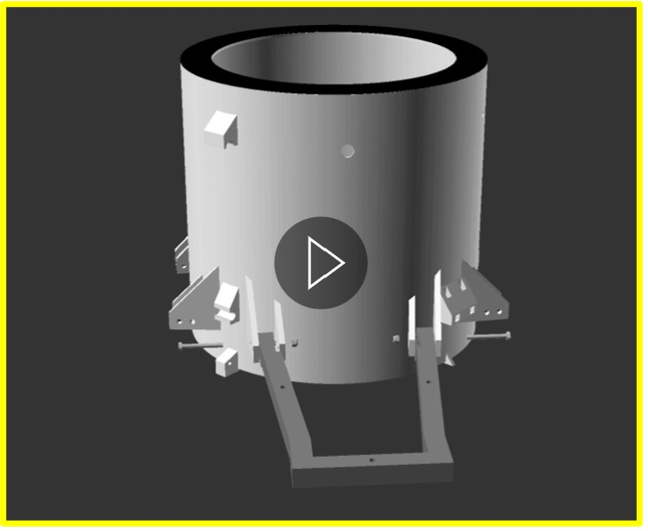

**c.)**

**Figure 42** Action diagrams (a, b and c) and animated gifs (d and e) illustrating step 2.2 float arm axle installation to the chamber body subassembly.

Notes:

Parts required for this section = Subassembly unit resulting from step 2.1 (figure 41 c), part 3, 2 x part 32 and 2 x part 34.

Orient part 3 as illustrated in figure 42 a and d, positioning between the shoulders of part 1 (now the subassembly unit), so that the holes in each part are lined up.

Following Insert part 32 through the outer shoulder hole closest to the chamber body, through the matching hole in part 3 and then out through the inner shoulder hole. Repeat this for both of the 2 shoulders (illustrated in figures 42 b, c and e).

Now screw on parts 34 to parts 32 (illustrated in figures 42 b, c and e) using an 8mm spanner/ wrench. Ideally a ratcheting spanner/wrench is used on the hex bolt outside of the shoulder to do the tightening/ rotation of part 32, while a standard spanner/wrench or pair of pliers are used to hold part 34 in place.

The bolt should be tensioned so that it and part 3 can still move freely. Its function is to act as an axle. Do not overtighten.

2.3 Float arm lock pin installation

**a.)**

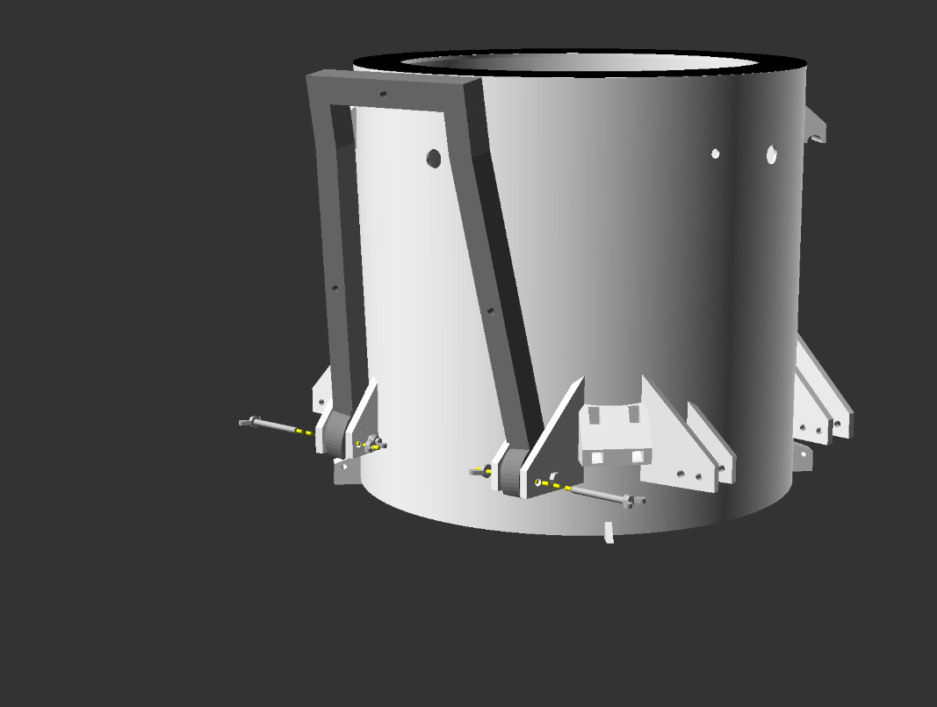

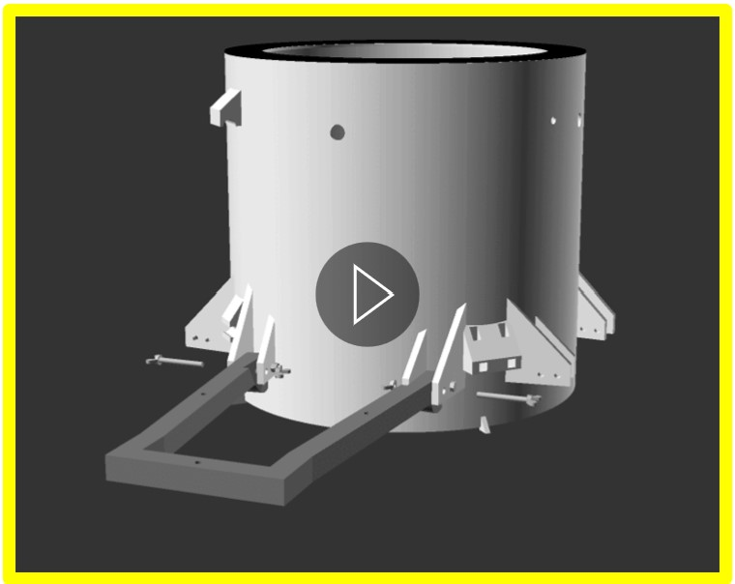

**d.)**

**b.)**

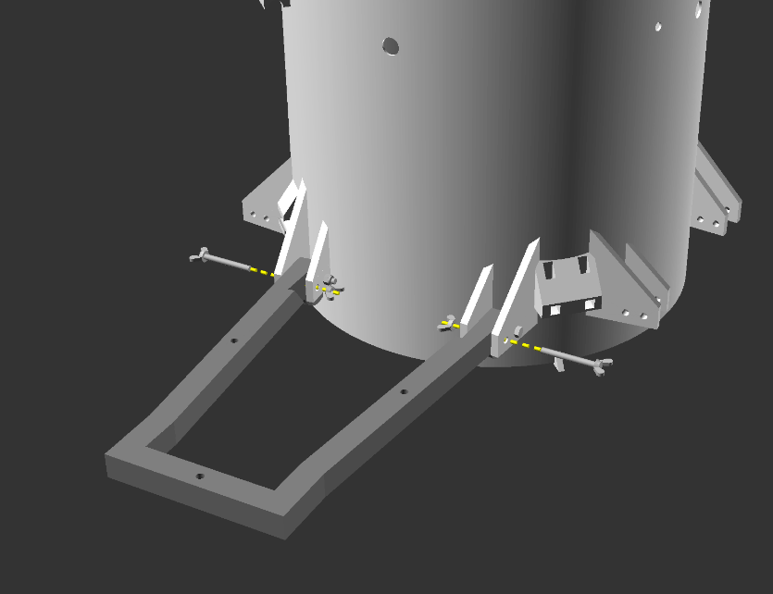

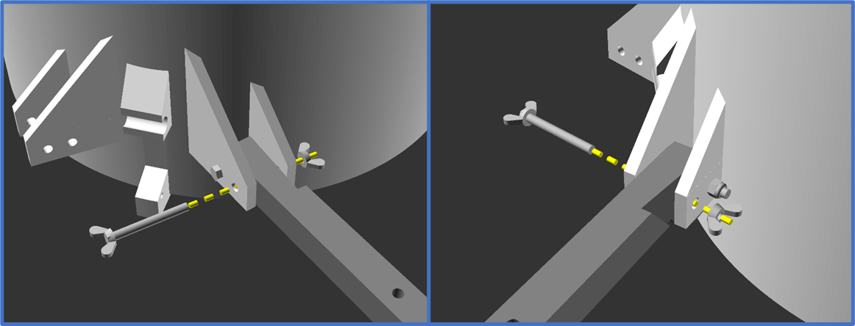

**c.)**

**Figure 43** Action diagrams (a, b and c) and animated gifs (d) illustrating step 2.3 float arm lock pin installation to the chamber body subassembly.

Notes:

Parts required for this section = Subassembly unit resulting from step 2.2 (figure 42 b and e), 2 x part 32.b and 2 x part 34b

This step locks the float arm (part 3) into 2 positions: vertical position for storage and transport (figure 42a), or horizontal position for use on the water (figure 42b). The position that we will work with for the next steps is the horizontal position.

Inset part 32.b through the outside of the chamber shoulder (part 1 shoulder) inwards, through the hole in part 3, and out through the internal chamber shoulder. Next thread part 34b onto part 32.b (illustrated in figure 43 b, c and d).

The role of this part is to lock the chamber arm in its position. The bolt and arm should not move. Tighten the bolt using your hands with only moderate force, so as not to break the 3d printed parts. Never use pliers or other tools to gain added leverage as this can result in overtightening and breaking of 3d parts.

2.4 Floats installation

**a.)**

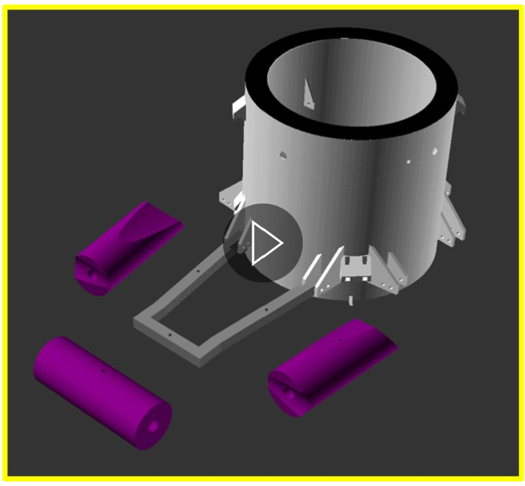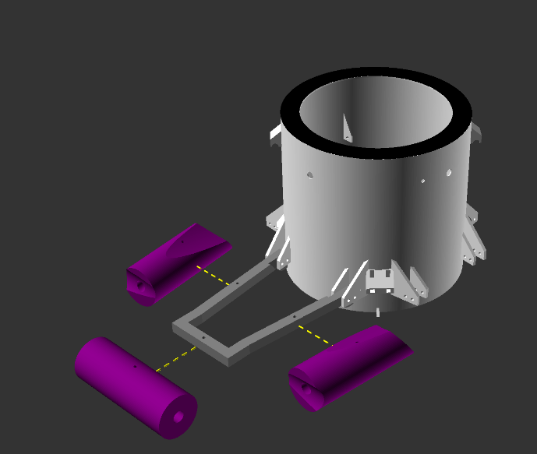

**d.)**

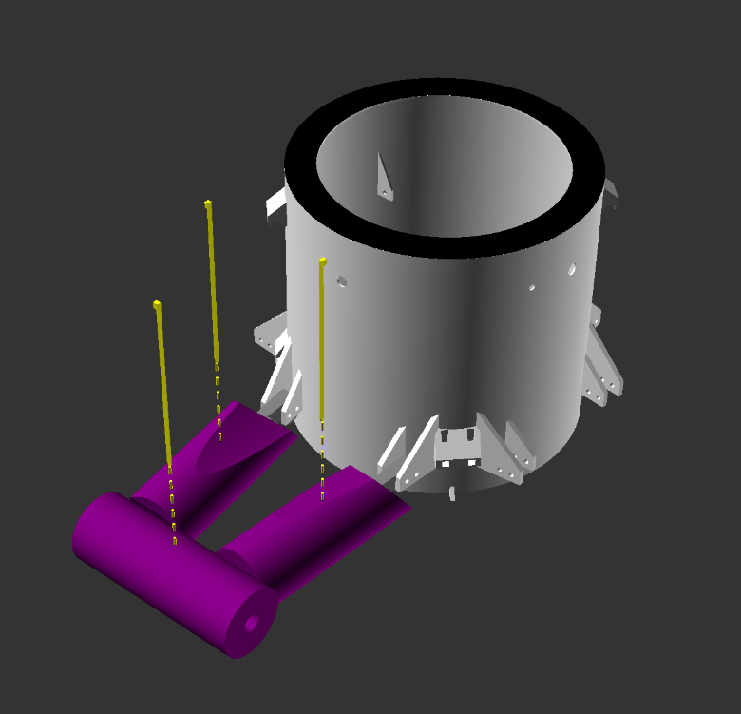

**b.)**

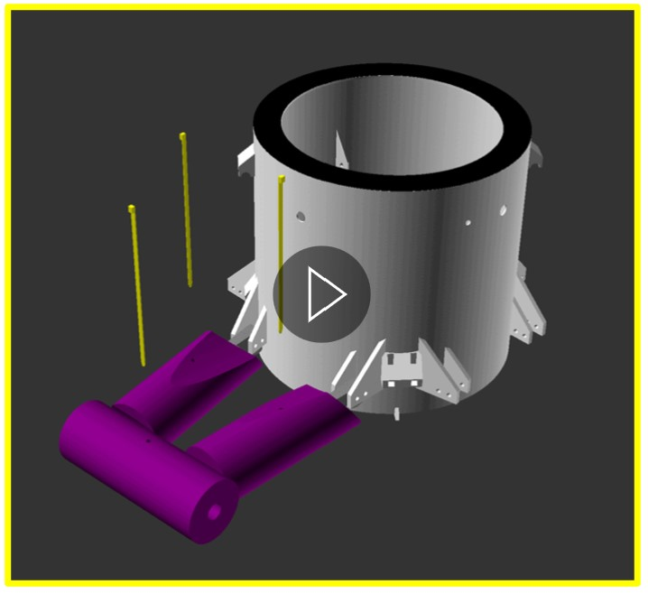

**e.)**

**c.)**

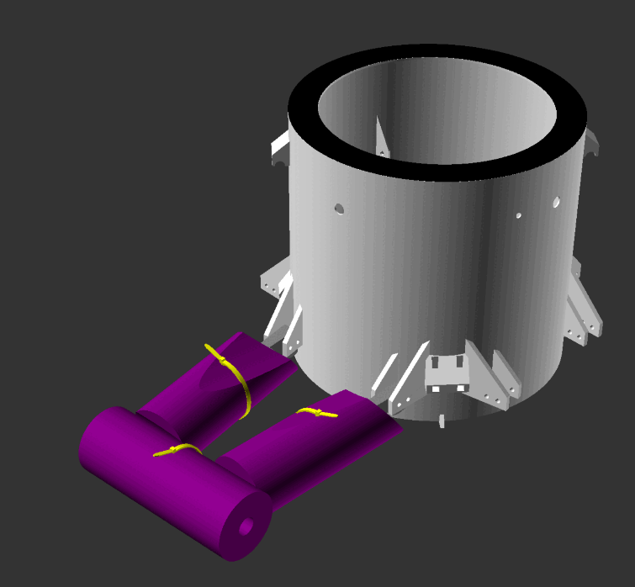

**Figure 44** Action diagrams (a, b and c) and animated gifs (d and e) illustrating step 2.4 float installation to the chamber body subassembly.

Notes:

Parts required for this section = Subassembly unit resulting from step 2.3 (figure 43 b and d), 1 x part 63, 1 x part 64, 1x part 64.b and 3x part 93 .

That foam floats (parts 63, 64, and 64.b) must be slipped onto part 3 of the subassembly through the open side of the foam pipe. The drilled holes in the floats should align with the holes in part 3. Parts 63 and 64 should be oriented such that the side cuts are on the chamber side and the end grove is pointing away from the chamber. This process is illustrated in figures 44 a and d, with part 63 being the left most float and part 64 being the right float in the image.

Push the cable/zip ties (part 93) through the top hole in the foam floats, then through the hole in part 3 and out through the bottom hole in the float again (figures 44 b and d). This is sometimes more easily done by peeling back the float around part 3 to see clearly what the cable tie is doing.

Connect the cable tie to its head and tighten to hold the foam in place (figures 44 c and d).

2.5 Complete arm installation

**a.)**

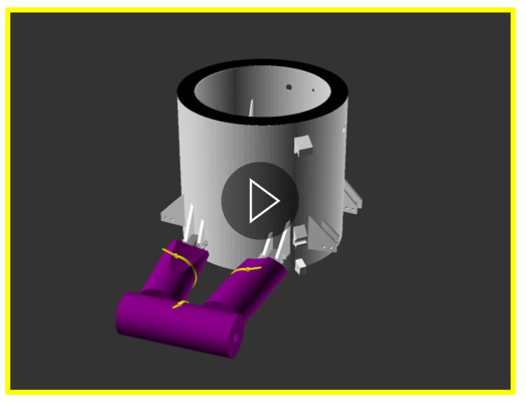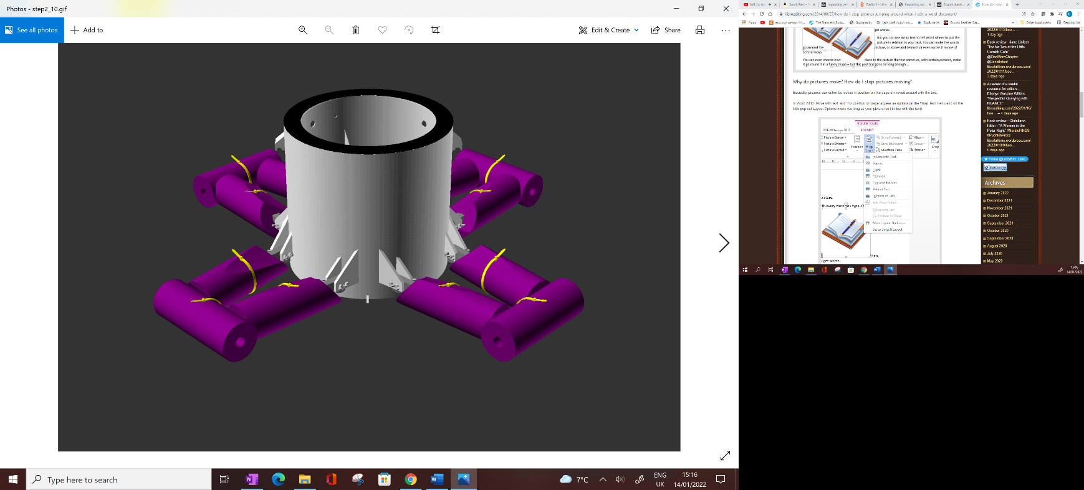

**b.)**

**Figure 45** Action diagrams (a) and animated gif (b) illustrating step 2.5 complete arm installation to the chamber body subassembly.

Notes:

Repeat steps 2.2 to 2.4 until all 4 of the chamber arms have been installed (figure 45 b).

The product of this step should resemble figure 45 a.

2.6 Push fit tube connector installation

**a.)**

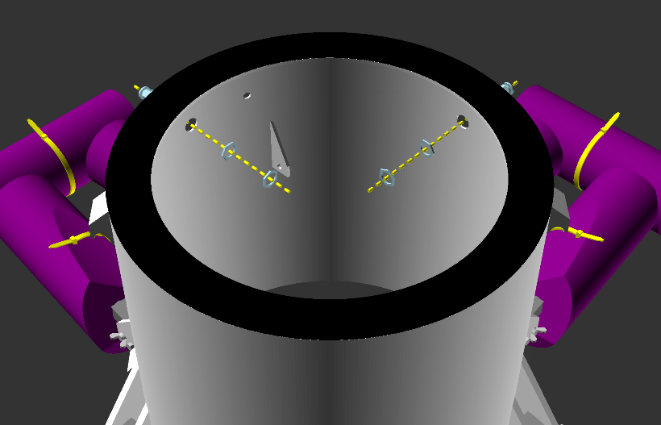

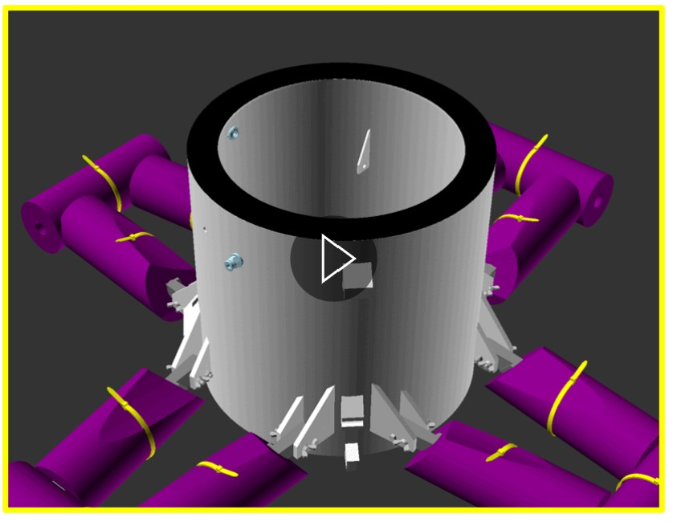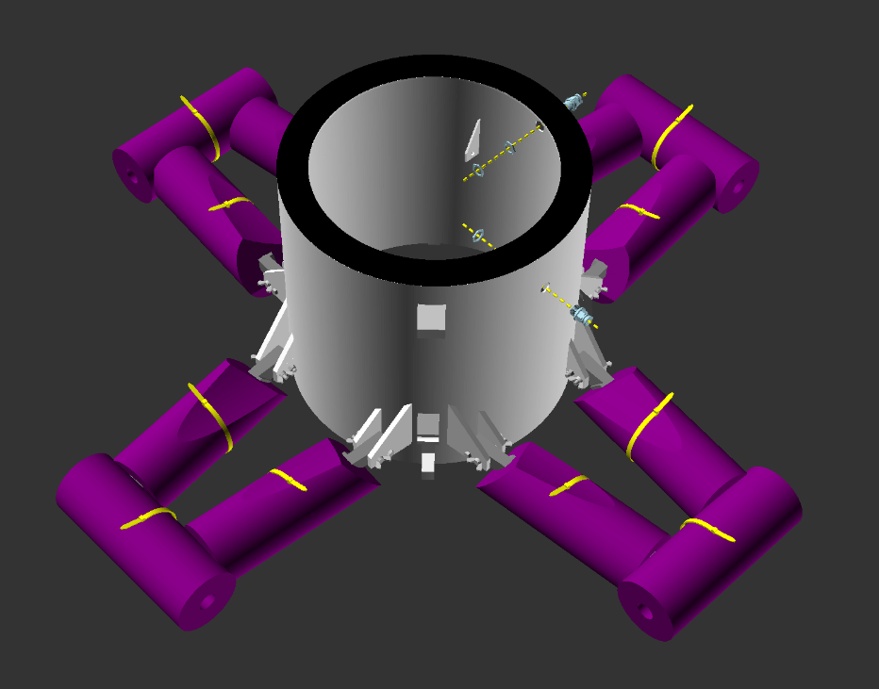

**d.)**

**b.)**

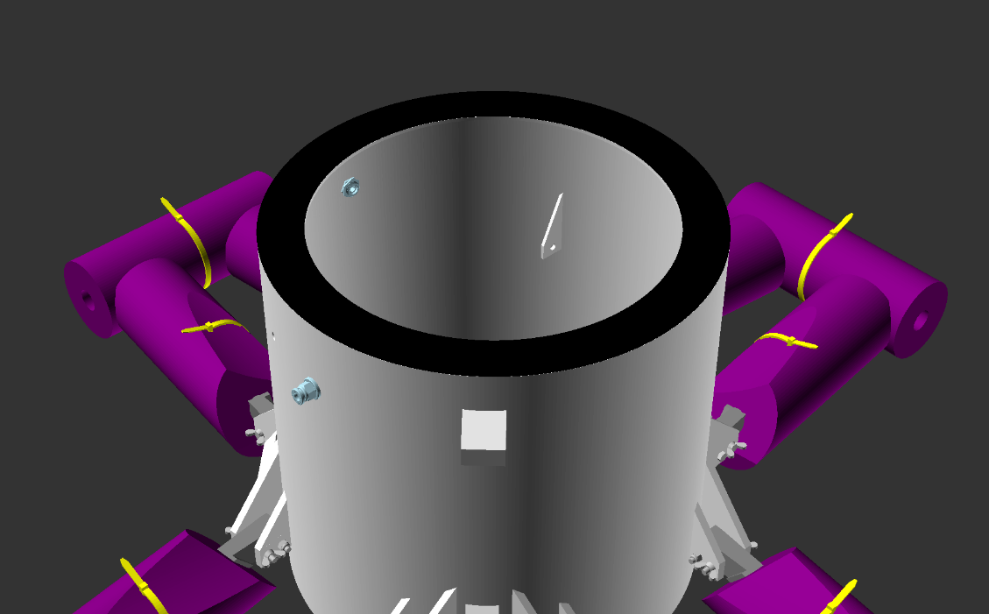

**c.)**

**Figure 46** Action diagrams (a, b, c) and animated gif (d) illustrating step 2.6 Push fit tube connector installation to the chamber body subassembly.

Notes:

Parts required for this section = Subassembly unit resulting from step 2.5 (figure 45 b), 2 x part 61, 4 x part 61.b.

Dry fit part 61 into the hole illustrated in figures 46 a, b and d. These are the two larger diameter holes (the smaller diameter hole in between is required for step 2.7).

Dry thread first 1 part 61.b onto the rear thread of part 61, tightening either with 2 pairs of pliers (one on the outside on part 61 and one on the inside on part 61.b) or by using wrenches/spanners. Next dry thread the second part 61.b to lock the first nut in place.

When happy that this assembly is correct and resembling figure 46 c, reverse the process and proceed to the wet fit.

Cover the threaded portion of part 61 with thickened epoxy (part 88) or gel superglue (part 90). Wearing gloves, insert part 61 into the hole again and follow the dry fit steps described above.

After the glue has cured, ensure that there are no leaks around part 61 by testing with water around the glued joint. If a water is leak is spotted, dry thoroughly, apply more glue and repeat until no leak is seen.

Repeat this step for the second push fit connector on the chamber.

2.7 Antenna installation

**a.)**

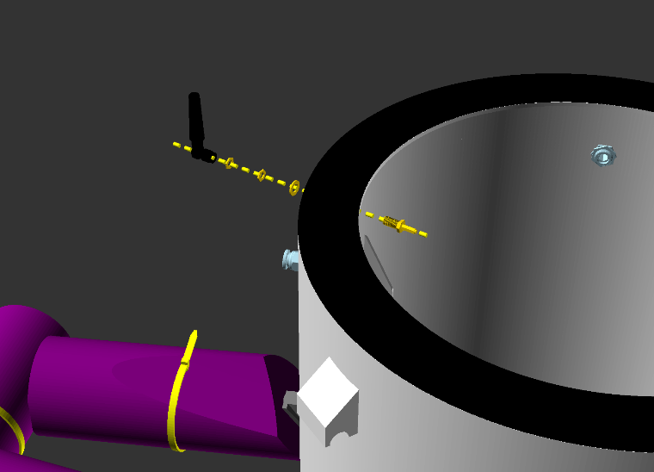

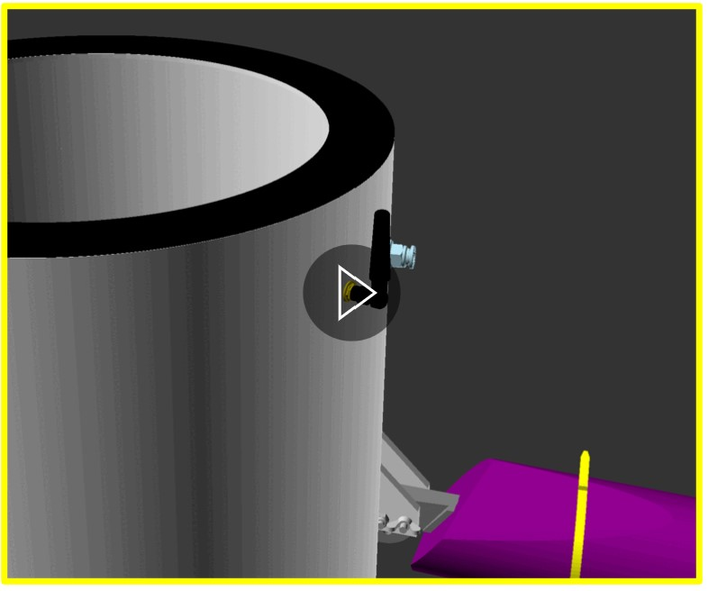

**c.)**

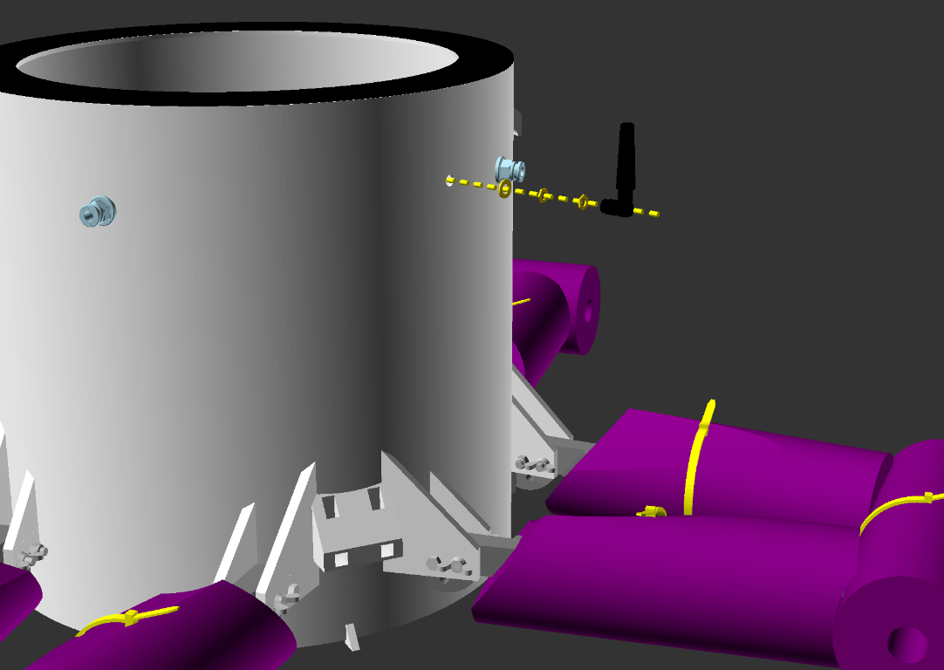

**b.)**

**Figure 47** Action diagrams (a, b) and animated gif (c) illustrating step 2.7 Antenna installation to the chamber body subassembly.

Notes:

Parts required for this section = Subassembly unit resulting from step 2.6 (figure 46 c), parts 73, 74, 74.b and 2 x part 74.c.

Dry fit part 74 into the the smaller diameter hole between the 2 push fit connectors (part 61), from the inside of the chamber (part 1) out (illustrated in figures 47 a, b and c).

On the outer side of the chamber apply first part 74.b then the two parts 74c to the threaded connector of part 74. Tighten carefully with 2 pairs of pliers (one on the outside on part 61 and one on the inside on part 61.b) or by using wrenches/spanners.

When happy that this assembly is correct and resembling figure 47 c, reverse the process and proceed to the wet fit.

Cover the threaded portion of part 74 with thickened epoxy (part 88) or gel superglue (part 90). Wearing gloves, insert part 74 into the hole again and follow the dry fit steps described above.

After the glue has cured, ensure that there are no leaks around part 74 by testing with water around the glued joint. If a water is leak is detected, dry the area thoroughly, apply more glue and repeat until no leak is seen.

Once complete, screw on part 73, with the antenna pointing upwards.

2.8a Stacking clip installation

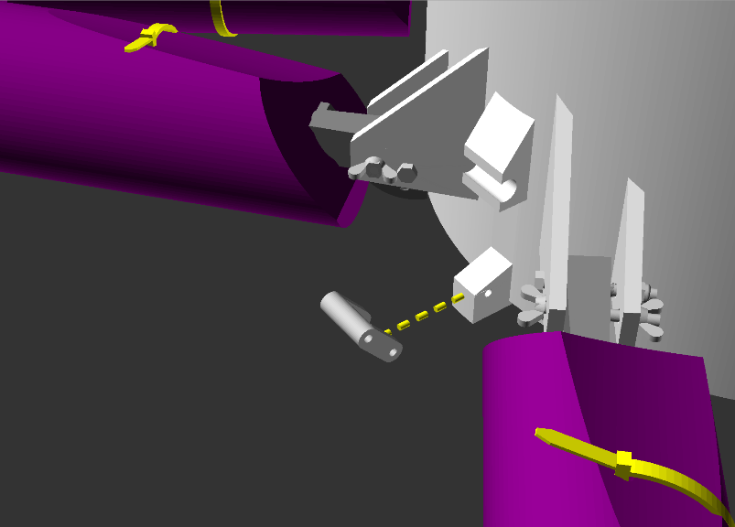

**a.)**

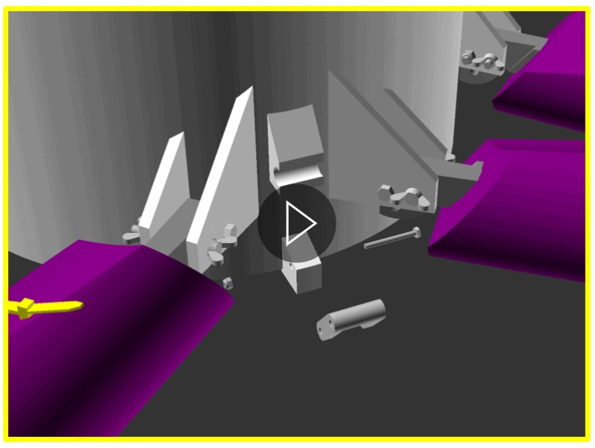

**c.)**

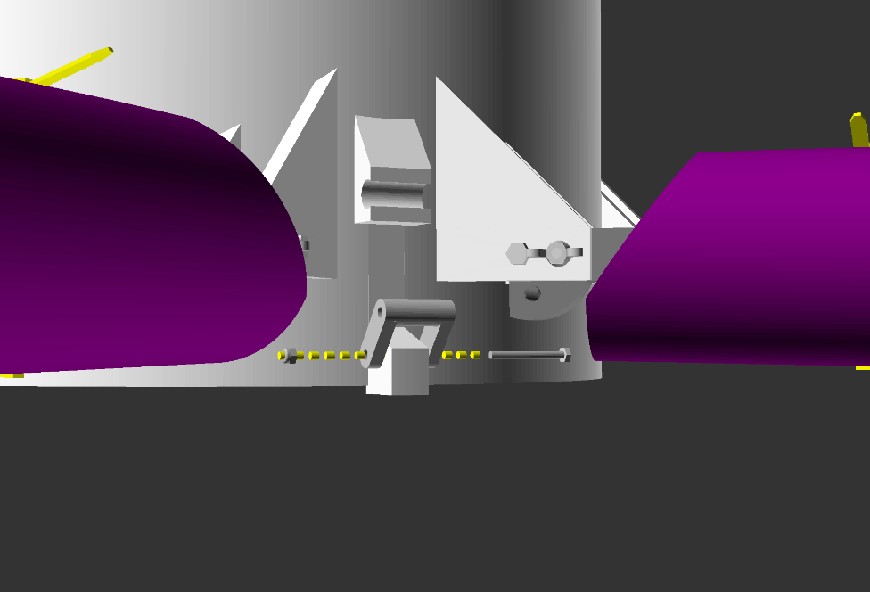

**b.)**

**Figure 48** Action diagrams (a and b) and animated gif (c) illustrating step 2.8a stacking clip installation to the chamber body subassembly.

Notes:

Parts required for this section = Subassembly unit resulting from step 2.7, 2x parts 27, 2 x part 42, 2x part 44 (or 2x part 44b combined with part 90 if spacing is an issue).

Position part 27 over the chamber body (part one), as illustrated in figures 48 a and c, lining up the holes in each part.

Following figures 48 b and c, insert part 42 through part 27, then through the hole in part 1, and out through part 27 again. Thread part 44 onto the exposed thread of part 42. Tighten with a 5mm spanner/ wrench, so that part 27 can rotate easily, while being confidently that it will not fall off.

In the case that part 44 blocks the movement of the latch, it can be replaced with a single part 44b and held in place with superglue (part 90). The result is shallower than part 44, though less durable.

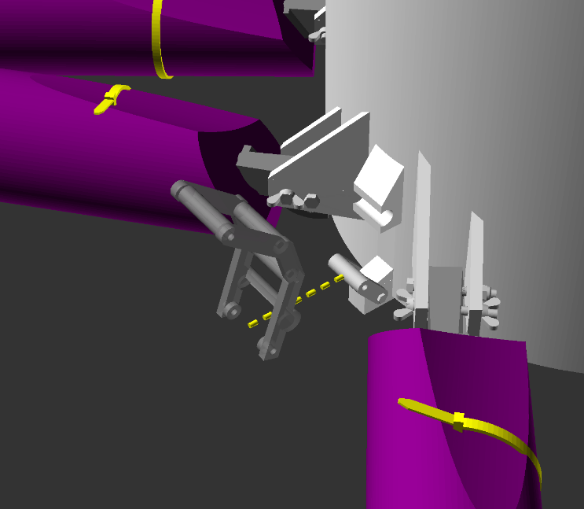2.8b Stacking clip installation

**a.)**

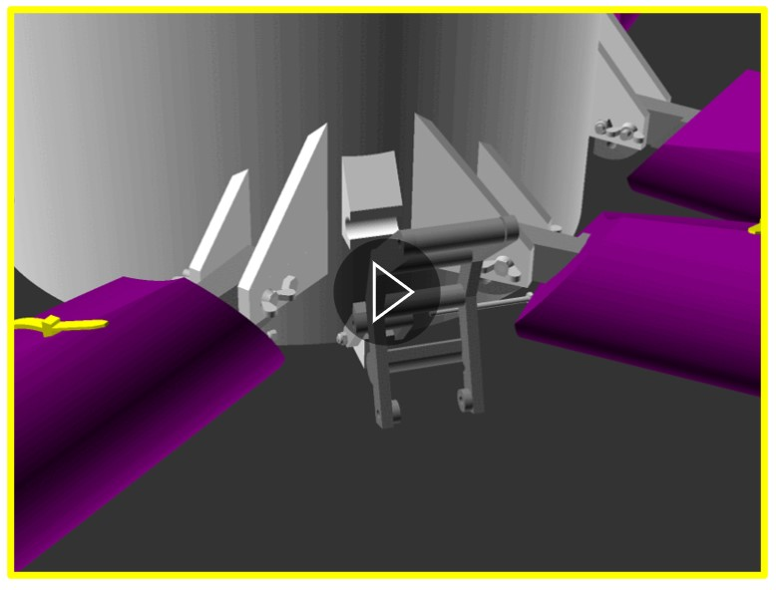

**c.)**

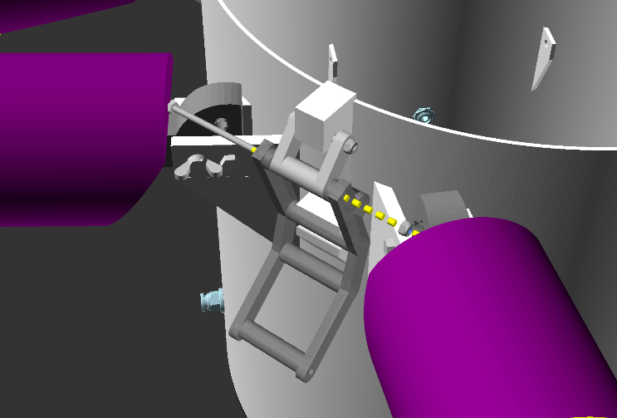

**b.)**

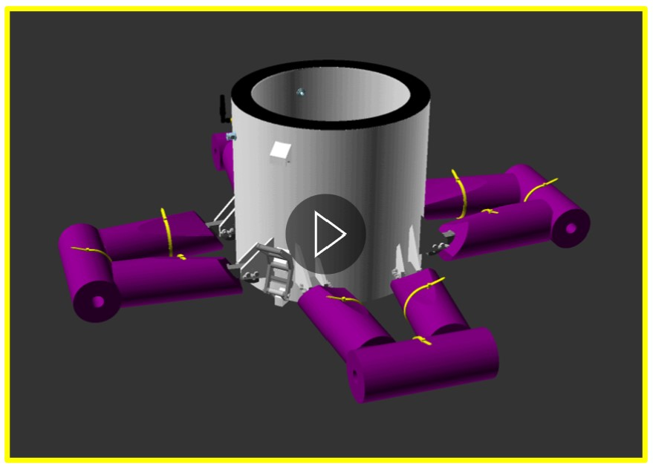

**d.)**

**Figure 49** Action diagrams (a and b) and animated gif (c and d) illustrating step 2.8b Stacking clip installation to the chamber body subassembly.

Notes:

Parts required for this section = Subassembly unit resulting from step 2.8a, 2x parts 28, 2 x part 41, 2x part 44.

Position part 28 over the top hole of part 27 as illustrated in figures 48 a and c, lining up the holes in each part.

Following figures 48 b and c, insert part 41 through part 28, then through the hole in part 27, and out through part 28 again. Thread part 44 onto the exposed thread of part 41. Tighten with a 5mm spanner/ wrench, so that part 28 can rotate easily, while being confidently that it will not fall off.

Repeat steps 2.8a and b on both sides of the chamber. Figure 49 d shows the position of both sets of stacking clips.

With this, step 2 and the chamber body subunit are completed, and should look like figures 40 and 49.

### Step 3: Chamber Lid

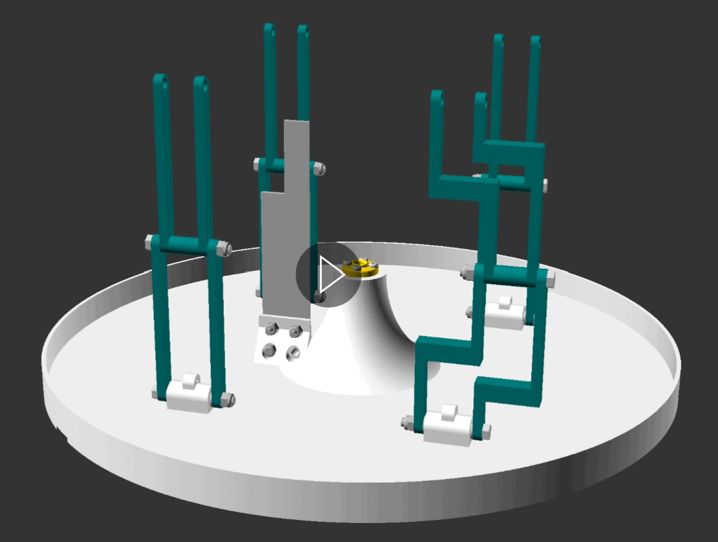

**Figure 50** 3d model illustrating the product of step 3. Before moving to step 4, your assembled piece should look like this. Print copy will just show one frame from this animation. View online pdf for the GIF animation modelled in openscad.

Step 3 focuses upon the subassembly piece “Chamber lid”. The end product of this step is the chamber lid with its guide arms, bracket mounts (in the form of fan mounts and sensor board mount), lead screw nut and optical end stop installed (Figure 50).

Updates:

* Need to edit the arm on the pawl side – it should be the weird piece!
* Need to use new chamber arms with curves, these avoid the mech box and ensure that the chamber lid closes fully.

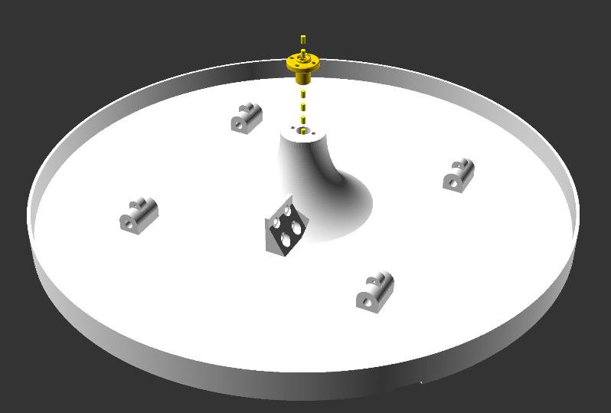3.1 Lead screw nut assembly

a.)

b.)

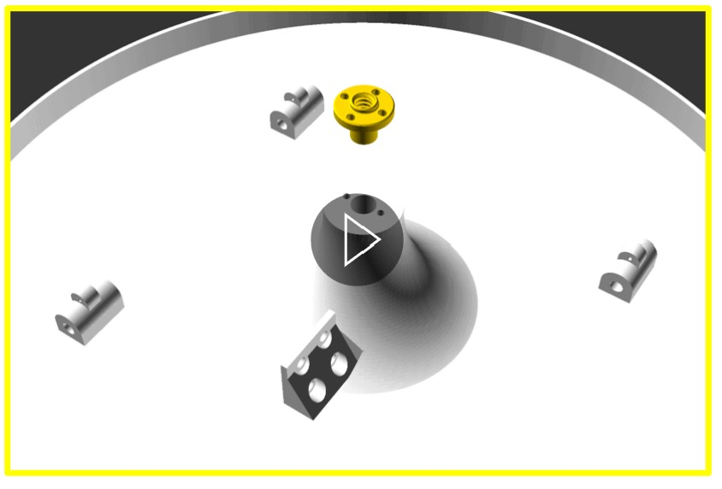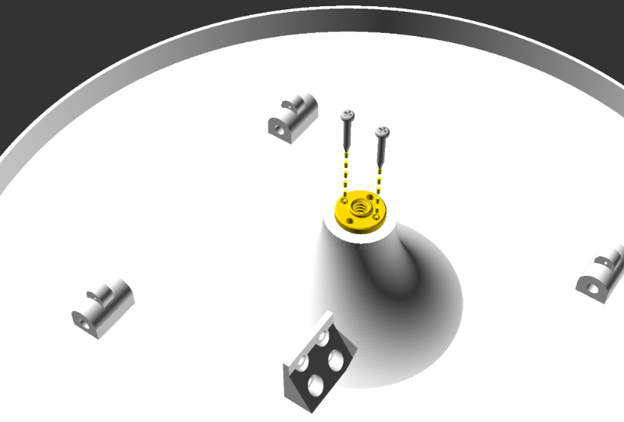

d.)

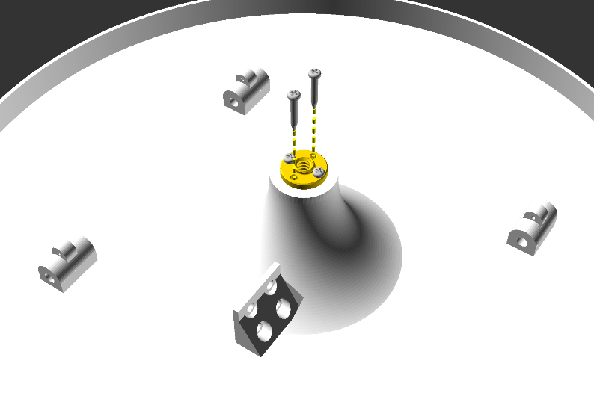

c.)

**Figure 51** Action diagrams (a, b and c) and animated gif (d) illustrating step 3.1, installing the lead screw nut to the chamber lid subassembly.

Notes:

Parts required for this section = 1 x part 2, 1x part 49, 2 to 4 x part 50.

Insert part 49, long side down, into the hole in the column section of part 2. Ensure that the screw holes in part 49 align with the indents/ holes of part 2, as illustrated in figures 51a and d.

Next screw 2 x part 50 in from the holes in part 49 that align with the indents / holes in part 2, throught the plastic of the chamber lid, as shown in figures 51b and d.

Now unscrew the 2x part 50 that were just inserted. This will leave a guide hole.

Apply superglue (part 90 or 91) to the guide hole in part 2 left by part 50, and to the threaded portion of part 50. Re-install the 2 part 50s, working quickly to ensure the glue does not dry before they are in place. Now the parts are secured in place .

In the case that part 49 has 4 screw holes available, insert the second set of part 50 into the remaining 2 holes of part 49 (illustrated by figures 51 c and d). Repeat the gluing step and the stage 3.1 is complete.

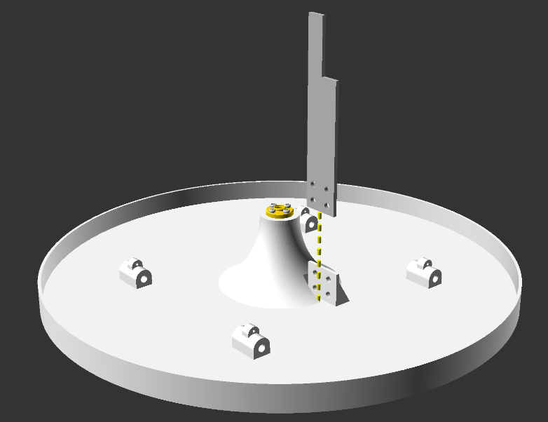3.2 Optical limit switch interrupter installation

a.)

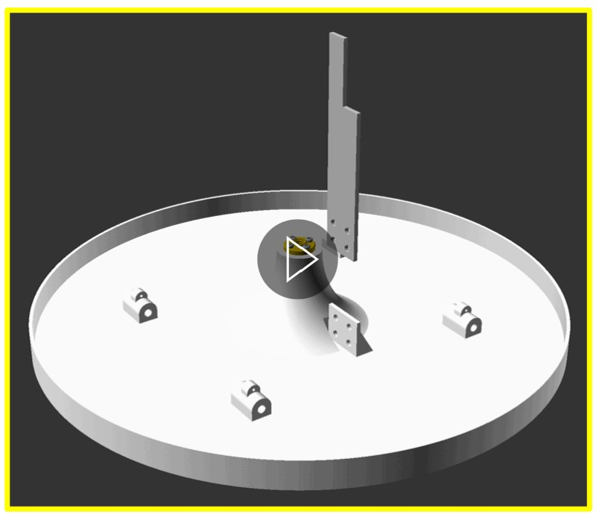

d.)

b.)

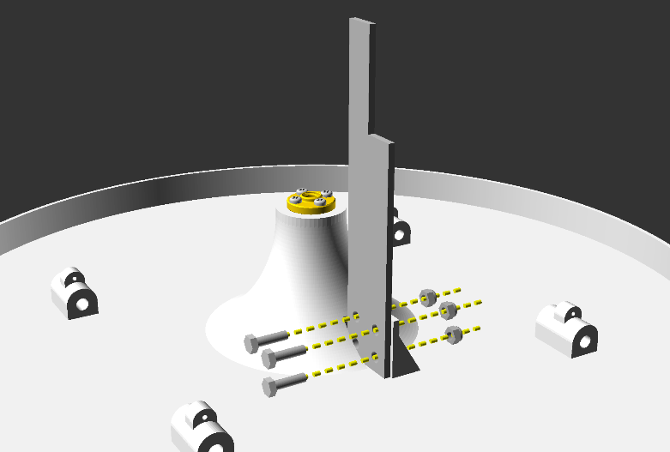

c.)

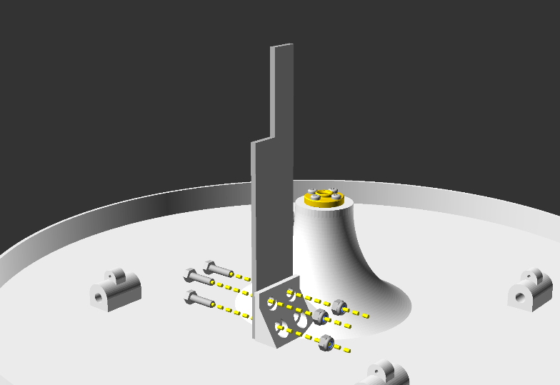

**Figure 52** Action diagrams (a, b and c) and animated gif (d) illustrating step 3.2, installing the optical limit switch interrupter to the chamber lid subassembly. This blocks the light beam across the optical limit switch to indicate the lid position.

Notes:

Parts required for this section = Subassembly unit resulting from step 3.1, part 56, 3 to 4 x part 38, 3 to 4 x part 39.

Place part 56 into the receiving slot of part 2. The longest side of part 56 is oriented towards the middle of the lid (part 2), and the holes in each piece should be aligned, as illustrated in figures 52a and d.

Insert the part 38 (bolts) first through part 56, then through part 2. Fix parts 38 in place using parts 39 (lock nuts) as illustrated in Figures 52 a, b and c. This is best done with a size 7mm spanner/ wrench.

These parts should be firmly in place, so that the aluminium bar (part 56) cannot move from side to side when moderate force is applied. This is important for the functioning of the chamber.

Ideally 4 of parts 38 and 39 are used here, however flaws in the current design only allows for 3 of the parts to be inserted (as shown in figure 52).

3.3 Lid arm 1 assembly: lower

a.)

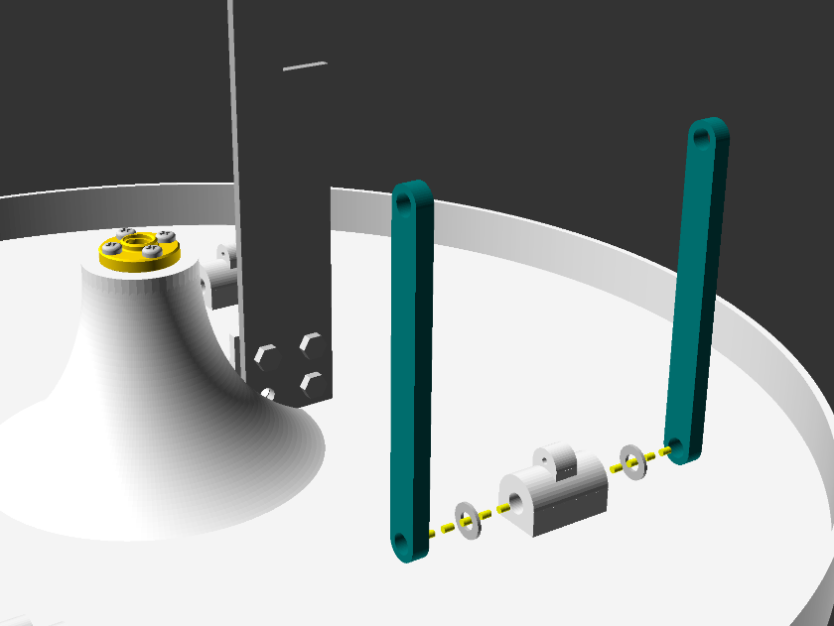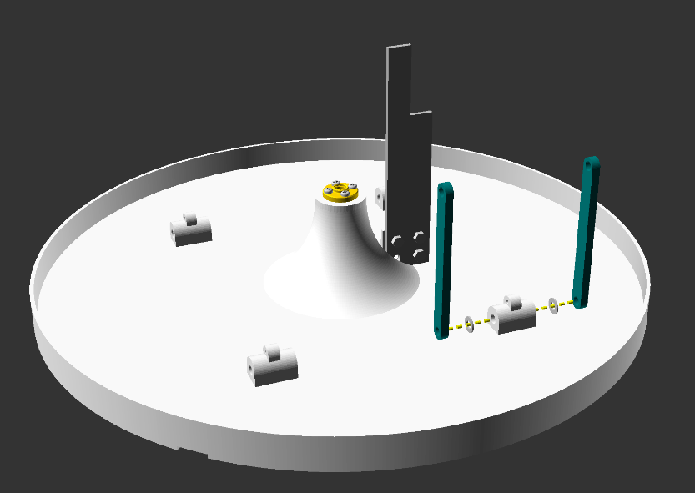

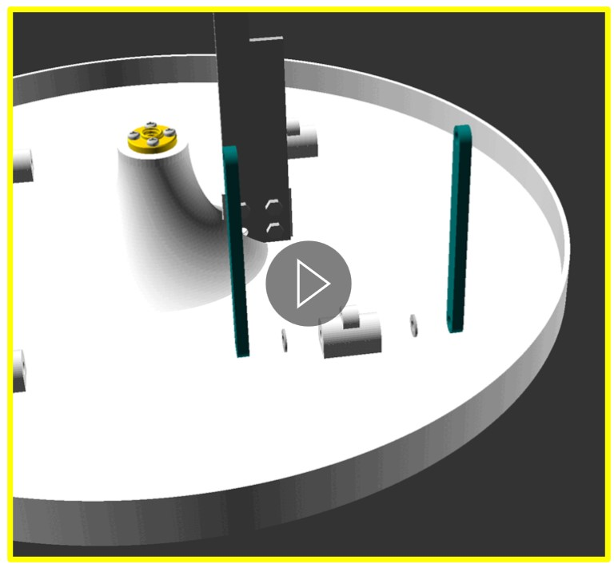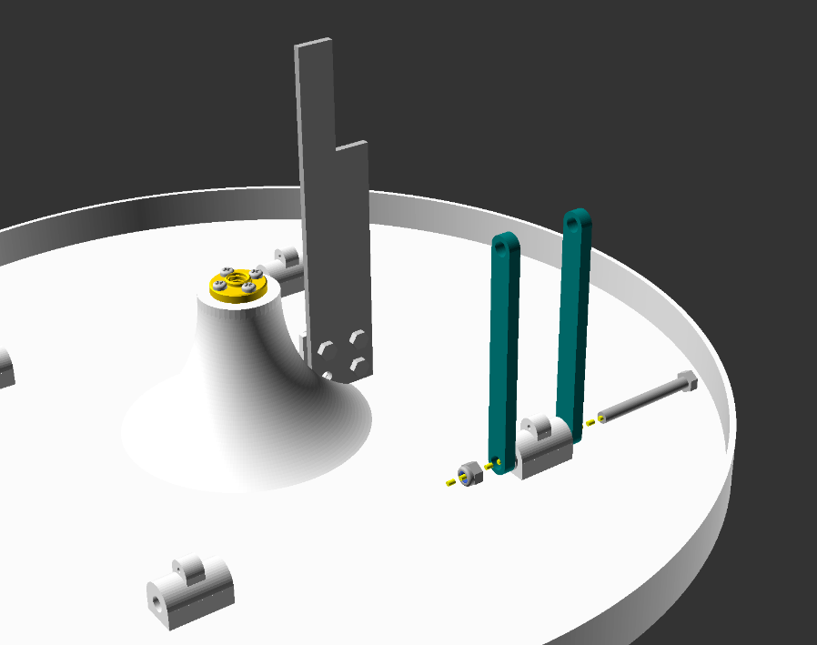

c.)

b.)

**Figure 53** Action diagrams (a and b) and animated gif (c) illustrating step 3.3, installing the bottom portion of lid arm 1 to the chamber lid subassembly.

Notes:

Parts required for this section - Subassembly unit resulting from step 3.2, 2x part 35, 1 x 32, 1 x part 34, 2x 22.

Following figures 53a and c, orient the 2 washers (part 35) on either side of the mounting point on part 2 located behind the aluminium bar (part 56), followed by the 2x part 22.

Ensuring that the holes in each of the parts are aligned, insert part 32 through part 22 and the rest of the parts as they are placed in the description above. It is **important** that the bolt (part 32) is inserted towards the middle of part 2 (shown in figure 53). Failure to do so will prevent the lid from sealing.

Finally, fix the lock nut (part 34) in place using either 2 size 8 spanner/ wrenches, or holding one side with a pair of pliers and using a spanner on the other side. Tighten gently until resistance is met, then back off 1 turn in the loosening direction, to ensure that the pieces rotate freely without resistance.

3.4 Lid arm 1 assembly: upper

a.)

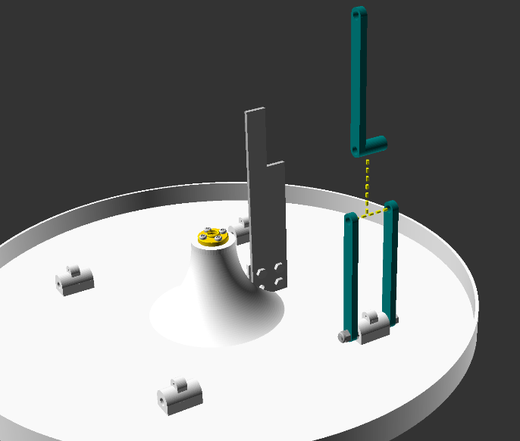

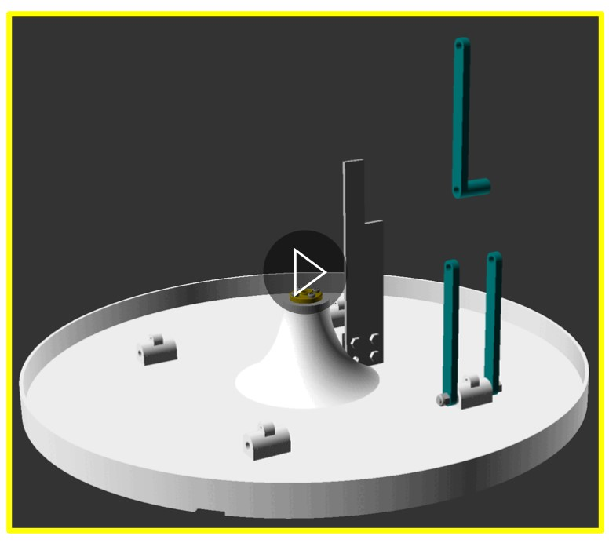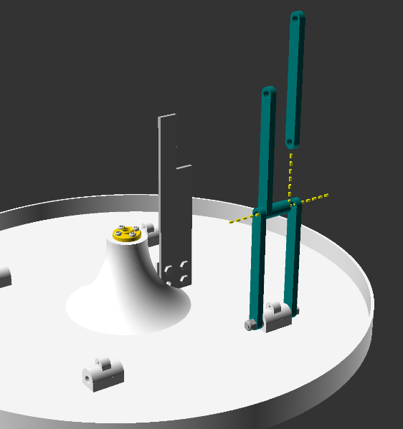

d.)

b.)

c.)

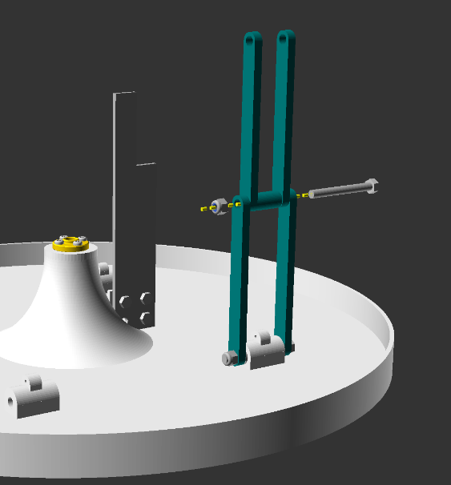

**Figure 54** Action diagrams (a, b and c) and animated gif (d) illustrating step 3.4, installing top portion of lid arm 1 to the chamber lid subassembly.

Notes:

Parts required for this section - Subassembly unit resulting from step 3.3, 1x part 22, 1x part 21, 1 x part 32, 1 x part 34.

Insert part 21 and 22 in-between parts 22 from step 3.3, ensuring that the holes for each part are in alignment, as shown in figures 54 a, b and d.

Insert part 32 through the aligned parts, towards the centre of part 2, as illustrated in figures 54 c and d.

Fix the lock nut (part 34) in place using either 2 size 8 spanners/ wrenches, or holding one side with a pair of pliers and using a spanner on the other side. Tighten gently until resistance is met, then back off 1 turn in the loosening direction, to ensure that the pieces rotate freely without resistance.

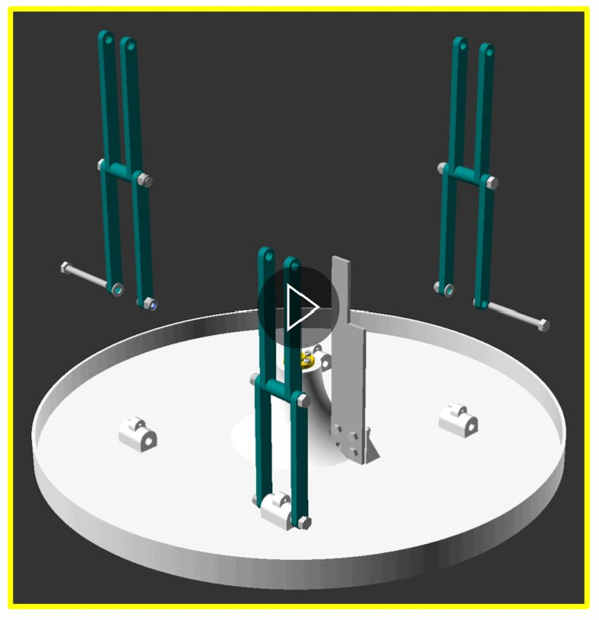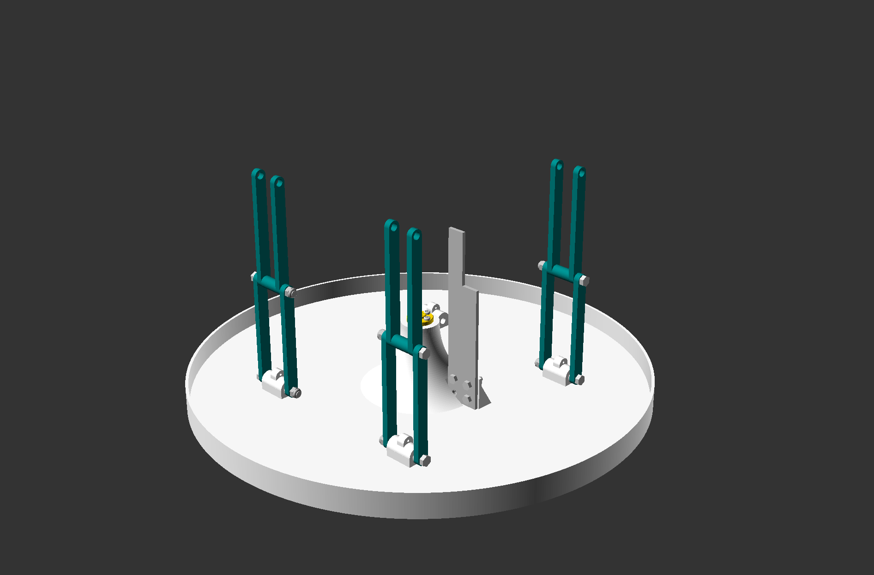3.5 Lid arm 2 and 3 assembly: repeat

b.)

a.)

**Figure 55** Action diagrams (a) and animated gif (b) illustrating step 3.5, installing lid arms 2 and 3 to the chamber lid subassembly.

Notes:

Parts required for this section - Subassembly unit resulting from step 3.4, 6x part 22, 2x part 21, 4 x part 32, 4 x part 34, 4x part 35.

Repeat steps 3.3 and 3.4 on the 2 adjacent lid mounting points (part 2) illustrated in figures 55 a and b.

3.6 Lid arm 4 assembly: lower

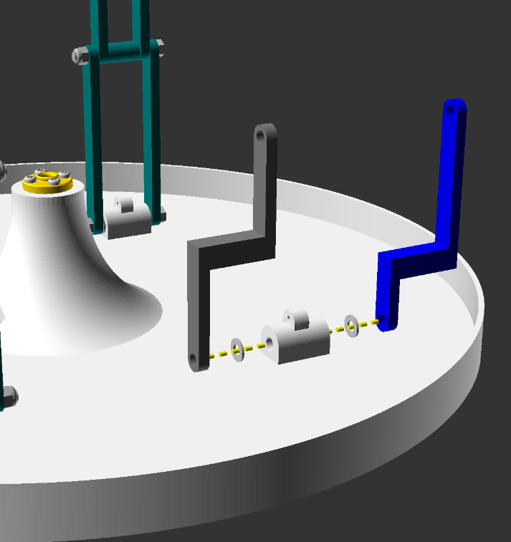

a.)

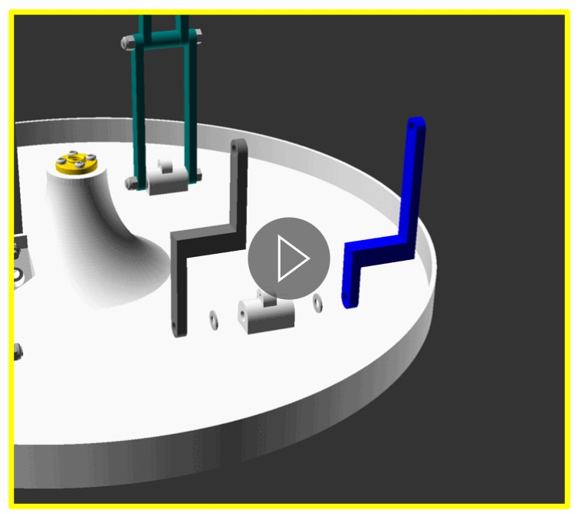

c.)

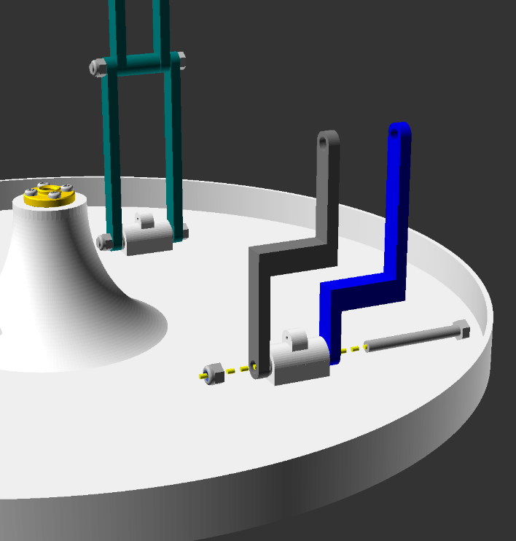

b.)

**Figure 56** Action diagrams (a and b) and animated gif (c) illustrating step 3.6, installing the bottom portion of lid arm 4 (pawl side lid arm) to the chamber lid subassembly.

Notes:

Parts required for this section - Subassembly unit resulting from step 3.5, 1 x part 32, 1 x part 34, 2x part 35, 1x 23, 1x 24.

Following figures 56a and c, orient the 2 washers (part 35) on either side of the remaining mounting point on part 2.

Arrange part 23 and 24 on either side of the 2 part 35 washers. Part 23 (figure 56 – part colour grey) **must** be on the side closer to the centre of the lid (part 2) and part 24 **must** be on the side closer to the outside of the lid (part 2). The orientation of these parts is illustrated in figure 56.

Ensuring that the holes in each of the parts are aligned, insert part 32 through part 24 and the rest of the parts as they are placed in the description above. It is **important** that the bolt (part 32) is inserted towards the middle of part 2 (shown in figure 56). Failure to do so will prevent the lid from sealing.

Finally, fix the lock nut (part 34) in place using either 2 size 8 spanner/ wrenches, or holding one side with a pair of pliers and using a spanner on the other side. Tighten gently until resistance is met, then back off 1 turn in the loosening direction, to ensure that the pieces rotate freely without resistance.

3.7 Lid arm 4 assembly: upper

a.)

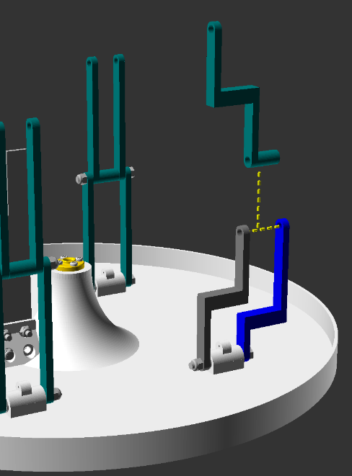

d.)

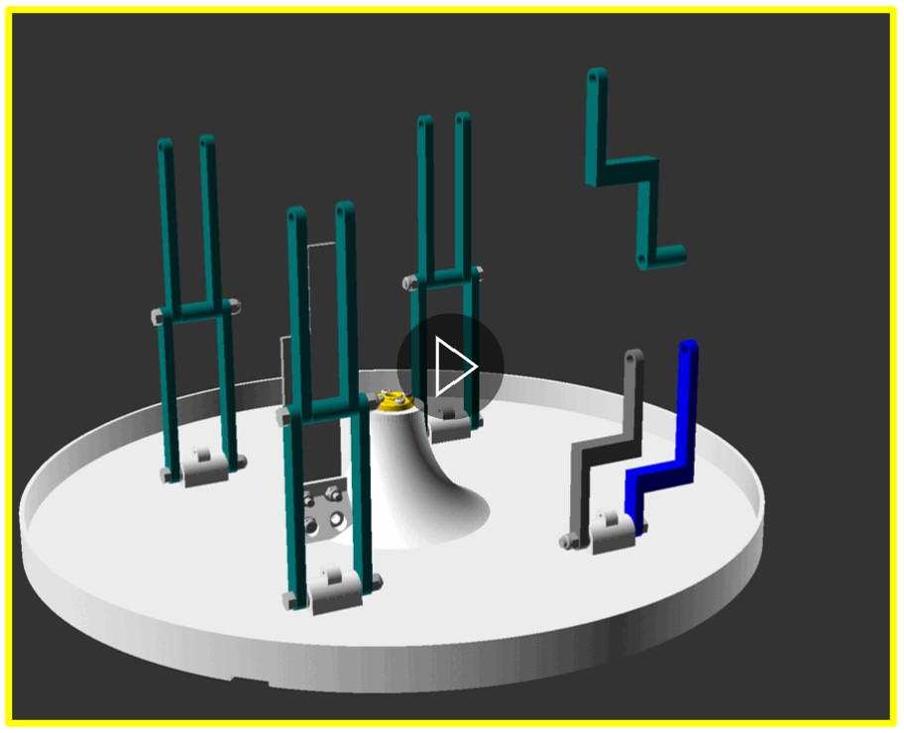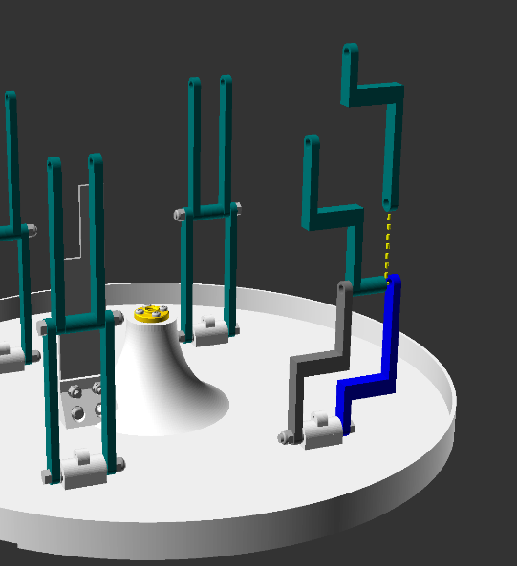

b.)

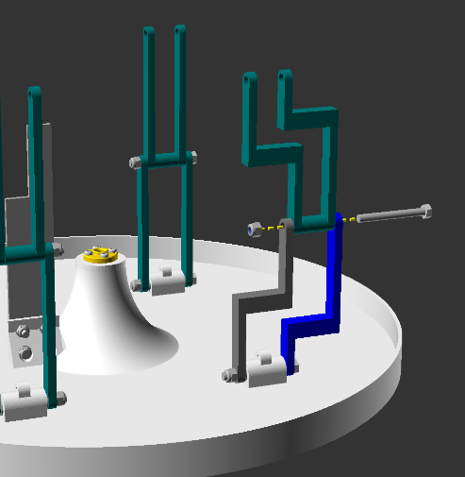

c.)

**Figure 57** Action diagrams (a, b and c) and animated gif (d) illustrating step 3.6, installing the upper portion of lid arm 4 (pawl side lid arm) to the chamber lid subassembly.

Notes:

Parts required for this section - Subassembly unit resulting from step 3.6, 1 x part 32, 1 x part 34, 1x 25, 1x 26.

Insert part 25 and 26 in-between parts 24 and 25 from step 3.6, ensuring that the holes for each part are in alignment, Part 25 **must** be on the side closer to the centre of the lid (part 2) and part 26 **must** be on the side closer to the outside of the lid (part 2), as illustrated by figures 57 a, b and d.

Insert part 32 through the aligned parts, towards the centre of part 2, as illustrated in figures 57 c and d.

Fix the lock nut (part 34) in place using either 2 size 8 spanner/ wrenches, or holding one side with a pair of pliers and using a spanner on the other side. Tighten gently until resistance is met, then back off 1 turn in the loosening direction, to ensure that the pieces rotate freely without resistance.

With this, step 3 and the chamber lid subunit are completed, and should look like figures 50 and 57d.

### Step 4: Motor Unit

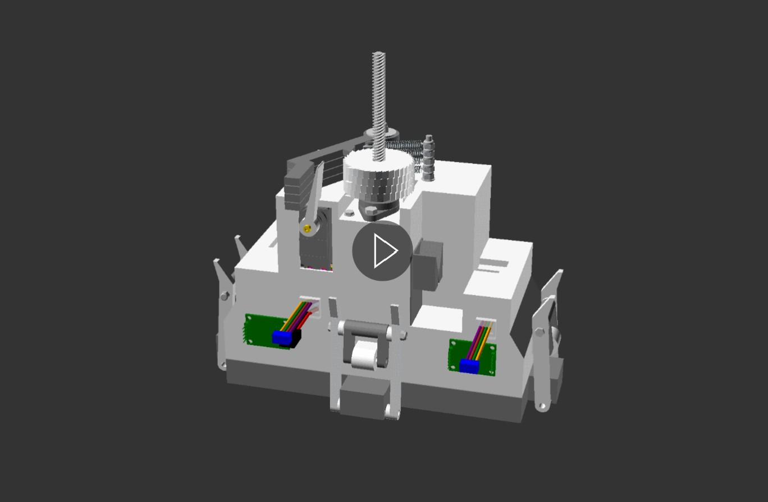

**Figure 58** 3d model illustrating the product of step 4. Before moving to step 5, your assembled piece should look like this. View this animation in file “step_4_end_product_animated.gif” available in the GitHub project repository “openChamber/Chamber_1/Build_Guide/Step 4_Construction_Manual_Animations/”. This animation was modelled in openscad and compiled into GIF format using ImageMagick.

Step 4 focuses upon the subassembly piece “Motor Unit”. The end product of this step is the motor unit with the steppers motor drive chain, servomotor and pawl system, optical interrupt, internal circuitry and wiring and water-tight lid installed (Figure 58).

4a.1 Optical limit switch assembly

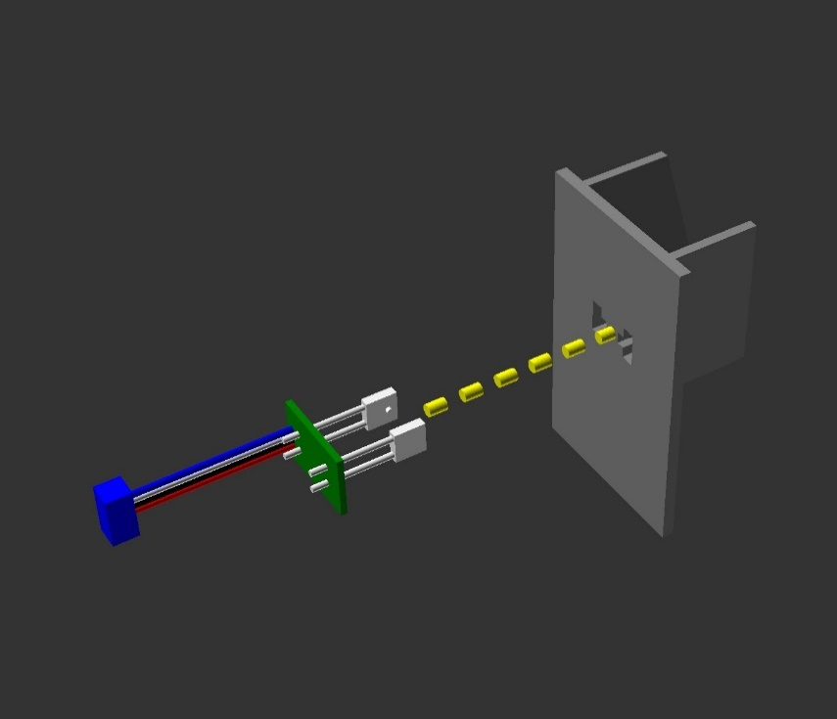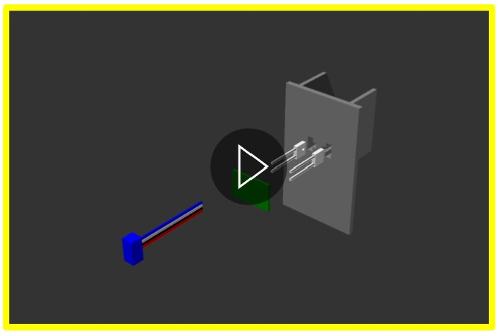

c.)

a.)

b.)

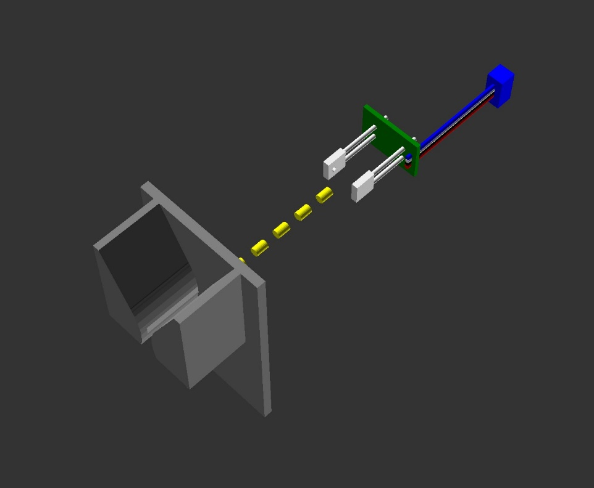

**Figure 59** Action diagrams (a and b) and animated gif (c) illustrating step 4a.1, mating of optical limit switch circuitry with 3d printed housing. View animation (c) in file “Step_4a_1 animated.gif” available in the GitHub project repository “openChamber/Chamber_1/Build_Guide/Step 4_Construction_Manual_Animations/”. This animation was modelled in openscad and compiled into GIF format using ImageMagick.

Notes:

Parts required for this section - 1 x part 13, 1 x part 67b, part 1x 90 or 91.

First dry fit the parts to ensure that you understand how the pieces fit together, before fitting with glue (part 90 or 91).

Insert part 67b into part 13. As illustrated in Figure 59, part 67b must be inserted from the flat side of part 13 (the back). The circuit board cable connection must be to the left-hand side of part 13, when viewed from the back, with the wide portion of part 13’s “V” or funnel pointing upwards.

It is critical that the raised bumps on the diode and transistor of 67b (the white cuboids with legs in figure 59) are in the open groves of part 13. This grove ensures that the pieces are directly opposite each other, as light must be emitted from the diode cuboid (the light bulb) and be detected by the transistor cuboid (the light switch). When these parts are miss aligned, there is a risk that the light will not be blocked / interrupted when the chamber lid is in the closed position. The light is blocked by the Optical limit switch interrupter in chapter 1.4.3.2, which passes between the “V” or funnel of part 13. This causes issues with chamber functionality; I.e the lid will never be acknowledged as closed even if it is.

Next, separate parts 67b and 13. Add a clear super glue (part 90 or 91) to the cuboids and surfaces that will touch part 13 when in the assembled position. If non-transparent glue is used, light may not be able to pass freely to the transistor cuboid and cause problems in functionality.

Carefully repeat the dry fit steps, but now with glue.

Leave the part for 24 hours, or the full cure time indicated by your glue instructions.

4a.2 Optical Limit Switch Assembly Installation

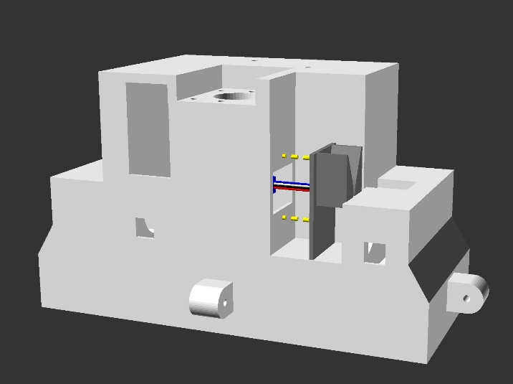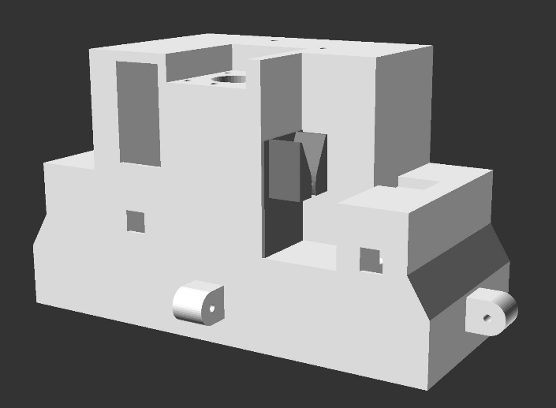

a.)

c.)

d.)

b.)

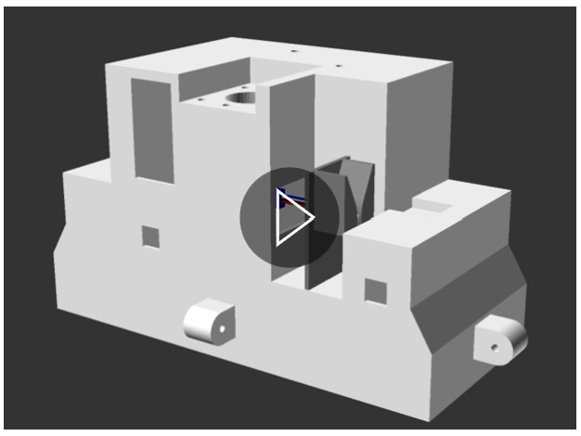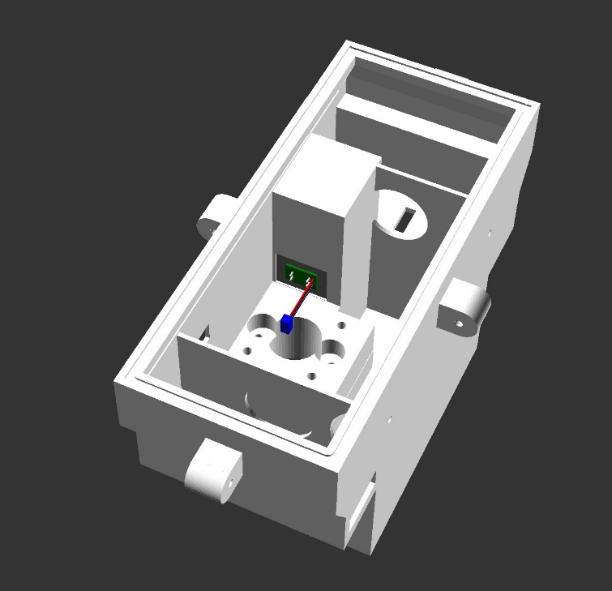

**Figure 60** Action diagrams (a, b and c) and animated gif (d) illustrating step 4a.2, mating of the optical limit switch subassembly with main motor unit body. View animation (d) in file “step_4a_2_animated.gif” available in the GitHub project repository “openChamber/Chamber_1/Build_Guide/Step 4_Construction_Manual_Animations/”. This animation was modelled in openscad and compiled into GIF format using ImageMagick.

Notes:

Parts required for this section - Subassembly unit resulting from step 4a.1, 1 x part 9, 1 x part 90 or 91.

Place part 9 with its open portion on the table, as illustrated in figures 60 a and d.

As this step required the gluing of parts, initially dry fit the parts together before committing repeating with glue (part 90 or 91).

Orient the subassembly unit resulting from step 4a.1 with the “v” or funnel in the upwards position. Position this with the bottom edge of the subassembly unit resulting from step 4a.1 touching the shelf surface of part 9, as illustrated in figures 60 a and d.

Next push this subassembly unit until it meets the wall of part 9 (figure 60 c), so that the circuitry and cable pass through the rectangular hole of part 9 and into the motor units internal space (figure 60 b). The flat back side of the subassembly unit resulting from step 4a.1 and the wall of part 9 should meet flush as a “plastic on plastic” joint.

Next, remove subassembly unit resulting from step 4a.1. Using a knife, score/ scratch the 2 surfaces that touch in the “plastic on plastic” joint in a cross-hatch pattern (like a “#” symbol). This provides a strong binding surface for glue adhesion.

Apply superglue (part 90 or 91) to the “plastic on plastic” joint of both part 9 and the subassembly unit resulting from step 4a.1. Repeat the initial steps but now with glue.

Clamp or wedge the piece together and leave for 24 hours, or the full cure time indicated by your glue instructions.

4a.3 Pillow Bushing Assembly

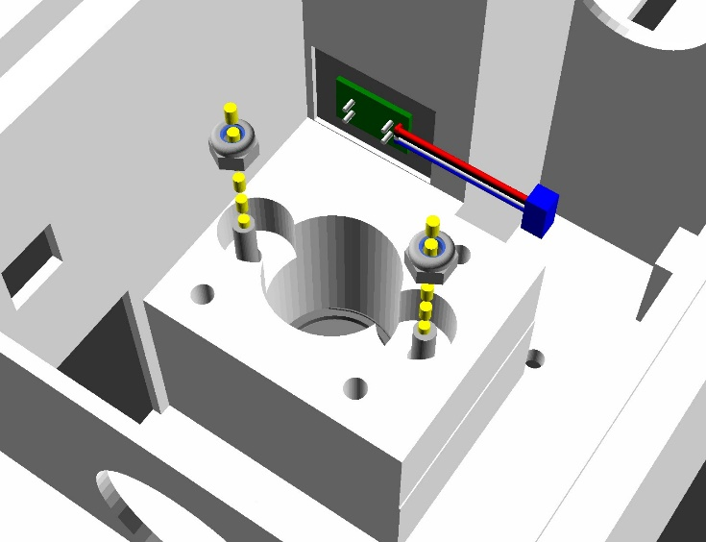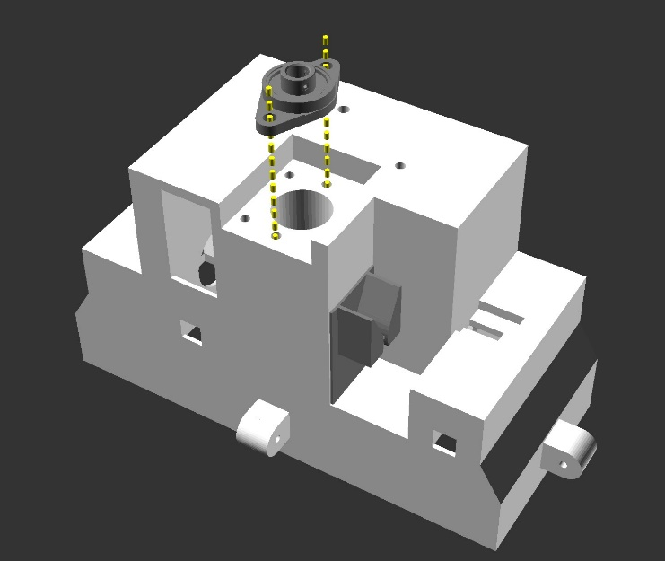

a.)

c.)

b.)

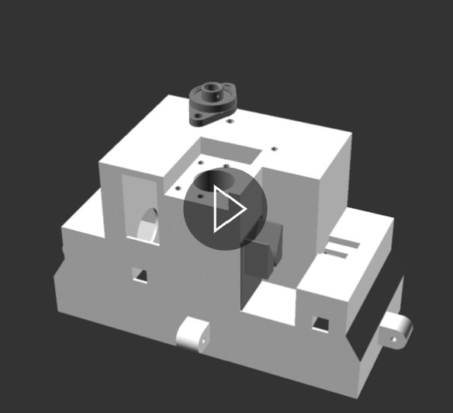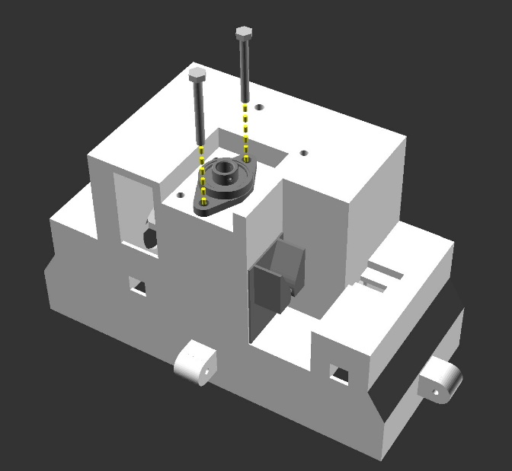

d.)

**Figure 61** Action diagrams (a, b and c) and animated gif (d) illustrating step 4a.3, installing the pillow bushing to the motor unit subassembly. View animation (d) in file “step_4a_3_animated.gif” available in the GitHub project repository “openChamber/Chamber_1/Build_Guide/Step 4_Construction_Manual_Animations/”. This animation was modelled in openscad and compiled into GIF format using ImageMagick.

Notes:

Parts required for this section - Subassembly unit resulting from step 4a.2, 1 x part 46, 2 x part 37 or 37a, 2 x part 39, 1x part 99.

Position part 46 so that its bolt holes align with the bolt holes in part 9 (the subassembly unit resulting from step 4a.2), as illustrated in figures 61 a and d. This should leave the central 8mm bearing of part 46 in a centralised position over the large cylindrical hole of part 9.

Insert the 2 x part 37 initially through the bolt holes of part 46, following down through the bolt holes of part 9 (figures 60 b and d).

Fix these bolts (part 37) in place using 2 x part 39, from the inside of part 9 (the subassembly unit). The tension of these bolts should tight enough to hold part 46 firmly in place (figures 60 c and d).

Appy hot glue (part 99) around the edges of part 46 to prevent water ingress into the centre of the motor unit. Alternatively, create a waterproof seal by uninstalling part 46, applying hotglue to its base and re-installing again.

4a.4 Servomotor Installation

c.)

a.)

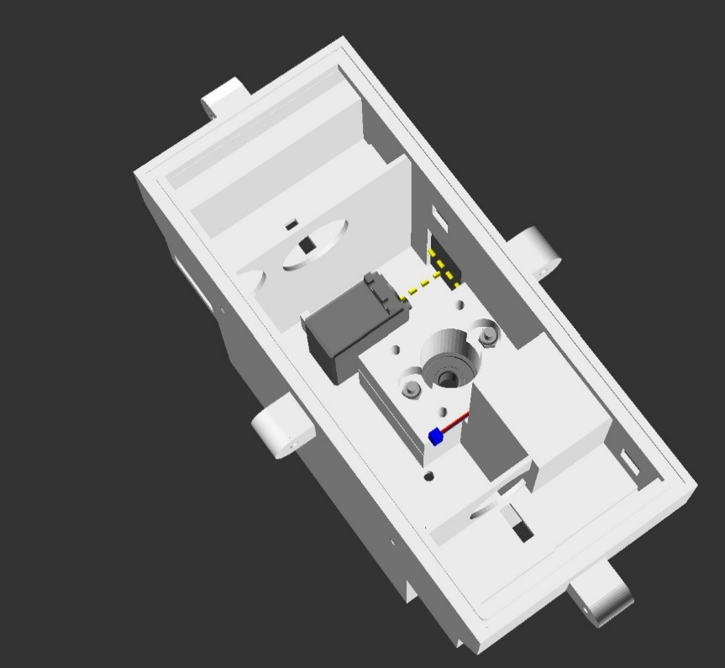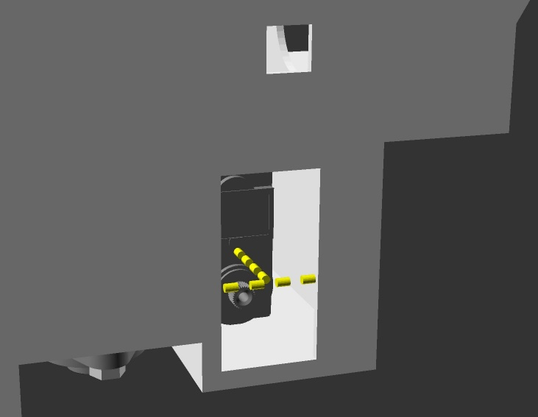

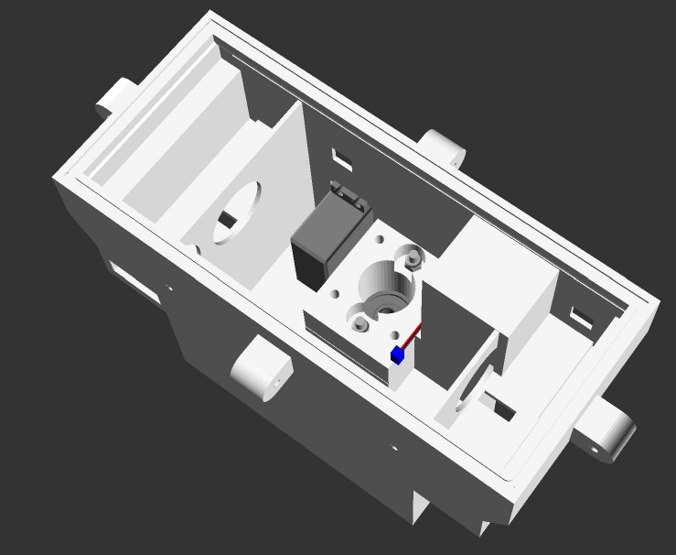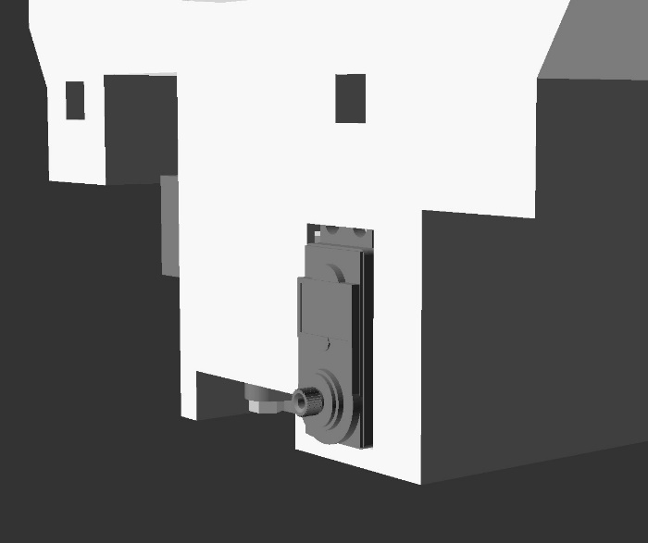

d.)

b.)

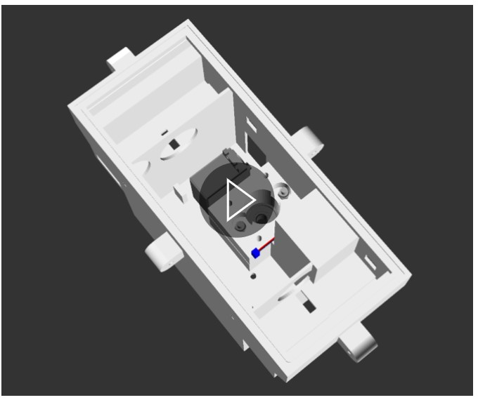

e.)

**Figure 62** Action diagrams (a, b, c and d) and animated gif (e) illustrating step 4a.4, installing the servomotor to the motor unit subassembly. View animation (e) in file “step_4a_4_animated.gif” available in the GitHub project repository “openChamber/Chamber_1/Build_Guide/Step 4_Construction_Manual_Animations/”. This animation was modelled in openscad and compiled into GIF format using ImageMagick.

Notes:

Parts required for this section - Subassembly unit resulting from step 4a.3, 1 x part 66, 1 x part 99.

With part 66 (the servomotor) oriented so that the motor output shaft is on the bottom, remove any bottom bolt connections that prevent the servo motor from sitting flush on the bottom of the 3d printed motor case (part 9). The top bolt connections must not be removed.

Following figure 62, place part 66 into the motor case so that the bottom of part 66 is flat and level on the bottom of the motor case. Push part 66 into the hole in the side of the motor case until the top bolt connectors of push up against the inside wall of the motor case. The motor output shaft of part 66 should protrude through the hole in the wall of the motor case.

Once confident with how part 66 should be installed, remove part 66. Apply hot glue (part 99) liberally to the areas of part 66 that will contact the motor case, i.e. the bottom surface and the upper bolt connectors.

Repeat the installation of part 66 described above.

Once the glue has set, apply hot glue (part 99) liberally around the edges of the servo motor, to fill any spaces between the part 66 and the motor case. Stop applying glue when the part 66 has a waterproof seal in the motor case.

In the future this step may be changed to allow for a mechanical binding of part 66 to the motor case (part 9). But for the scope of this project as a part of my PhD, I do not have time to adjust this step at present.

4a.5 O-ring/Gasket Installation

c.)

a.)

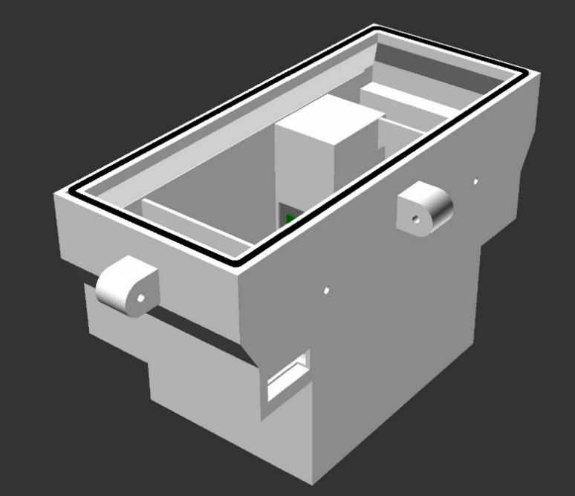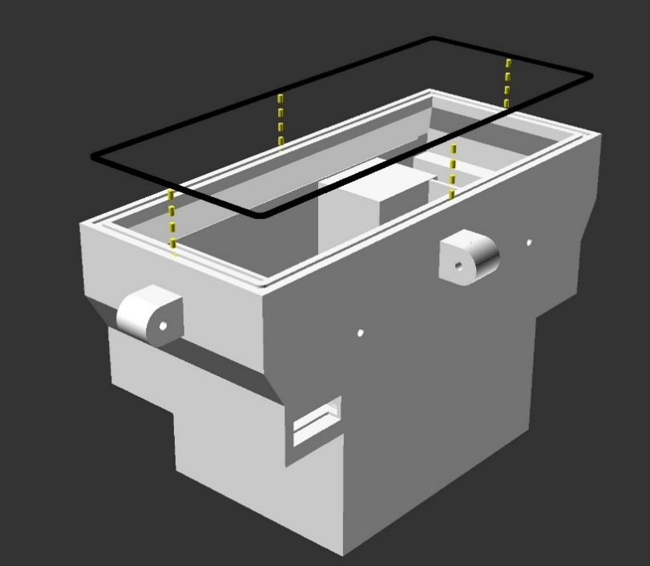

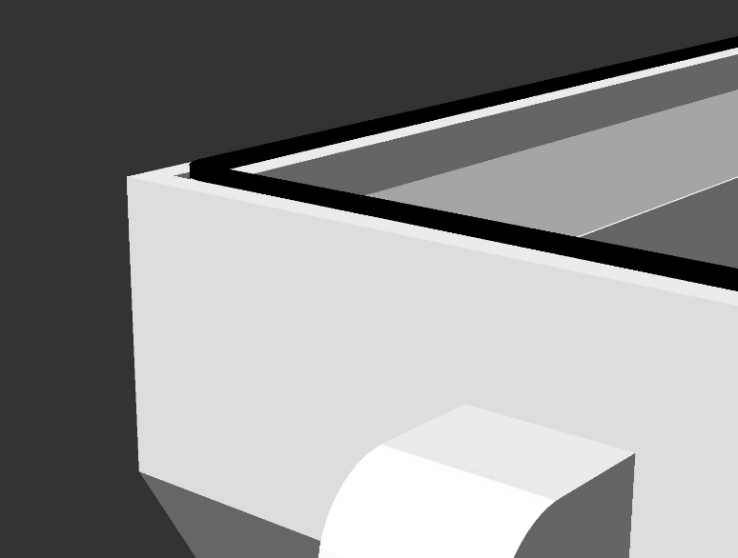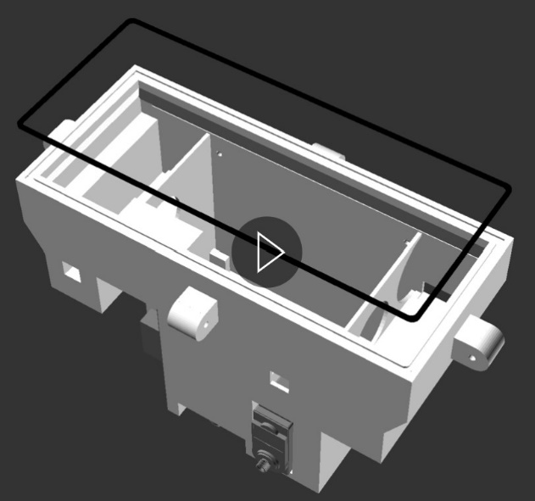

d.)

b.)

**Figure 63** Action diagrams (a, b and c) and animated gif (d) illustrating step 4a.5, installing the O-ring/ Gasket to the motor unit subassembly. View animation (e) in file “step_4a_5_animated.gif” available in the GitHub project repository “openChamber/Chamber_1/Build_Guide/Step 4_Construction_Manual_Animations/”. This animation was modelled in openscad and compiled into GIF format using ImageMagick.

Notes:

Parts required for this section - Subassembly unit resulting from step 4a.4, 1 x part 62, 1 x part 90.

Cut the end of the spooled nitrile rubber cord (part 62) so that it is as vertical as possible. This will have to be glued to the other edge cut edge of the nitrile rubber cord and a clean joint is important.

Apply flexible superglue (part 90) to the grove in the top of part 9 (the motor case), illustrated in figures 63 a and d. When this glue is tacky / sticky (as opposed to wet), insert the nitrile rubber cord into the grove so that it binds into the grove and protrudes above the surface, as illustrated in figures 63 b and d.

Failiure to wait until the glue has become tacky can result in glue spreading and hardening across the nitrile rubber cord. This results in a compromised water seal with the Motor case lid (part 10), which is pressure sealed to the nitrile rubber gasket (illustrated in section 1.4.4c.1).

Better results can sometimes be achieved by working along progressive sections of the grove, waiting until the cord is bound to one section before moving on to the next section of the grove.

Once the cord reaches the starting point of the nitrile rubber cord, carefully cut the end of the cord with a razor blade, so that a tight clean joint is formed, butting up to the starting point. Apply a drop of glue sparingly to the two surfaces that are to meet. Press them together and wait for them to dry.

The result is a flexible gasket ring that should look similar to figures 63 c and d.

4a.6 Small Latch Arm Installation

a.)

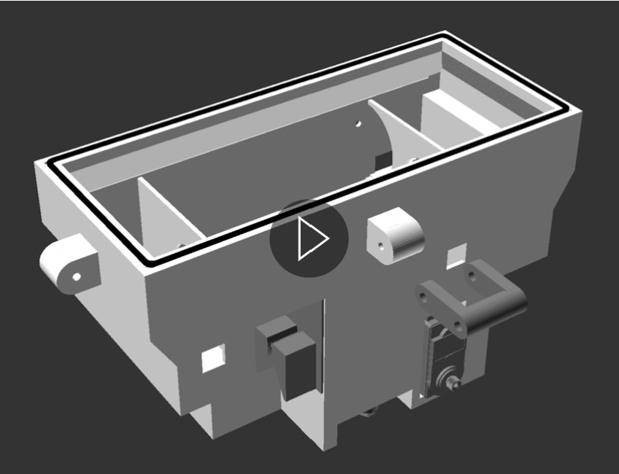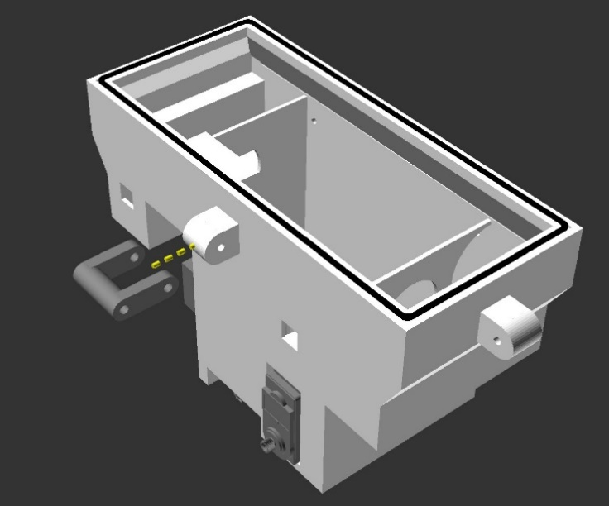

d.)

e.)

b.)

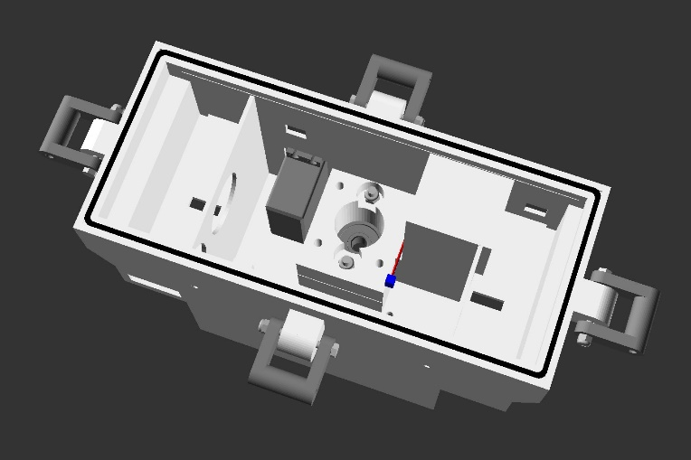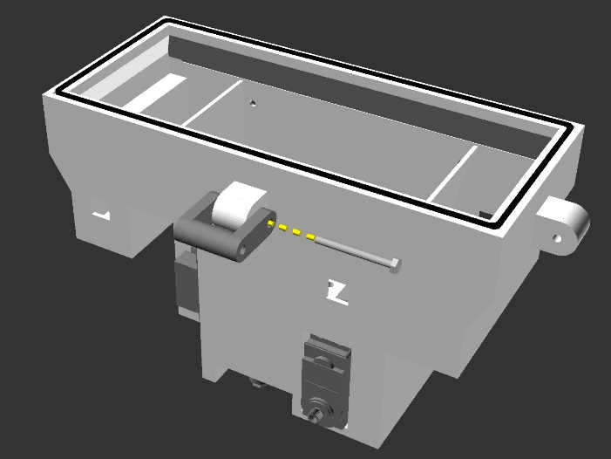

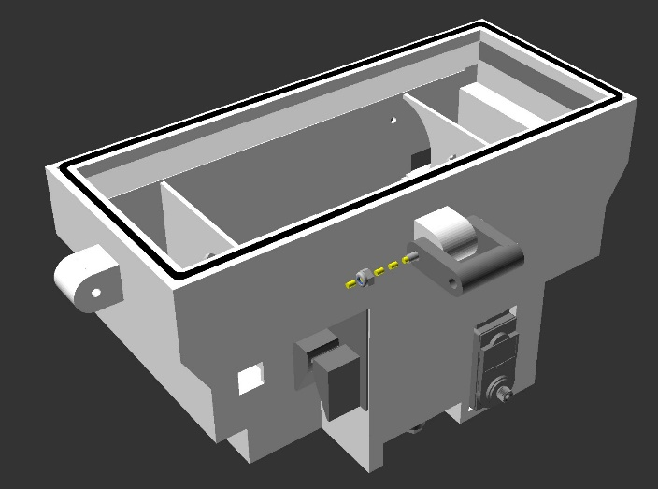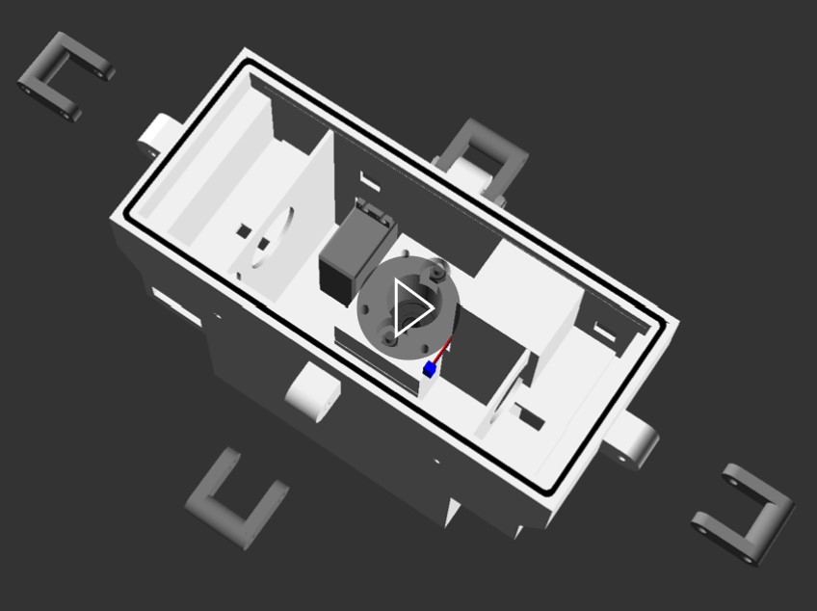

f.)

c.)

**Figure 64** Action diagrams (a, b, c and e) and animated gifs (d and f) illustrating step 4a.6, installing the small latch pieces to the motor unit subassembly. View animation (d) in file “step_4a_6a_animated.gif” and animation (f) in file “step_4a_6b_animated.gif”, available in the GitHub project repository “openChamber/Chamber_1/Build_Guide/Step 4_Construction_Manual_Animations/”. This animation was modelled in openscad and compiled into GIF format using ImageMagick.

Notes:

Parts required for this section - Subassembly unit resulting from step 4a.5, 4 x part 11, 4 x part 44, 4x 42.

Line up part 11 (the small latch arm), open end first, onto the motor case (part 9), ensuring the bolt holes are aligned (figures 64 a and d).

Insert 1x part 42 ( the bolt) from outside part 11, through the bolt hole in part 9 (the motor case), and out through part 11 again (figure 64 b and d).

Screw part 44 onto the threaded end of part 42 that protrudes out of part 11 (figures 64 c and d). Tension this nut (part 44) so that the small latch arm (part 11) can rotate freely, but that the bolt (part 42) is not at risk of excessive movement laterally.

Repeat this process a further 3 times for the remaining small latch arm connections (figures 64 e and f).

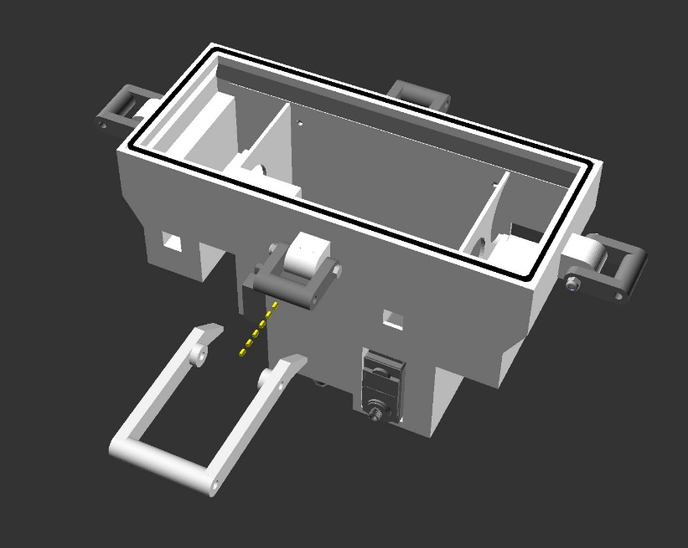4a.7 Large Latch Arm Installation

a.)

d.)

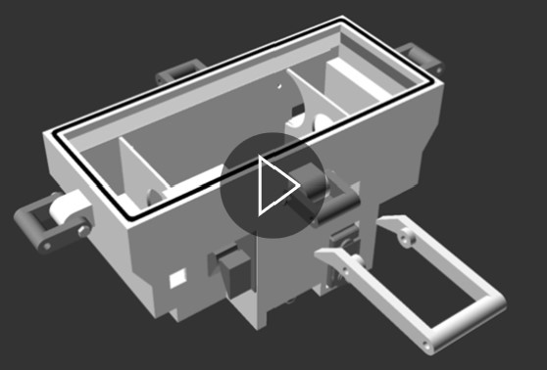

e.)

b.)

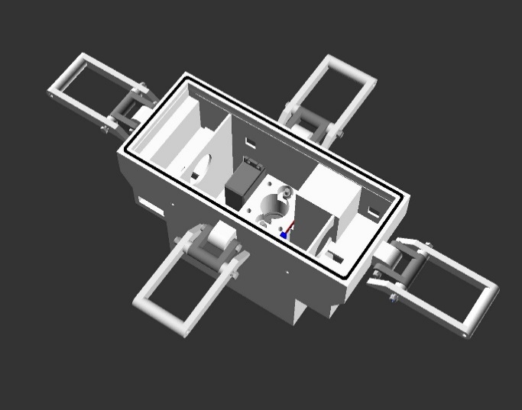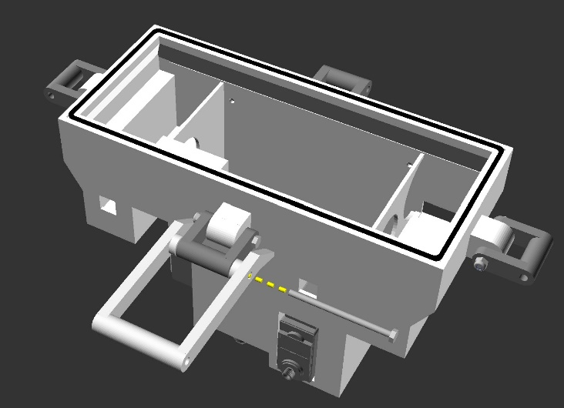

f.)

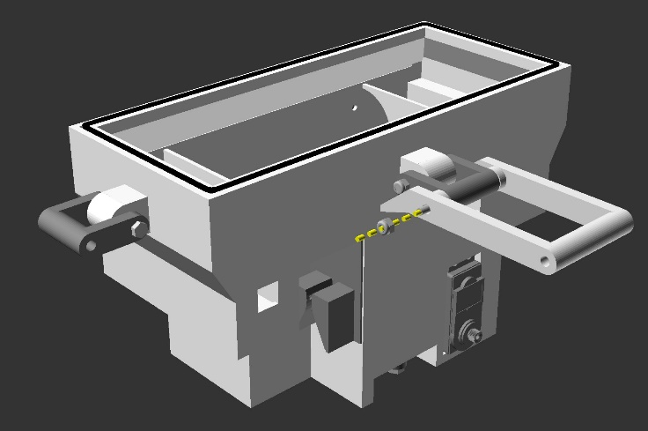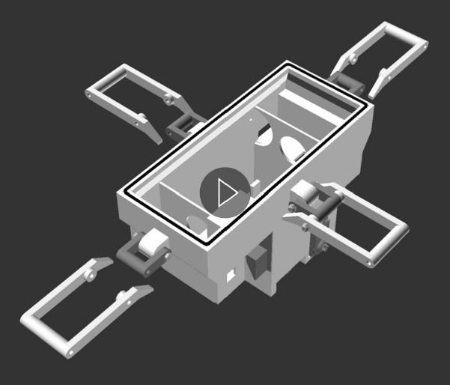

c.)

**Figure 65** Action diagrams (a, b, c and e) and animated gifs (d and f) illustrating step 4a.7, installing the large latch pieces to the motor unit subassembly. View animation (d) in file “step_4a_7a_animated.gif” and animation (f) in file “step_4a_7b_animated.gif”, available in the GitHub project repository “openChamber/Chamber_1/Build_Guide/Step 4_Construction_Manual_Animations/”. This animation was modelled in openscad and compiled into GIF format using ImageMagick.

Notes:

Parts required for this section - Subassembly unit resulting from step 4a.6, 4 x part 12, 4 x part 44, 4x 41.

Line up part 12 (the large latch arm), open end first, onto the small latch arm (part 11), ensuring the bolt holes are aligned (figures 65 a and d).

Insert 1x part 41 (the bolt) from outside part 12, through the bolt hole in part 11 (small latch arm), and out through part 12 again (figure 65 b and d).

Screw part 44 onto the threaded end of part 41 that protrudes out of part 12 (figures 65 c and d). Tension this nut (part 44) so that the large latch arm (part 12) can rotate freely, but that the bolt (part 41) is not at risk of excessive movement laterally.

Repeat this process a further 3 times for the remaining large latch arm connections (figures 65 e and f).

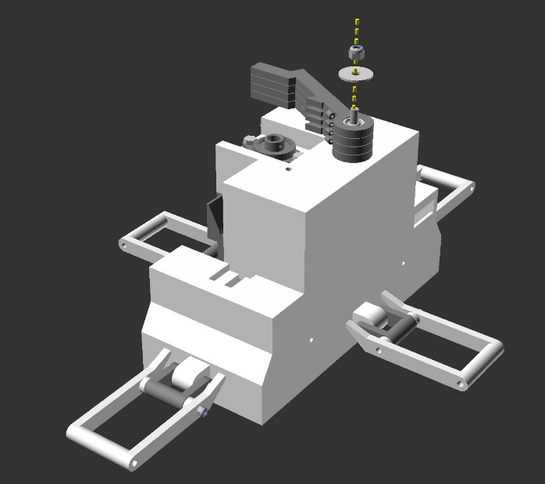4a.8 Pawl Arm Installation

d.)

a.)

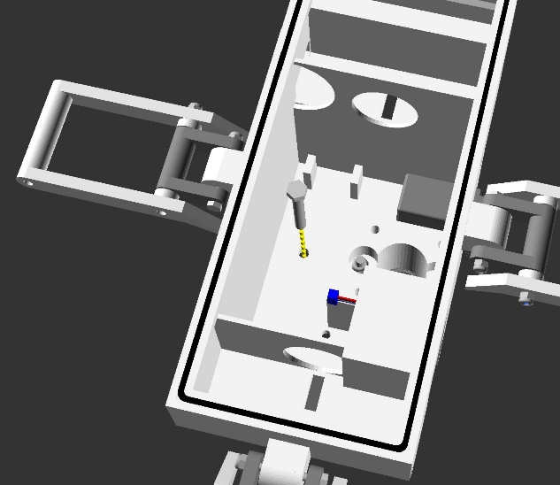

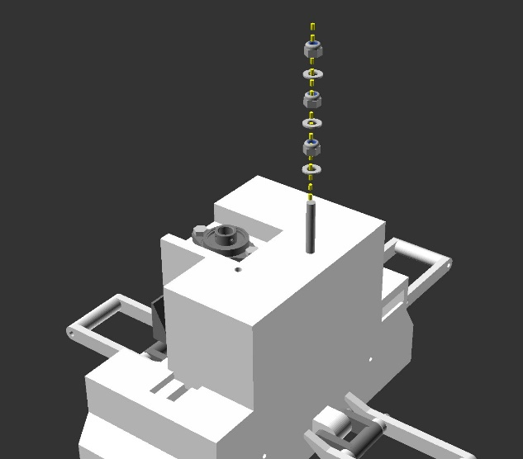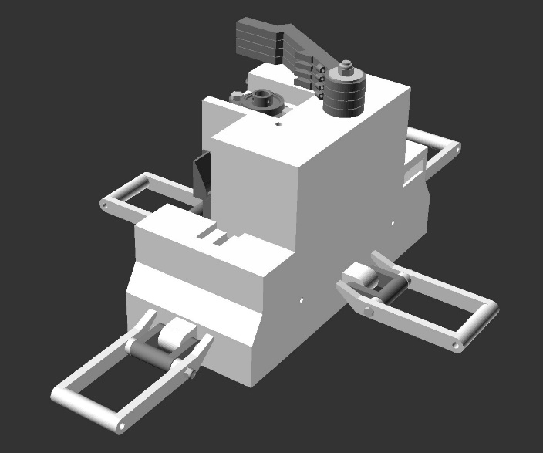

e.)

b.)

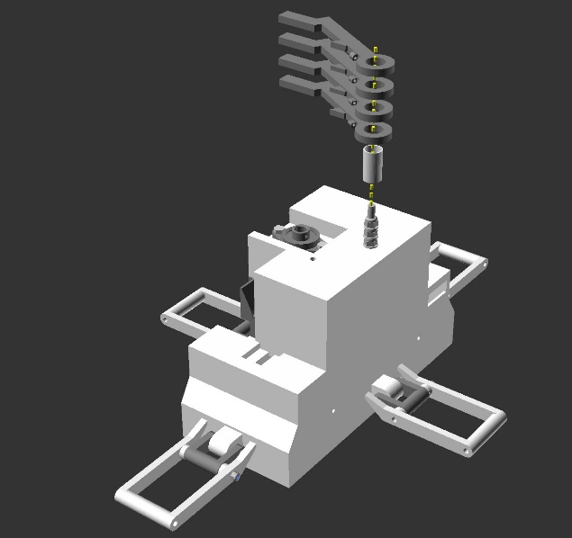

c.)

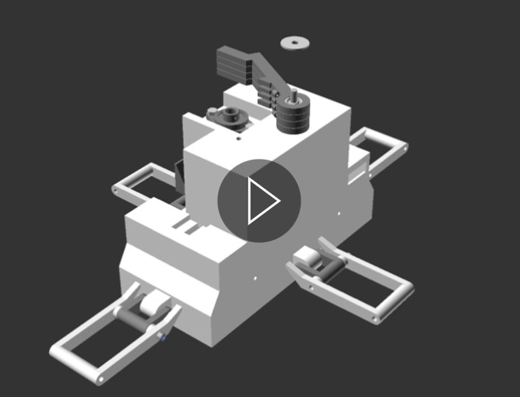

f.)

**Figure 66** Action diagrams (a, b, c, d and e) and animated gifs (f) illustrating step 4a.8, installing the pawl arms to the motor unit subassembly. View animation (f) in file “step_4a_8_animated.gif” available in the GitHub project repository “openChamber/Chamber_1/Build_Guide/Step 4_Construction_Manual_Animations/”. This animation was modelled in openscad and compiled into GIF format using ImageMagick.

Notes:

Parts required for this section - Subassembly unit resulting from step 4a.8, 1 x part 33, 4 x part 34, 3x part 35, 1x part 35b, 1x part 57, 1x part 15, 2x part 16, 1x part 17.

Insert part 33 (M5 40mm bolt) from the inside of part 9 (the motor case), in the bolt hole closest to the servomotor (part 66), illustrated in figures 66 a, b and f.

On the outside of part 9, place 1x part 35 (standard M5 washer) over part 33, followed by 1x part 34 (M5 lock nut). Tension so that part 35 is held firmly in place.

Next place a second part 35 onto the bolt (part 33), followed by a second part 34. However, this time tension the nut (part 34) so that the washer (part 35) can still spin freely on the shaft of the bolt. The nut is in place to maintain a space between this and subsequent washers.

Repeat this step once more so that there are 3 washers (part 35) and 3 nuts (part 34) on the shaft of the bolt (part 33). This is illustrated in figures 66 b, c and f.

Next place part 57 over this set up, like a sleeve, illustrated in figures 66 c and f. This sleeve rotates around the bolt (part 33) setup described above.

Next place part 15 onto part 57, followed by the 2x part 16 and finally the part 17, as shown in figures 66 c, d and f.

Place part 35b (the M5 penny washer, or M5 wide washer) over the portion of part 33 that is still protruding from the top of the setup. Lock this in place using the final part 34, tensioning so that the parts 15, 16, 17 and 57 are free to spin around the axis of part 33, but are held tightly enough that they are not at risk of slipping from the top of the part 33 assembly. This is shown in figures 66 d, e and f.

4a.9 Pawl Arm Installation

c.)

a.)

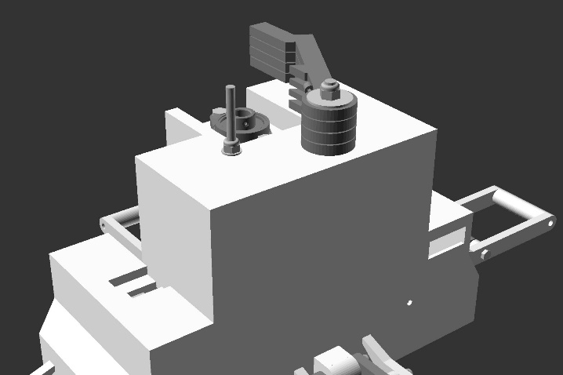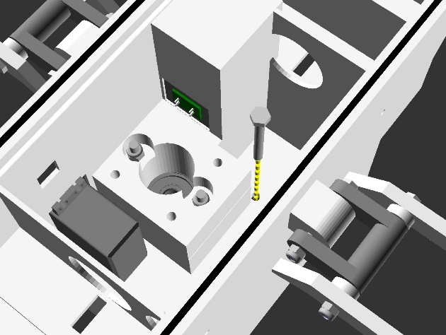

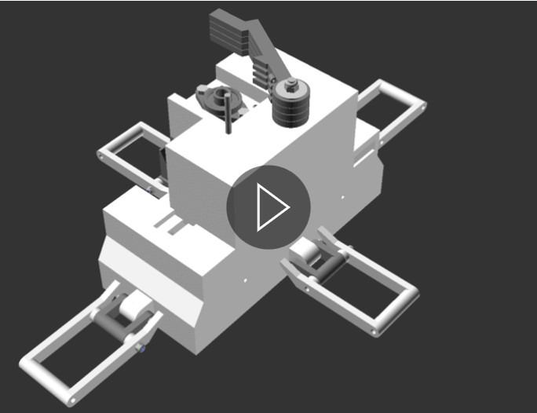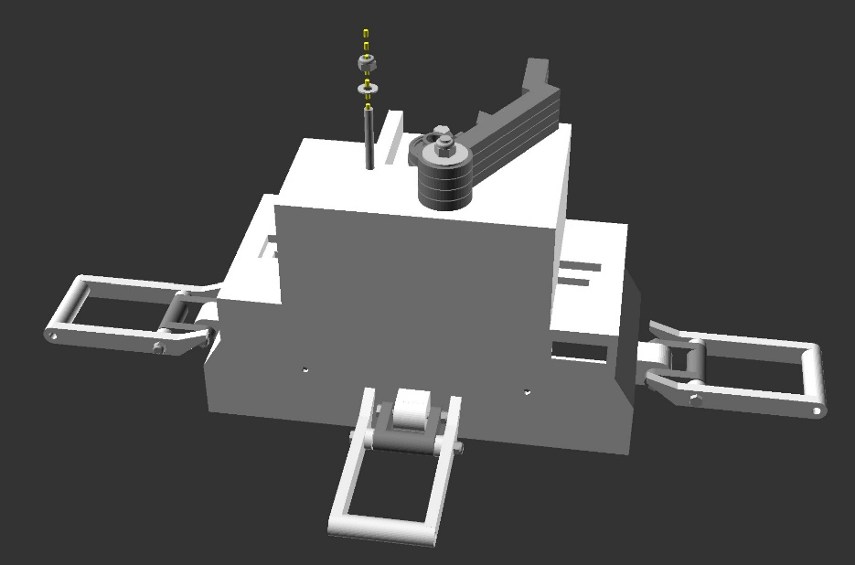

d.)

b.)

**Figure 67** Action diagrams (a, b, and c) and animated gifs (d) illustrating step 4a.9, installing the pawl spring bolt to the motor unit subassembly. View animation (d) in file “step_4a_9_animated.gif” available in the GitHub project repository “openChamber/Chamber_1/Build_Guide/Step 4_Construction_Manual_Animations/”. This animation was modelled in openscad and compiled into GIF format using ImageMagick.

Notes:

Parts required for this section - Subassembly unit resulting from step 4a.8, 1 x part 37, 1 x part 40, 1x39.

Insert part 37 (M4 40mm bolt) from the inside of part 9 (the motor case), in the bolt hole closest to the Optical Limit Switch Assembly, illustrated in figures 67 a, b and d.

(Note - the optical limit switch assembly cable is not rendered for the purpose of illustration simplification).

On the outside of part 9, place 1x part 40 (standard M4 washer) over part 37, followed by 1x part 39 (M4 lock nut). Tension so that part 37 is held firmly in place.

4b.1 Leadscrew Assembly

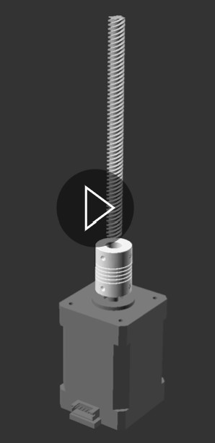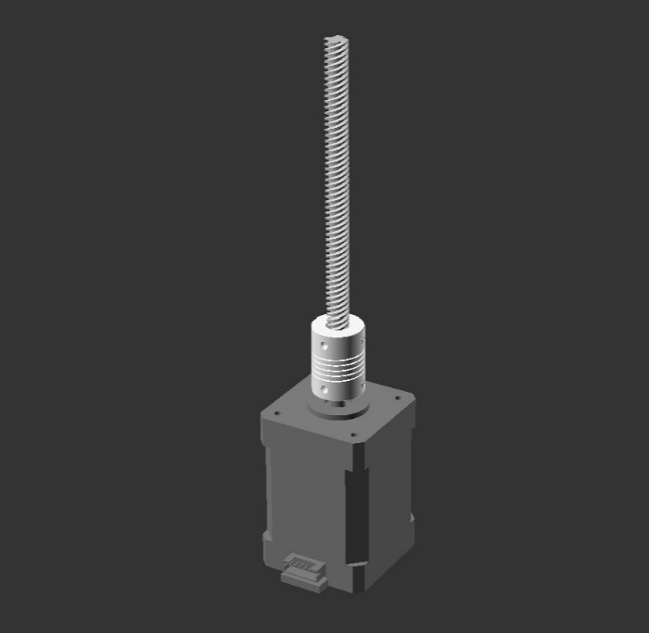

d.))

c.)

b.)

a.)

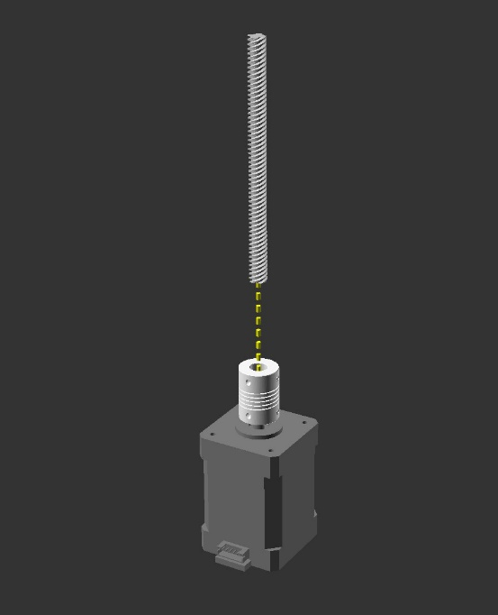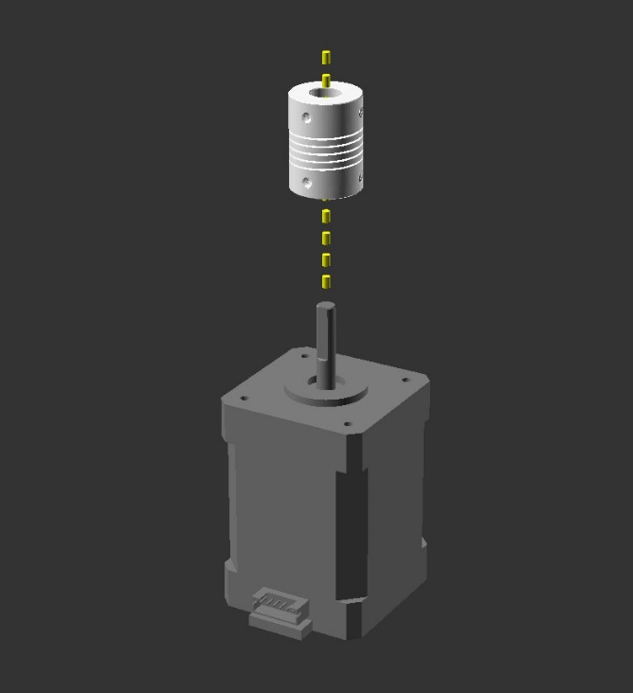

**Figure 68** Action diagrams (a, b, and c) and animated gifs (d) illustrating step 4b.1, assembling the leadscrew subassembly in preparation for subsequent installation into the motor unit subassembly. View animation (d) in file “step_4b_1_animated.gif” available in the GitHub project repository “openChamber/Chamber_1/Build_Guide/Step 4_Construction_Manual_Animations/”. This animation was modelled in openscad and compiled into GIF format using ImageMagick.

Notes:

Parts required for this section - 1 x part 65, 1 x part 47, 1x part 48.

Place part 47 (flexible coupling) 5mm diameter side first (the smaller of the 2 end holes) onto the drive/output shaft of part 65 (nema stepper motor). Align so that the top of the drive shaft ends at the middle point of part 47. Once in the correct position, lock the coupling in place by tightening the bottom 2 grub screws firmly, located on the outside of part 47 (illustrated in figures 68a, b and d).

Next place part 48 (the leadscrew) into the 8mm side (the larger of the 2 end holes) of part 47, ideally leaving the non-cut end pointing upwards. This should fill the top half of part 47 and rest upon the drive shaft of part 65. Lock the coupling onto part 48 by tightening the top 2 grub screws firmly, located on the outside of part 47 (illustrated in figure 68 b, c and d).

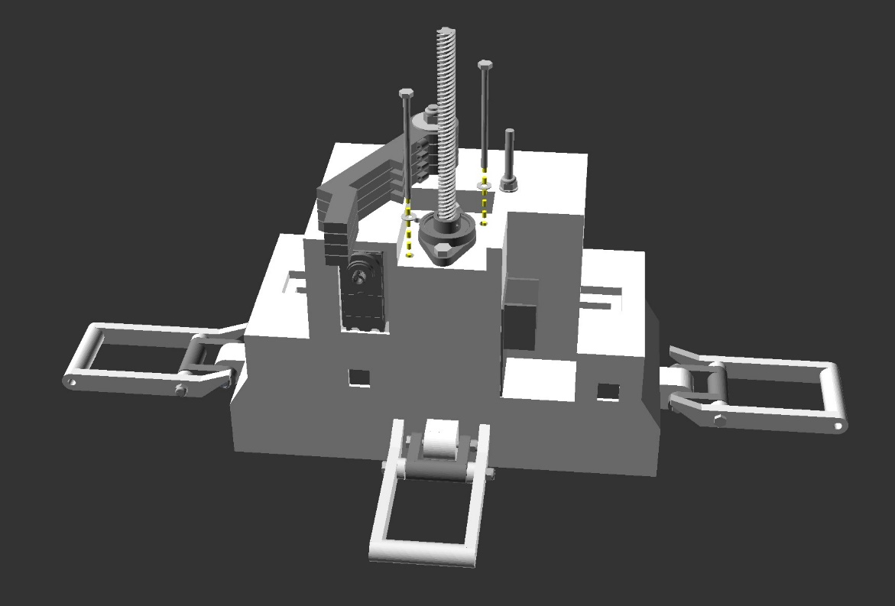4b.2 Leadscrew Assembly Installation

d.)

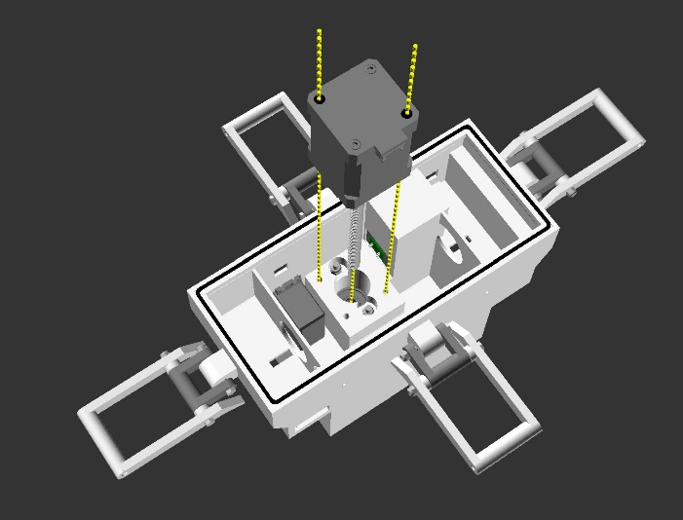

a.)

e.)

b.)

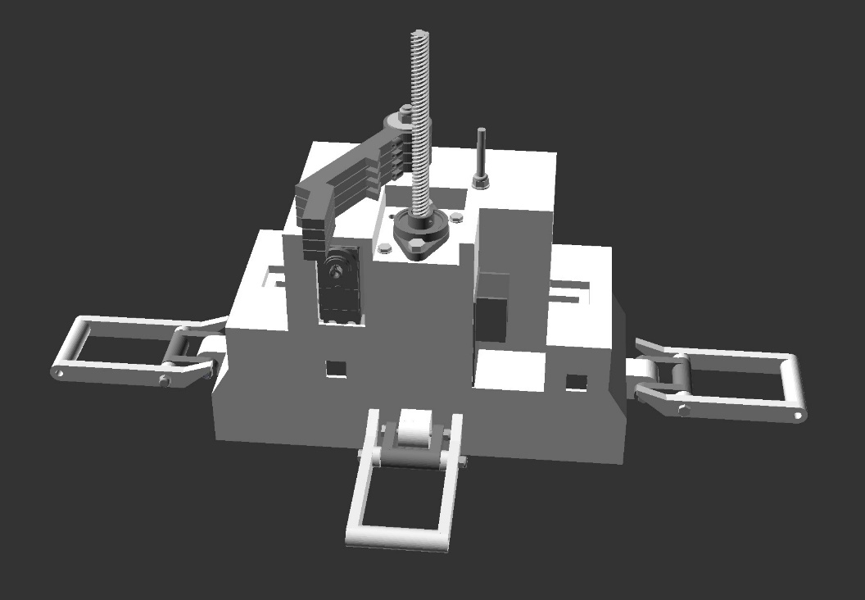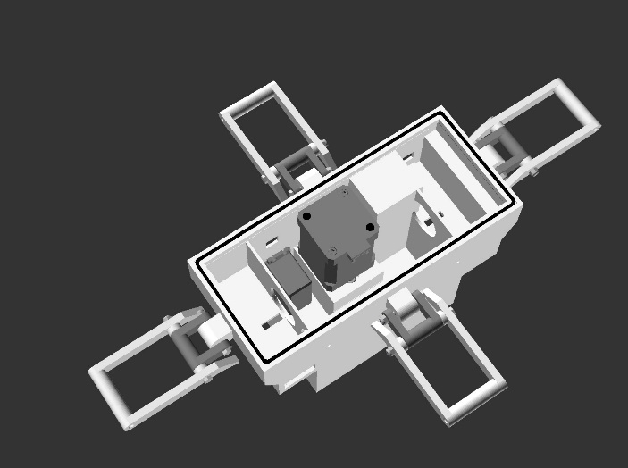

c.)

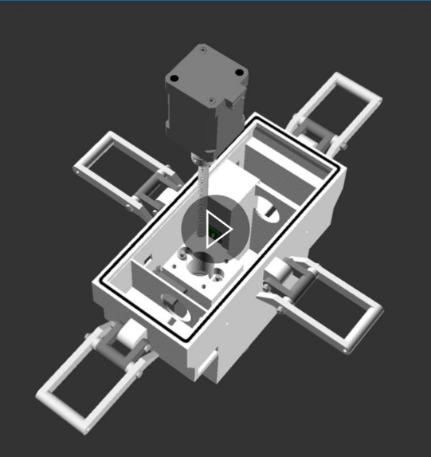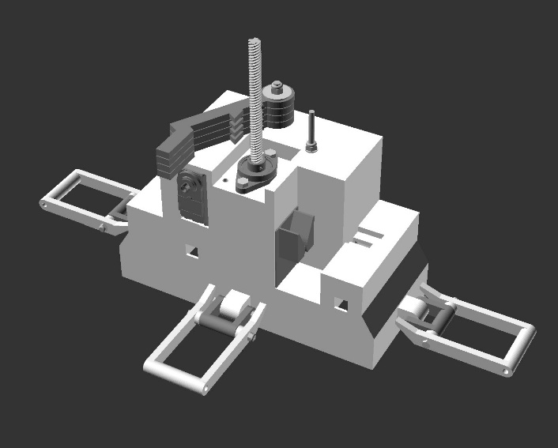

f.)

**Figure 69** Action diagrams (a, b, c, d and e) and animated gif (f) illustrating step 4b.2, installing the leadscrew assembly into the motor unit subassembly. View animation (f) in file “step_4b_2_animated.gif” available in the GitHub project repository “openChamber/Chamber_1/Build_Guide/Step 4_Construction_Manual_Animations/”. This animation was modelled in openscad and compiled into GIF format using ImageMagick.

Notes:

Parts required for this section - Subassembly unit resulting from step 4a.9, subassembly unit resulting from step 4b.1, 2 x part 41, 2x 45, 1x part 99, 1x part 90/91.

Remove the 2x bolts from the stepper motor (part 65) indicated as black dots on the bottom of the stepper motor in figure 69.

Orient the subassembly unit resulting from step 4b.1 so that the lead screw (part 48) passes through the middle of the pillow block (part 46), and the top surface of the stepper motor (part 65) meets the motor case (part 9). The stepper motor female cable connector should face the inside of the motor case. Ensure that the bolt holes in the motor case (part 9), align with the open bolt holes of the stepper motor, which were previously removed (as shown in figures 69 a, b, c and f).

From the outside of the motor case (part 9), insert the 2 x part 41 (50mm M3 bolts), each through a single part 45 (m3 washer) and into the motor case bolt holes illustrated in figures 69 d, e and f. These bolts then bind with the thread in the stepper motor (part 65).

Tension these bolts so that the hold the stepper motor firmly in place.

After test fitting the subassembly unit resulting from step 4b.1 to the motor unit subassembly, ensure that the top of part 47 does not rub against bottom of part 46 or inhibit the movement of the nema stepper motor driveshaft (part 65). If this does occur, repeat step 4b.1, but adjust the height of part 47 to be lower on the driveshaft of part 65.

Once confident that the Leadscrew assembly is correct, finalise step 4b.1 by applying superglue to the grub screws of part 47, locking the assembly together. Superglue should also be applied to the bottom of part 48, and to the drive shaft of part 65. This binds the flexible coupling to the lead screw assembly.

Failure to glue the grubscrews will result in the leadscrew assembly becoming loose during chamber operation and the failiure of the chamber to function.

Re-install the finalised subassembly unit resulting from step 4b.1 to the subassembly unit resulting from step 4a.9 as describe above.

Finally, apply hot glue around/ on the bolt heads on the outside of part 9 (i.e. the side illustrated in figure 69 e) to waterproof the joints.

4b.3 Ratchet Installation

a.)

c.)

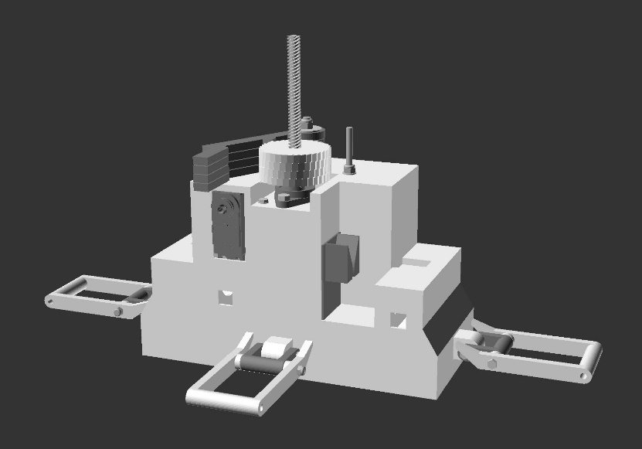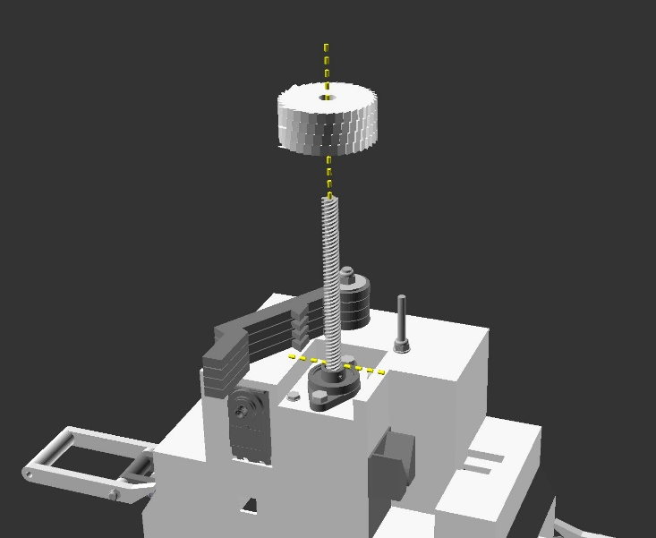

b.)

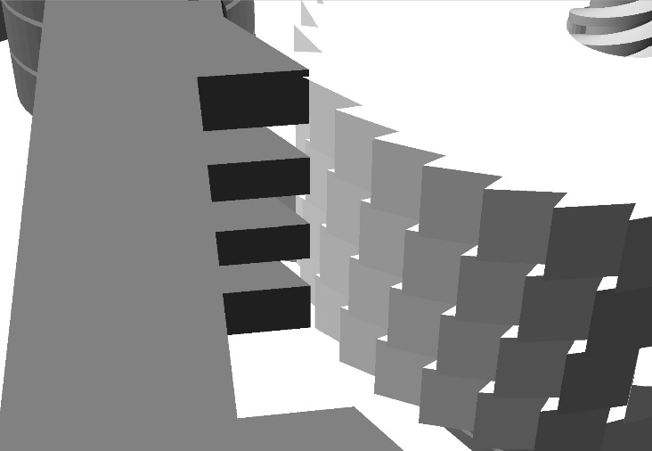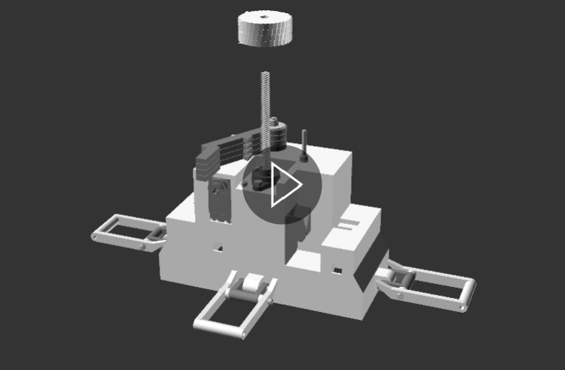

d.)

**Figure 70** Action diagrams (a, b, and c) and animated gif (d) illustrating step 4b.3, installing the ratchet onto the motor unit subassembly. View animation (d) in file “step_4b_3_animated.gif” available in the GitHub project repository “openChamber/Chamber_1/Build_Guide/Step 4_Construction_Manual_Animations/”. This animation was modelled in openscad and compiled into GIF format using ImageMagick.

Notes:

Parts required for this section - Subassembly unit resulting from step 4b.3, 1 x part 18, 1 x 90/91.

Orient part 18 (the ratchet) so that the locking portion of the ratchets (the overhang) face towards the pawls as illustrated in figure 70 b.

Place part 18 over the leadscrew (part 48), so that it passes through the hole in the middle of the part 18.

Part 18 must not rub against the top surface of the motor case (part 9). The goal is to have it ~2mm above the surface of the motor case, and still engage with the pawl arms as illustrated in figure 70.

Once confident about how part 18 fits to the subassembly unit resulting form step 46.3, remove part 18. Apply super glue (part 90 or 91) to the area on the leadscrew (part 48) where the ratchet to be installed. Replace the ratchet into position over the glue, adding extra glue if necessary to the top of the ratchet when in place.

Be careful to not get glue on the leadscrew above the ratchet, as this is important for later chamber functionality.

Wait for the glue to dry following the instructions indicated on your glue.

4b.4a Circuit Board Standoff Bolts Installation

c.)

a.)

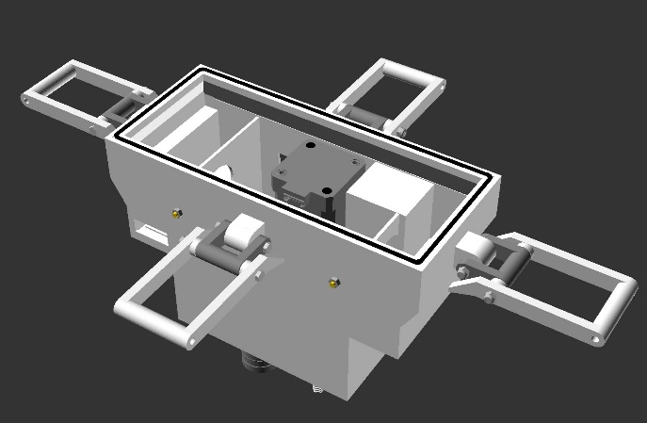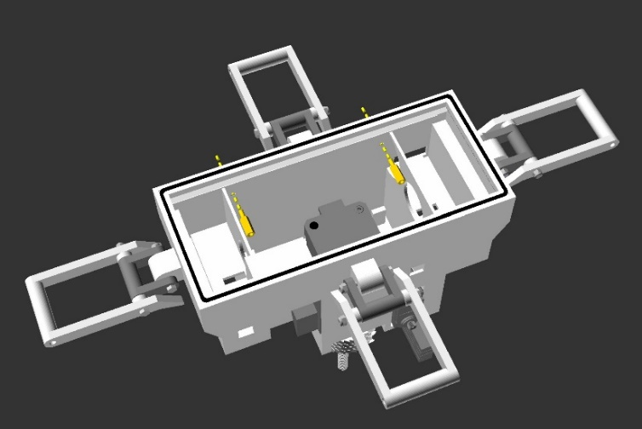

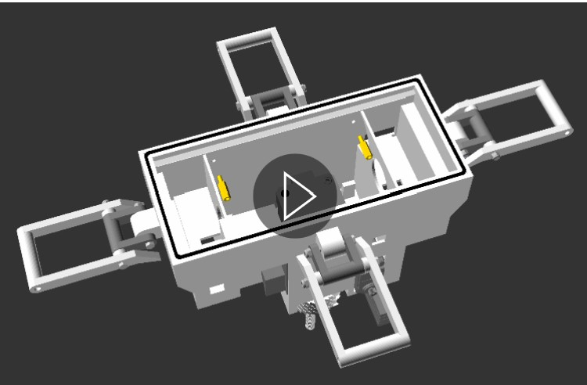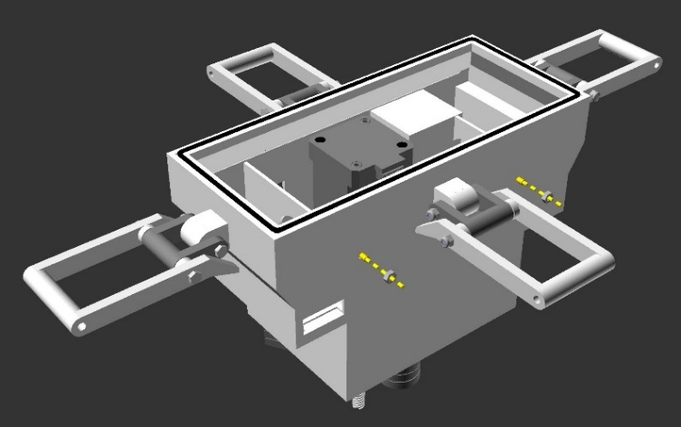

d.)

b.)

**Figure 71** Action diagrams (a, b, and c) and animated gif (d) illustrating step 4b.4a, installing the circuit board standoff bolts onto the motor unit subassembly. View animation (d) in file “step_4b_4_animated.gif” available in the GitHub project repository “openChamber/Chamber_1/Build_Guide/Step 4_Construction_Manual_Animations/”. This animation was modelled in openscad and compiled into GIF format using ImageMagick.

Notes:

Parts required for this section - Subassembly unit resulting from step 4b.3, 2 x part 53, 2 x part 44b, 1x part 90 or 91.

Insert the threaded portion of standoff bolts (parts 53), through the holes in the wall of the motor case (part 9), opposite the stepper motor (part 65), as illustrated in figure 71 a and d.

Fix the standoff bolts in place using 1x part 44b on each standoff bolt, from the outside of the motor case (illustrated in figures 71 b, c and d). Tension so that the bolts are held firmly in place.

Apply super glue (part 90 or 91) to the outside facing nuts (figure 71 c). This is to fix them in place and prevent loosening, in addition to waterproofing the joint.

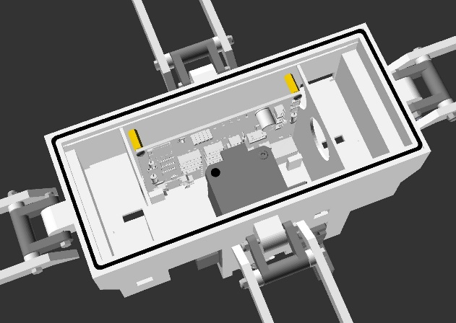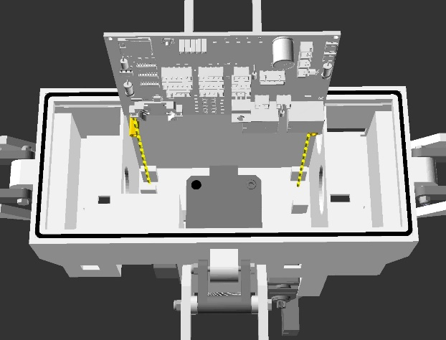4b.4b Circuit Board Installation

c.)

a.)

b.)

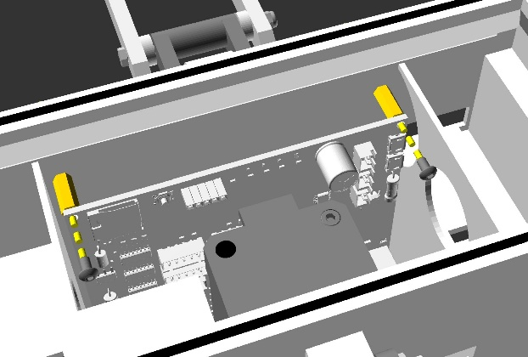

d.)

**Figure 72** Action diagrams (a, b, and c) and animated gif (d) illustrating step 4b.4b, installing the main circuit board onto the motor unit subassembly. View animation (d) in file “step_4b_4_animated.gif” available in the GitHub project repository “openChamber/Chamber_1/Build_Guide/Step 4_Construction_Manual_Animations/”. This animation was modelled in openscad and compiled into GIF format using ImageMagick.

Notes:

Parts required for this section - Subassembly unit resulting from step 4b.4a, 2 x part 54, 1 x part 76.

Orient the main circuit board (part 76) so that the corner bolt holes are at the top of the board. The coin cell battery should be at the bottom left, when facing the standoff bolts (part 53).

The bottom of the circuit board slots into brackets printed into the motor case (part 9), illustrated in figures 72 a and d.

The bolt holes in the top corners of the circuit board (part 76) should now align with the standoff bolts (part 53). Insert one part 54 into each of the bolt holes of the circuit board and into the standoff bolts. Gently tension the bolts so that the circuit board is held in place, but that the surface is not damaged.

This step is important for general usage of the chambers.

4b.5 Glue-on Accessory Circuits Installation

a.)

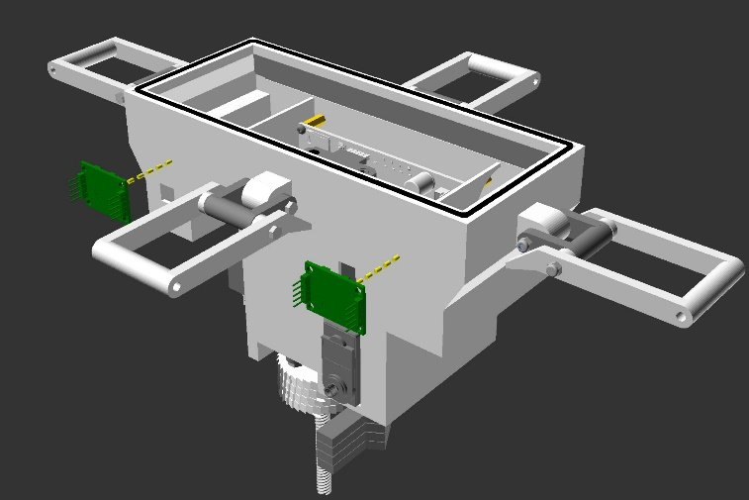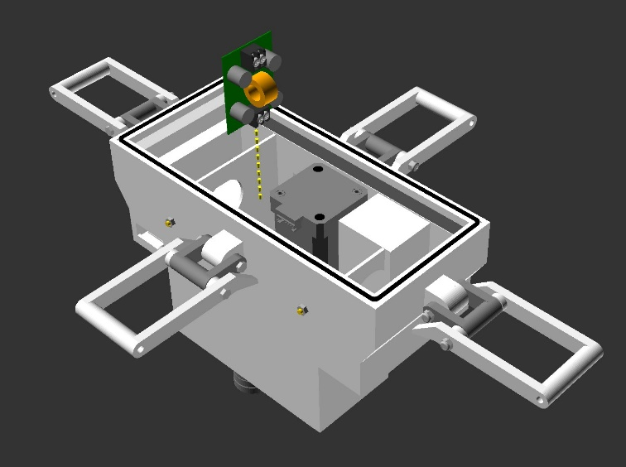

c.)

b.)

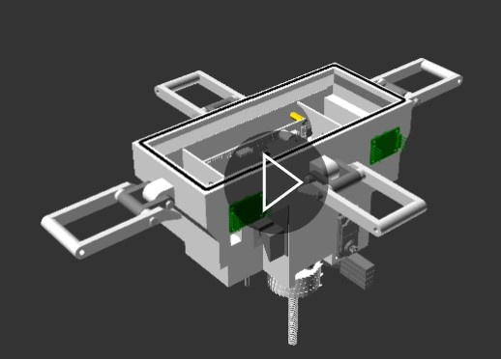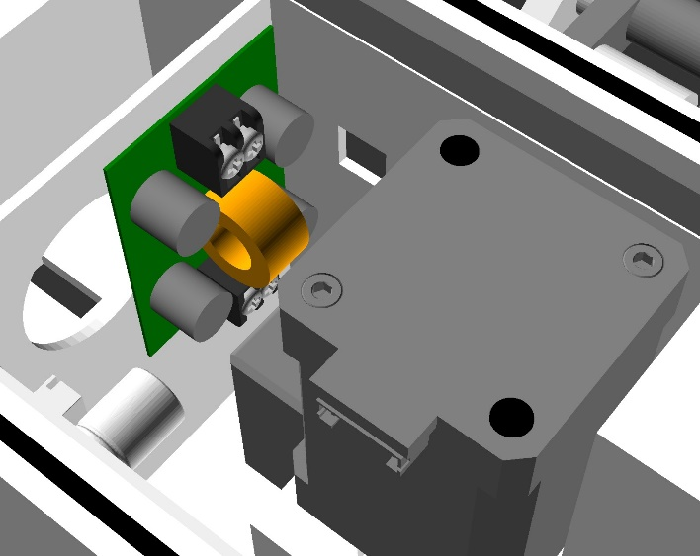

d.)

**Figure 73** Action diagrams (a, b, and c) and animated gif (d) illustrating step 4b.5, gluing the accessory circuit boards onto the motor unit subassembly. View animation (d) in file “step_4b_5_animated.gif” available in the GitHub project repository “openChamber/Chamber_1/Build_Guide/Step 4_Construction_Manual_Animations/”. This animation was modelled in openscad and compiled into GIF format using ImageMagick.

Notes:

Parts required for this section - Subassembly unit resulting from step 4b.5, 1 or 2 x part 69, 1 x part 80b, 1x part 99.

Dry fit part 80b into the motor case as illustrated in figures 73 a, b and d. It is important that the top of part 80b does not protrude over the plastic printed bracket of the motor case that it rests against, as illustrated in figure 73 b. This is because the power bank are positioned upon this bracket, described in step 1.4.4c.1.

Once happy with the fit, apply hot glue to the back of the circuit board and replace in its position.

Dry fit parts 69 onto the outside motor case as illustrated in figures 73 c and d. This should be, with the cable connectors facing away from the motor case (part 9). If only using one load cell in your build, just fit the part 69 to the left in figure 73 c.

Once happy with the fit, apply hot glue to the back of the circuit boards and replace in their positions.

In the future this step may be changed to allow for a mechanical binding of part 73b and parts 69 to the motor case (part 9). But for the scope of this project as a part of my PhD, I do not have time to adjust this step at present.

4b.6, 7, 8 and 9 Motor Unit Wiring

c.)

a.)

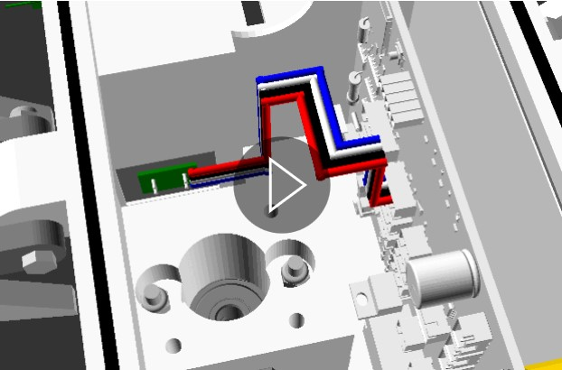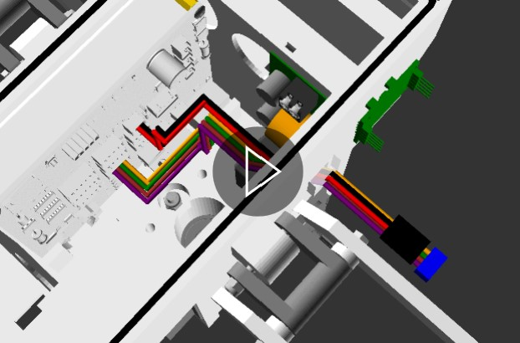

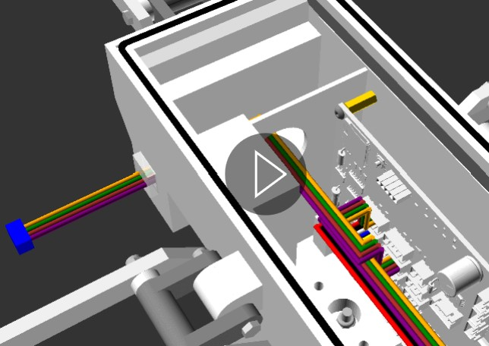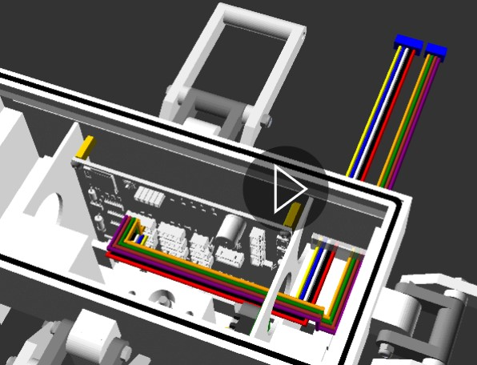

d.)

b.)

**Figure 74** Animated gifs (a, b, c and d) illustrating step 4b.6 to 9, installing and gluing in motor unit subassembly wiring. View animation (a) in file “step_4b_8_animated.gif”, animation (b) in file “step_4b_6_animated.gif”, animation (c) in file “step_4b_9_animated.gif” and animation (d) in file “step_4b_7_animated.gif”, available in the GitHub project repository “openChamber/Chamber_1/Build_Guide/Step 4_Construction_Manual_Animations/”. This animation was modelled in openscad and compiled into GIF format using ImageMagick.

Notes:

Parts required for this section - Subassembly unit resulting from step 4b.5, 1 x part 77a, 1 x part 77b, 1 x part 78a, 1 x part 78b, 1 x part 79b, 1x part 99,

This step installs cables that pass from inside the motor unit into the chamber body cavity, sealing them in place. The leadscrew assembly described in step 4b.1 is absent in figure 74 to make illustration of the cable installation clearer.

Uninstall the main circuit board (part 76) from the motor unit subassembly, following step 4b.4b. Keep the circuit board as close as you can to its fitted position, while having easy access to all of the cable connectors on the circuit board. This is done as it is easier to install cables onto the main circuit board outside of the motor case, rather than attempting it when the main circuit board is installed.

Insert parts 77a and 77b (the sensor board cable and radio cable) from the outside of the motor case (part 9) to the inside of the motor case, as illustrated in figure 74b.

Connect the cables to the main circuit board (part 76) in the appropriate male connectors (part 77a to labelled connector “Sensors”, part 77b to labelled connector “HC-12”). *

When confident that the cables (parts 77a and 77b) have enough length on the inside, fix in place by applying part 99 (hot glue) to the hole in the motor case (part 9) that they are routed through. This holds the cables in place and waterproofs the joint. **

Insert part 79b (the fan cable) and if using the second load cell, part 78b (load cell cable 2) from the outside of the motor case (part 9) to the inside of the motor case, as illustrated in figure 74a.

Connect the cables to the main circuit board (part 76) in the appropriate male connectors (part 78b to labelled connector “Strain 2”, part 79b to labelled connector “Fan”). *

When confident that the cables (parts 79b and 78b) have enough length on the inside, fix in place by applying part 99 (hot glue) to the hole in the motor case (part 9) that they are routed through. This holds the cables in place and waterproofs the joint. **

Insert part 78a (the load cell cable 1) from the outside of the motor case (part 9) to the inside of the motor case, as illustrated in figure 74d.

Connect the cable to the main circuit board (part 76) in the appropriate male connectors (part 78a to labelled connector “Strain 1”). *

When confident that the cable (parts 78a) has enough length on the inside, fix in place by applying part 99 (hot glue) to the hole in the motor case (part 9) that it is routed through. This holds the cable in place and waterproofs the joint. **

Figure 74 c illustrates how cable the Optical Limit Switch cable (step 4a.2) is routed to the main circuit board (part 76). This travels around the leadscrew assembly described in step 4b.1 and connects to the male connector (labelled end stop 1).

Re-install the main circuit board with the connected cables to the motor unit subassembly, following step 4b.4b.

*Ensure that the cables have enough length on the inside of the motor case to connect to the main circuit board. Cables that are too short will be very difficult to work with in subsequent steps, for example when trouble shooting hardware.

**In the future this step may be changed to include cabinet fit cable connectors from the outside of the motor case (part 9), instead of a hot glue permanent joint. This would give more simple chamber body cavity cable length adjustment. But for the scope of this project as a part of my PhD, I do not have time to adjust this step at present.

4c.1 Power-Bank and Lid Installation

a.)

b.)

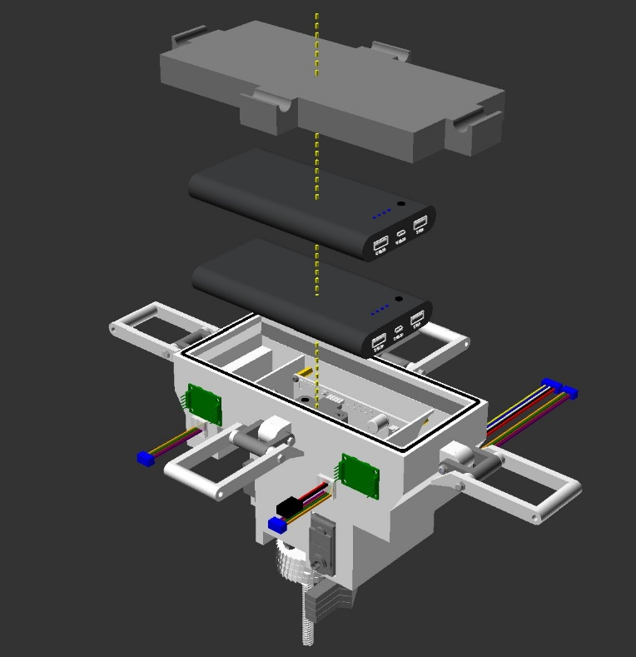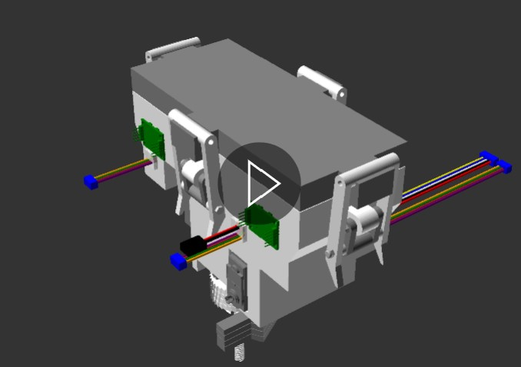

**Figure 75** Action diagrams (a) and animated gif (b) illustrating step 4c.1, installing the 2 power banks and lid to the motor unit subassembly. View animation (b) in file “step_4c_1_animated.gif” available in the GitHub project repository “openChamber/Chamber_1/Build_Guide/Step 4_Construction_Manual_Animations/”. This animation was modelled in openscad and compiled into GIF format using ImageMagick.

Notes:

Parts required for this section - Subassembly unit resulting from step 4b.6, 7, 8 and 9, 2 x part 80, 1 x part 10.

This step illustrates how the power banks are installed into the motor unit, and how the lid is attached. We will not provide power to the main circuit board (part 76) at this stage, so will not connect the power banks to the main circuit board.

Place the first Power bank (part 80) onto the cross brackets of the motor case (part 9). The LEDs and power button of part 80 (the front surface of the Power bank) should face upwards. The female USB connectors (the top surface of the power bank) should face to the servomotor side of the motor unit subassembly. The opposite side to the female USB connectors (the bottom surface of the power bank) should butt up against the load cell 1 end of the motor case.

Ensure that no cables are trapped between the power bank and the cross brackets of the motor case. Trapped cables can prevent the power bank from lying flat on the brackets or result in damage to the cables.

Place the second Power bank (part 80) onto top of the first power bank, in the same location and orientation described above.

Place the motor case lid (part 10) on top of the 2 power banks. The bottom edge of the motor case lid should press against the O-ring/Gasket of the motor unit subassembly, installed in step 4a.5.

Clamp the motor case lid in place by engaging the motor unit latches with the motor case lid. This and the previous steps are illustrated more clearly in figure 75.

Clamping the motor case lid (part 10) to the gasket of the motor unit subassembly provides a waterproof seal.

4c.2 Pawl Spring Installation

a.)

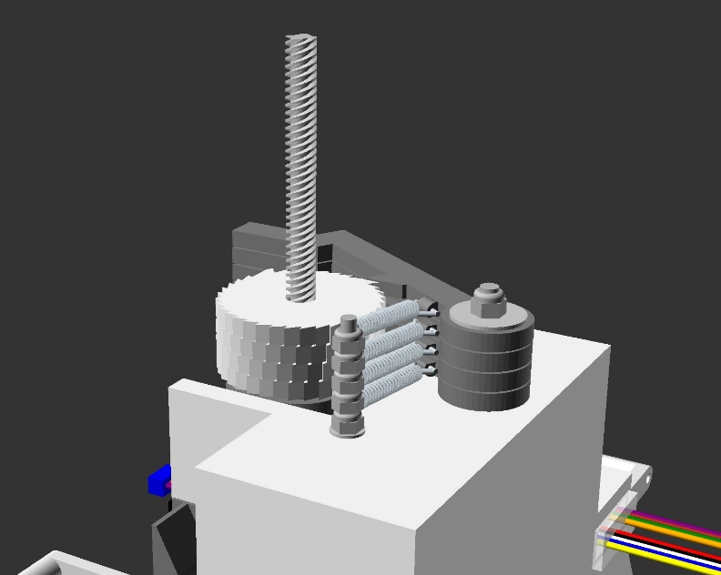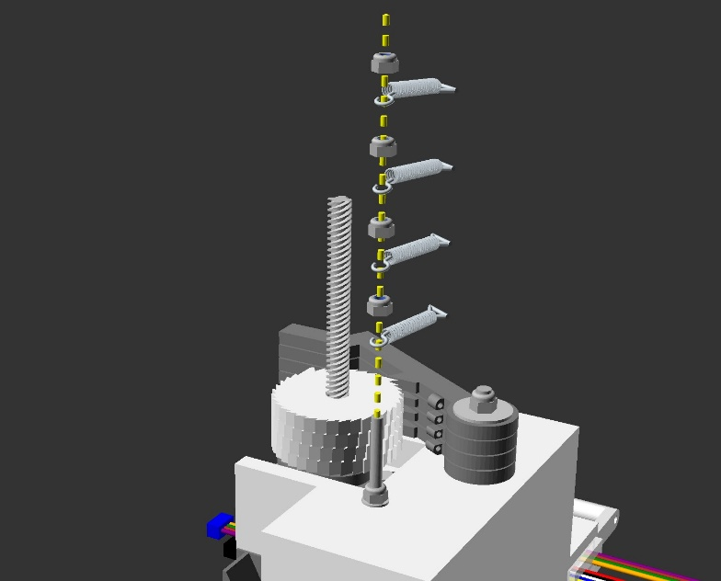

b.)

c.)

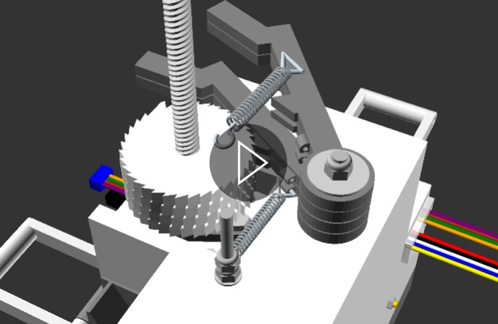

**Figure 76** Action diagrams (a and b) and animated gif (c) illustrating step 4c.2, installing the pawl springs onto the motor unit subassembly. View animation (c) in file “step_4c_2_animated.gif” available in the GitHub project repository “openChamber/Chamber_1/Build_Guide/Step 4_Construction_Manual_Animations/”. This animation was modelled in openscad and compiled into GIF format using ImageMagick.

Notes:

Parts required for this section - Subassembly unit resulting from step 4c.1, 4 x part 58, 4 x part 39.

Insert the round end of the first part 58 (the “helical extension spring” or “tension spring”) onto the shaft of part 37 (M4 bolt installed in step 4a.9) as illustrated in figure 76.

Thread the loop of the other end of the tension spring through the bottom pawl arm (part 15) and fold the spring end back on itself to lock the tension spring onto the pawl arm (as illustrated in figure 76).

Next insert 1 part 39 (M4 locking nut) onto part 37. Screw this locking nut onto part 37 until just above the first tension spring.

Insert the round end of the second part 58 (the “helical extension spring” or “tension spring”) onto the shaft of part 37, as illustrated in figure 76.

Thread the loop of the other end of the tension spring through the first middle pawl arm (part 16) and fold the spring end back on itself to lock the tension spring onto the pawl arm (as illustrated in figure 76).

Next insert 1 part 39 (M4 locking nut) onto part 37. Screw this locking nut onto part 37 until just above the second tension spring. *

Insert the round end of the third part 58 (the “helical extension spring” or “tension spring”) onto the shaft of part 37, as illustrated in figure 76.

Thread the loop of the other end of the tension spring through the second middle pawl arm (part 16) and fold the spring end back on itself to lock the tension spring onto the pawl arm (as illustrated in figure 76).

Next insert 1 part 39 (M4 locking nut) onto part 37. Screw this locking nut onto part 37 until just above the third tension spring. *

Insert the round end of the fourth part 58 (the “helical extension spring” or “tension spring”) onto the shaft of part 37, as illustrated in figure 76.

Thread the loop of the other end of the tension spring through the top pawl arm (part 17) and fold the spring end back on itself to lock the tension spring onto the pawl arm (as illustrated in figure 76).

Next insert 1 part 39 (M4 locking nut) onto part 37. Screw this locking nut onto part 37 until just above the fourth tension spring. *

Figures 76 b and c illustrate the end product: a unidirectional locking ratchet, which allows rotation in one direction but not the other.

*This nut acts as a spacer between the tension springs, preventing the tension springs from contacting each other, therefore maintaining the independent movement of each of the pawl arms (parts 15, 16 and 17) as they engage with the rotating ratchet (part 18). These lock nuts (parts 39) can also be adjusted after installation to ensure spring independence.

4c.3 Servo Arm Installation

a.)

c.)

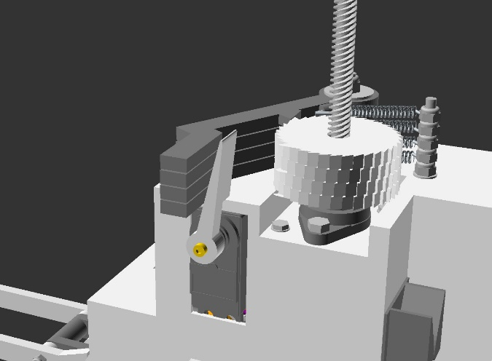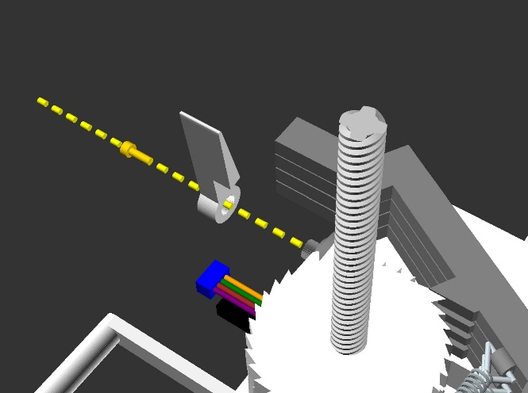

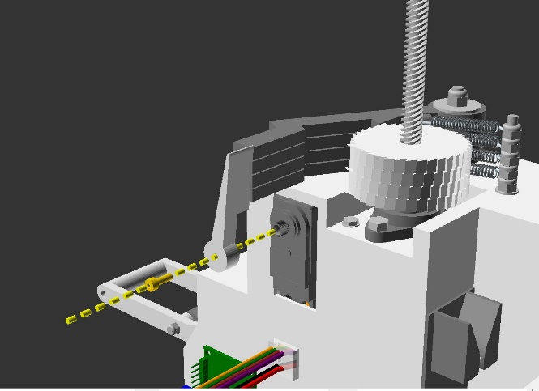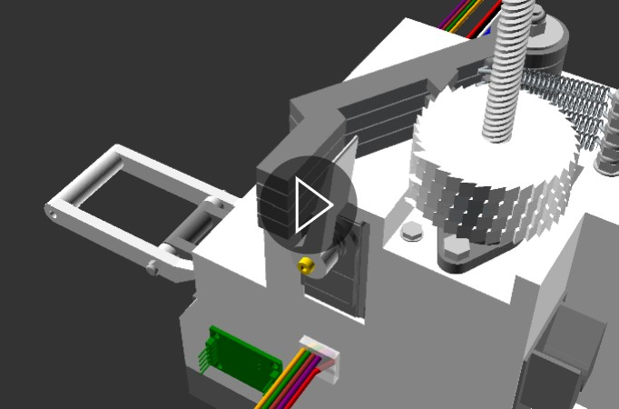

b.)

d.)

**Figure 77** Action diagrams (a, b and c) and animated gif (d) illustrating step 4c.3, installing the pawl springs onto the motor unit subassembly. View animation (d) in file “step_4c_3_animated.gif” available in the GitHub project repository “openChamber/Chamber_1/Build_Guide/Step 4_Construction_Manual_Animations/”. This animation was modelled in openscad and compiled into GIF format using ImageMagick.

Notes:

Parts required for this section - Subassembly unit resulting from step 4c.2, 1 x part 19, 1 x part 50.b.

This step describes the installation of the servomotor arm (part 19). This step may need to be repeated during servomotor calibration, to ensure that the servomotor arm engages with the pawl arms (parts 15, 16 and 17) correctly.

Push part 19 (the servomotor arm) onto the servomotor output shaft (part 66), so that the paddle of the of part 19 is ~1mm away from the pawl arms (parts 15, 16 and 17). This is illustrated in figure 77.

Next lock the servomotor arm in place by inserting the servomotor arm bolt (part 50.b) through the hole in the middle of the servomotor arm (part 19), threading into the servomotor output shaft (illustrated in figure 77).

Tension the servomotor arm bolt (part 50.b) so that the arm is held firmly onto the servomotor output shaft, without impeding the internal mechanical movement of the output shaft.

With this, step 4 and the Motor Unit subunit are completed, and should look like figures 58 and 77d.

### Step 5: Chamber brackets

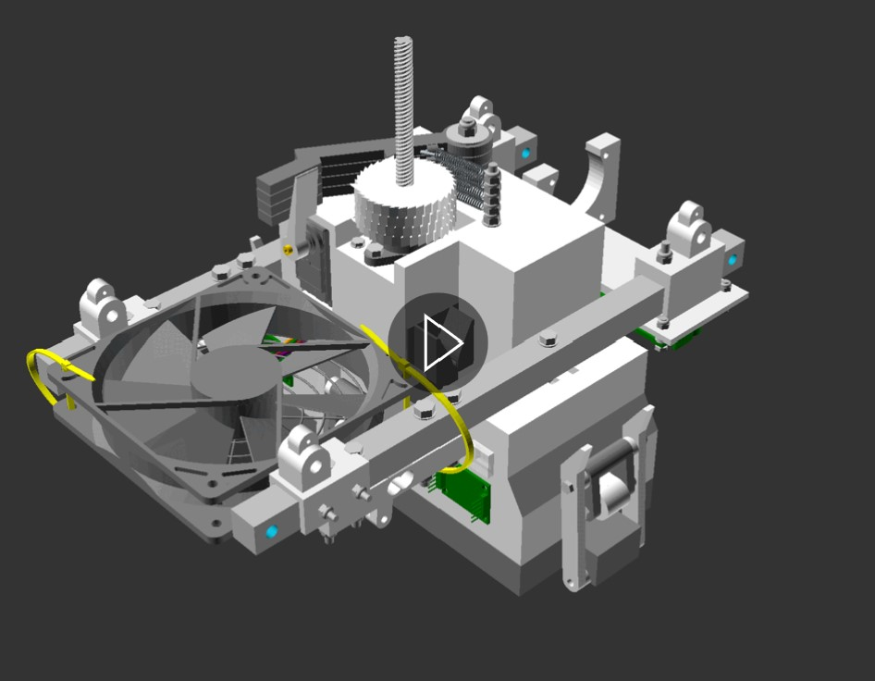

**Figure 78** 3d model illustrating the product of step 5. Before moving to step 6, your assembled piece should look like this. View this animation in file “step_5_end_product_animated.gif” available in the GitHub project repository “openChamber/Chamber_1/Build_Guide/Step 5_Construction_Manual_Animations/”. This animation was modelled in openscad and compiled into GIF format using ImageMagick.

Step 5 focuses upon the subassembly piece “Chamber Brackets”. The end product of this step is the chamber brackets with the Motor Unit, sensor bracket, sensor board, load cells/strain gauges, fan brackets, and fan installed (Figure 78).

5.1 Bracket “mounting bolt” installation

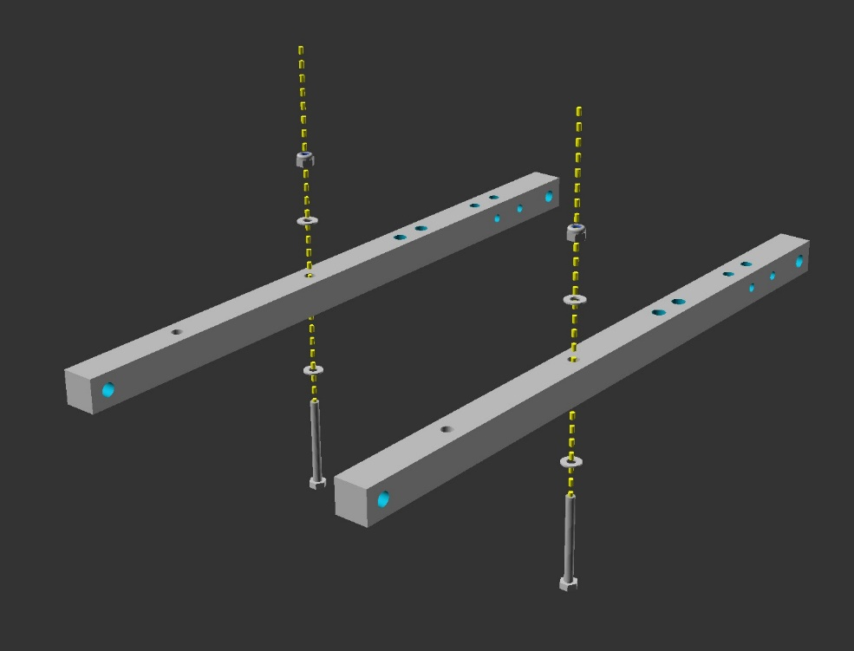

a.)

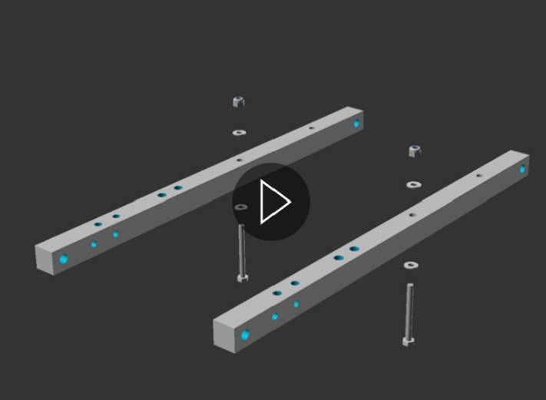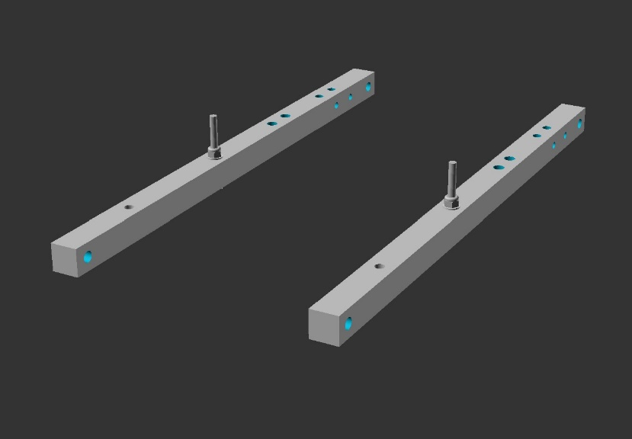

c.)

b.)

**Figure 79** Action diagrams (a and b) and animated gif (c) illustrating step 5.1, installing the bracket “mounting bolt”. View animation (c) in file “step_5_1_animated.gif” available in the GitHub project repository “openChamber/Chamber_1/Build_Guide/Step 5_Construction_Manual_Animations/”. This animation was modelled in openscad and compiled into GIF format using ImageMagick.

Notes:

Parts required for this section - 2 x part 51, 2 x part 37, 2 x part 39, 4 x part 40.

Insert part 37 (M4 bolt) through a single part 40 (m4 washer), then through the central hole in part 51 (the bracket), followed by a second part 40 and finally a single part 39 (lock nut). This step is illustrated in figure 79 a, b and c.

Tension part 39 until the bolt is held firmly in place, without damaging part 51 (aluminium bracket) through crushing force.

Repeat this for a second bracket. At the end you should have 2 brackets as illustrated in Figure 79 b and c.

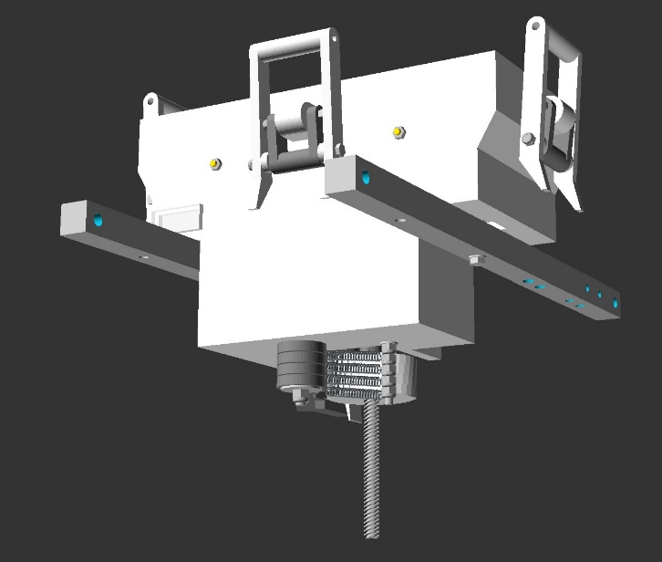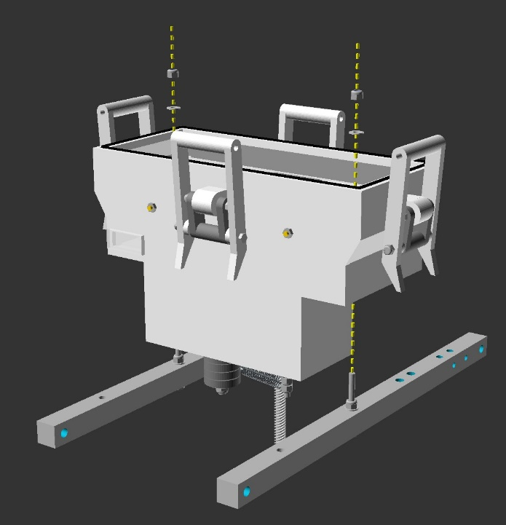5.2 Motor Unit Installation

d.)

a.)

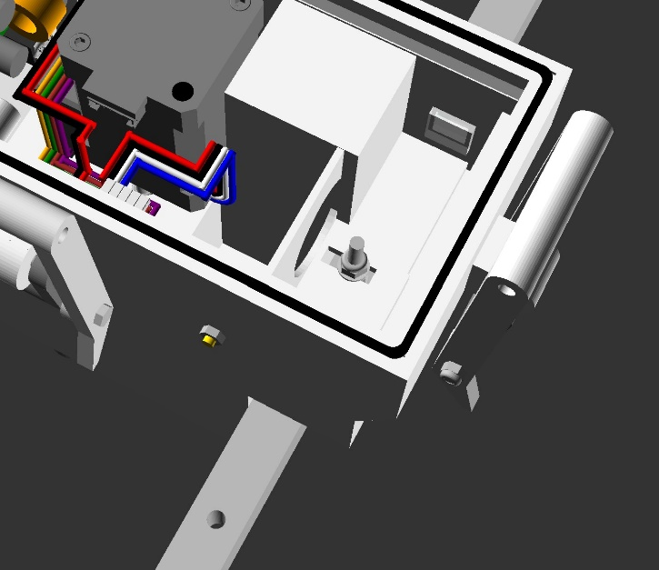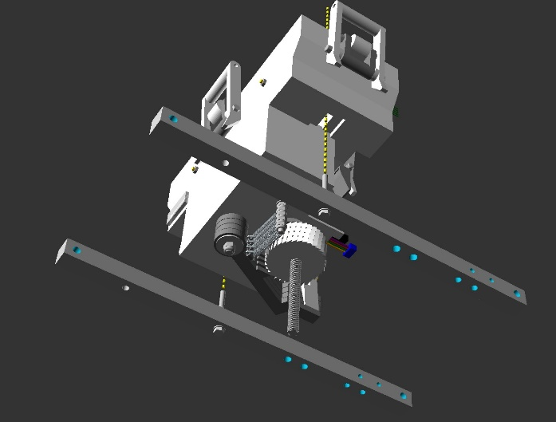

e.)

b.)

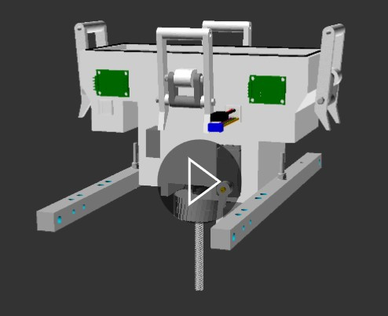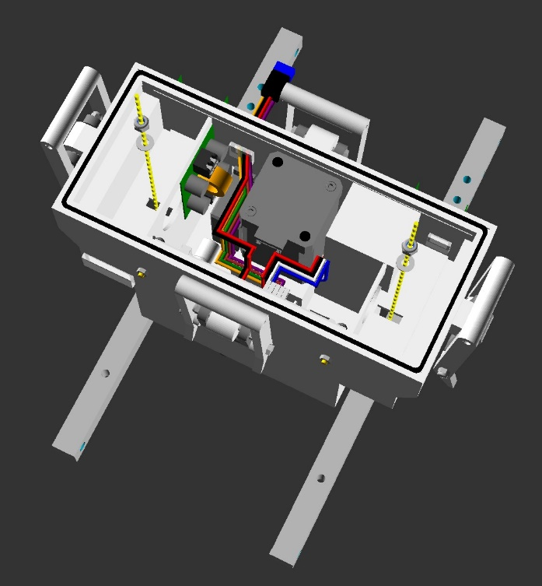

f.)

c.)

**Figure 80** Action diagrams (a, b, c, d and e) and animated gif (f) illustrating step 5.2, installing the motor unit onto the chamber brackets. View animation (f) in file “step_5_2_animated.gif” available in the GitHub project repository “openChamber/Chamber_1/Build_Guide/Step 5_Construction_Manual_Animations/”. This animation was modelled in openscad and compiled into GIF format using ImageMagick.

Notes:

Parts required for this section - Subassembly unit resulting from step 5.1, Motor Unit unit resulting from step 4c.3, 2 x part 39, 2 x part 40.

This step fixes the motor unit to the chamber brackets.

With the servomotor (part 66) and load-cell circuit boards (part 69) side of the motor unit facing towards the side of the brackets with 4 vertical holes (per bracket), guide the threaded end of the bolt from step 5.1 through the hole in the motor unit, as illustrated in figure 80 a, b, c and f.

Next place a single part 40 (washer) over each bracket bolt, followed by a single part 39 (lock nut) over each bolt. Tension these lock nuts so that the brackets are clamped firmly to the motor unit, but not so tightly that the motor unit plastic is damaged through crushing.

In subsequent steps, you may find it necessary to adjust the bracket positioning from side to side. For this reason, the motor unit bolt holes are rectangular, allowing for this later adjustment to be made.

Please also note that this bolt hole will require sealing with hot glue before deployment onto the water, to ensure that the inside of the motor unit remains dry. This should be done later however, as the motor case will need to be removed and refitted in Step 6.

5.3 Loadcell / strain gauge installation

a.)

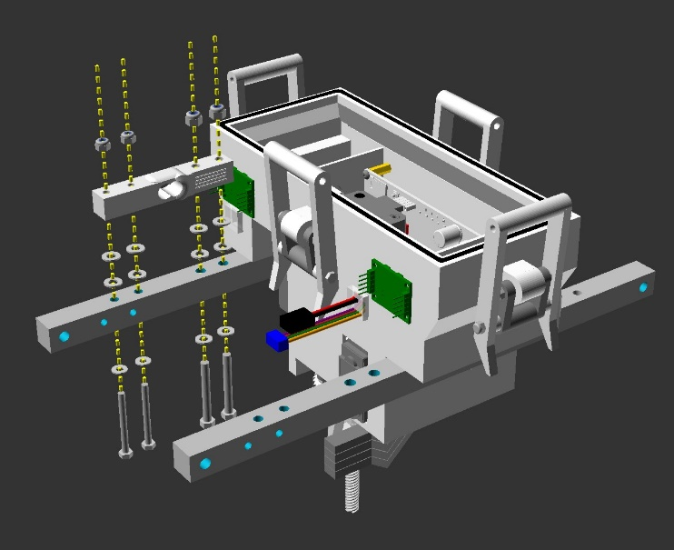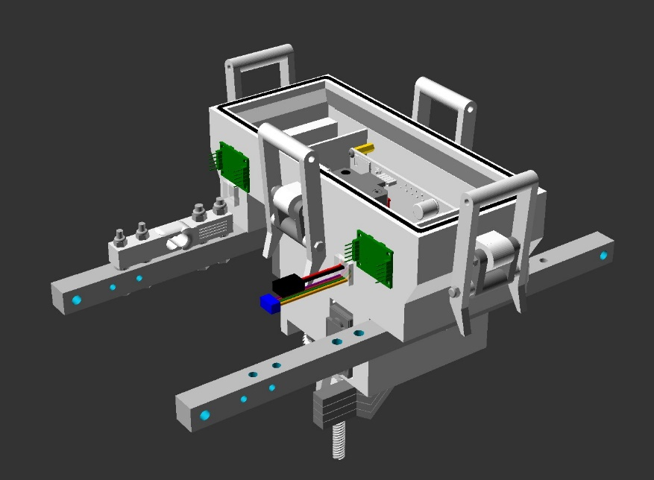

b.)

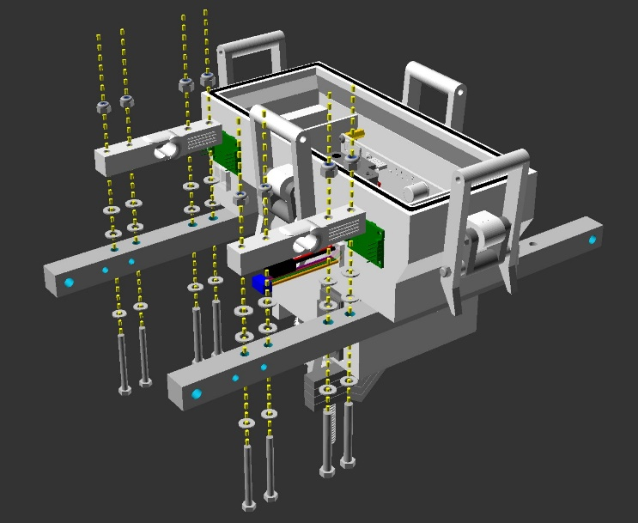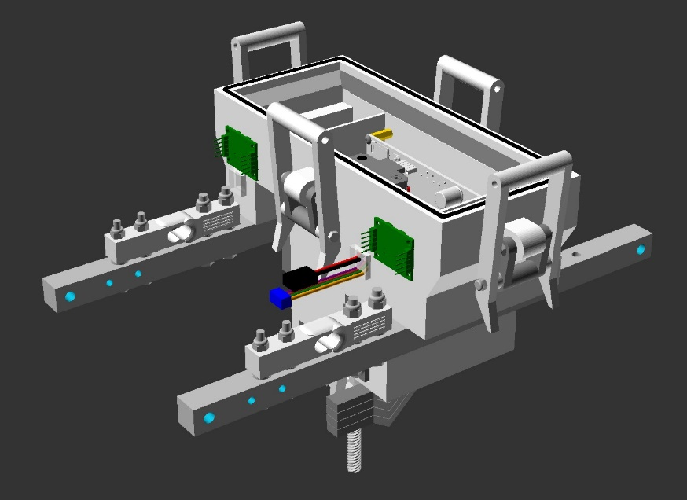

d.)

c.)

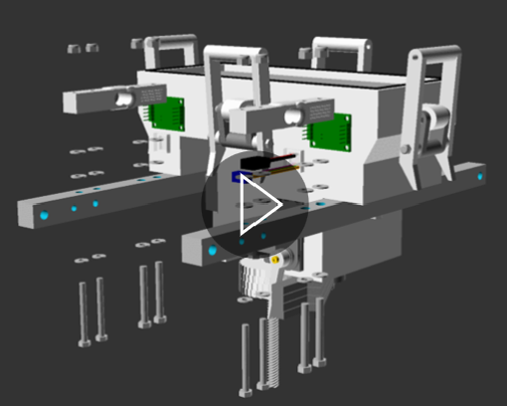

e.)

**Figure 81** Action diagrams (a, b, c and d) and animated

gif (e) illustrating step 5.3, installing load cells/strain gauge’s

onto chamber brackets. View animation (e) in file

“step_5_3_animated.gif” available in the GitHub project

repository “openChamber/Chamber_1/Build_Guide/

Step 5_Construction_Manual_Animations/”.

This animation was modelled in openscad and compiled

into GIF format using ImageMagick.

Notes:

Parts required for this section - Subassembly unit resulting from step 5.2, 1 or 2 x part 68a or 68b (loadcells - in the beginning I recommend using 1 x 68b). 2 or 4 x part 33 (M5 x 40mm bolt), 2 or 4 x part 34 (M5 lock nut), 2 or 4 x part 37 (M4 x 40mm bolts), 2 or 4 x part 39 (m4 lock nuts), 2 or 4 x part 40 (M4 washers), 8 or 16 x part 35 (M5 washers).

Beginning with the chamber bracket illustrated in figure 81a, orient part 68a / 68b so that the larger M5 holes are closer to the motor unit and the smaller M4 holes are close to the end of the chamber bracket. This orientation allows the shortest load cell to load cell circuit board (part 69) wires and the. Longer wires result in less reliable lid closing force readings.

Secondly, orient the arrow on the end of the load cell towards the lid of the motor unit. The arrow indicates whether a negative or positive force will be measured upon the lid closing and opening.

Guide 2 x part 33 each into a single part 35, then through the 2 chamber bracket holes closer to the motor unit, then through 2 x part 35s each, then through the loadcell holes and finally through a single part 34 each. This is illustrated in figure 81 a, b and e. Do not fully tighten the nuts (part 34) or bolts (part 33) yet.

Guide 2 x part 37 each into a single part 40, then through the 2 chamber bracket holes closer to the end of the chamber bracket, then through 2 x part 35s each, then through the loadcell holes and finally through a single part 39 each. This is illustrated in figure 81 a, b and e.

Gently bring the bolts and nuts together so that the load cell is clamped onto the chamber bracket; first fixing the 2 outer bolts, and then the 2 inner bolts. It is essential that excessive load cell bending in this clamping process is avoided, to prevent negatively impacting the load cells accuracy/performance. The load cell should be firmly in place with no freedom to move.

If using 2 load cells, repeat this process for the second load cell on the servomotor (part 66) side bracket, illustrated in figure 81 c, d and e.

5.4 Fan-side lid-arm connection point installation

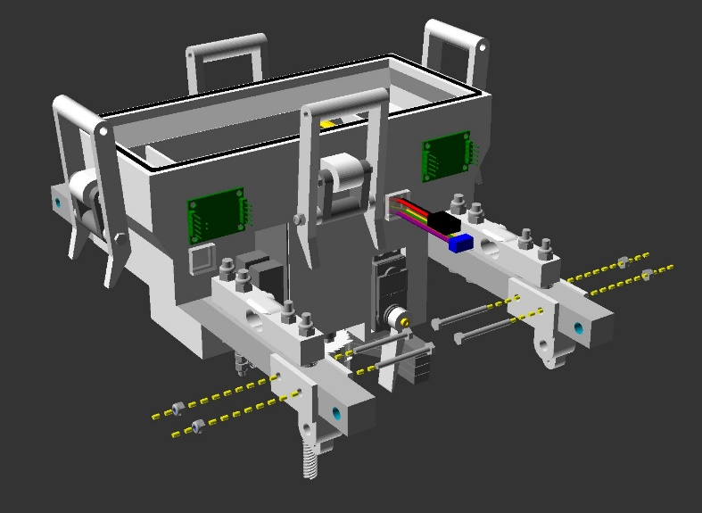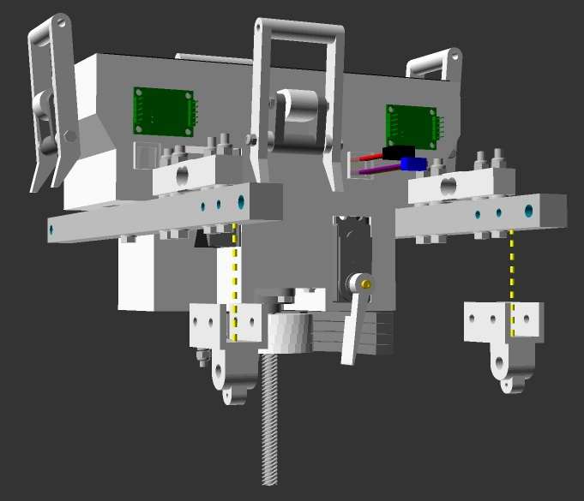

c.)

a.)

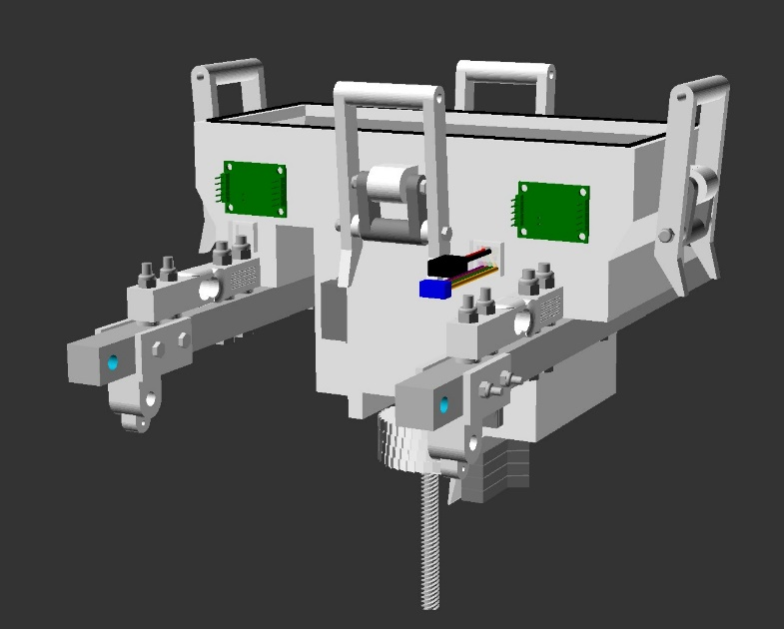

d.)

b.)

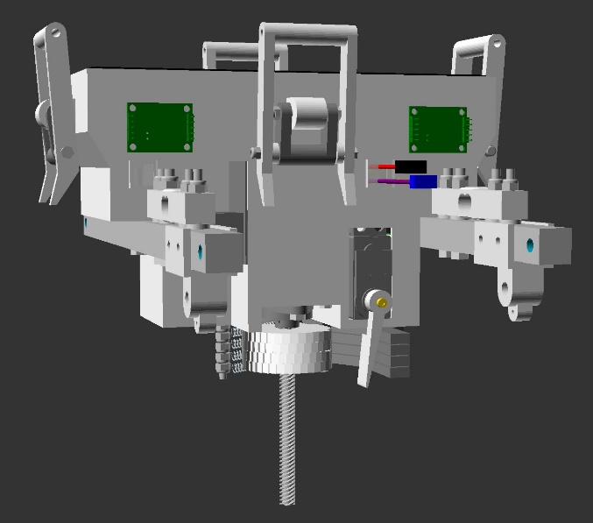

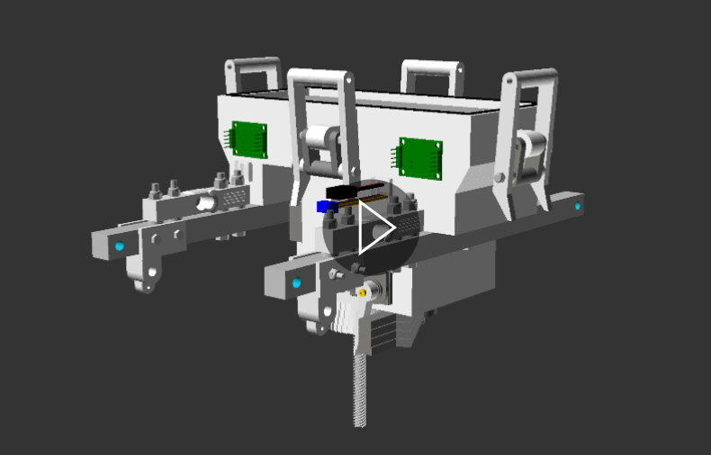

e.)

**Figure 82** Action diagrams (a, b, c and d) and animated

gif (e) illustrating step 5.4, installing Fan-side lid-arm

connection point onto chamber brackets. View animation (e)

in file “step_5_4_animated.gif” available in the GitHub project

repository “openChamber/Chamber_1/Build_Guide/

Step 5_Construction_Manual_Animations/”.

This animation was modelled in openscad and compiled

into GIF format using ImageMagick.

Notes:

Parts required for this section - Subassembly unit resulting from step 5.3, 2 x part 6 (the fan side bracket), 4 x part 42 (M3 x 30mm bolt), 4 x part 44 (M3 lock nut).

Position part 6 so that its open face points towards the lid of the motor unit its longer portion faces towards the motor unit servomotor (part 66) side.

Bring part 6 to meet the chamber bracket (part 51), matching the side holes in the chamber bracket with the side holes in part 6 (figure 82 a, b and e).

Insert parts 42 through part 6 (fan side bracket) and part 51 (the chamber bracket), from the inside to the outside. Lock the bolts in place using the 4x part 44, tensioning until tight without damaging the 3d printed parts. This is illustrated in figure 82 c, d and e.

5.5 Sensor platform V2 installation

a.)

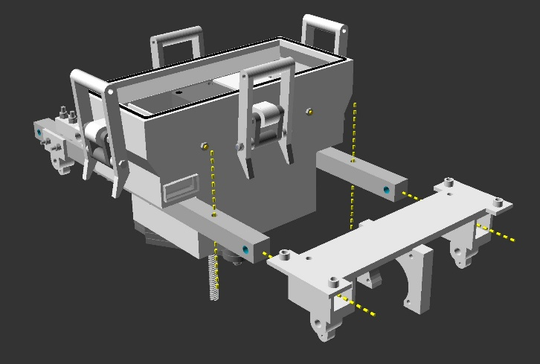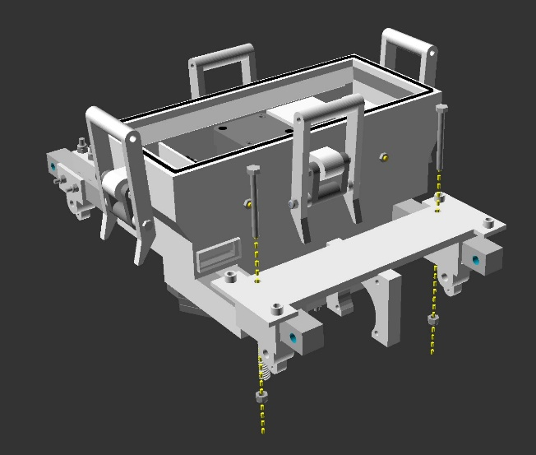

c.)

b.)

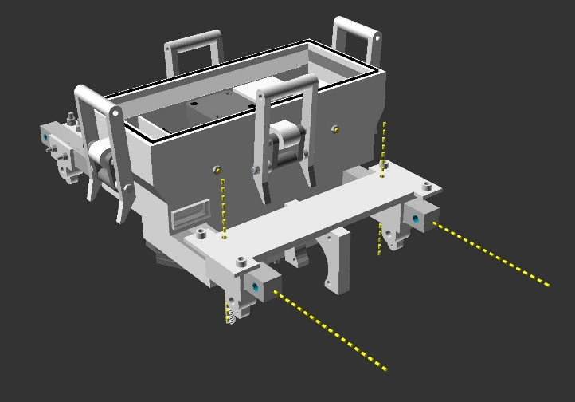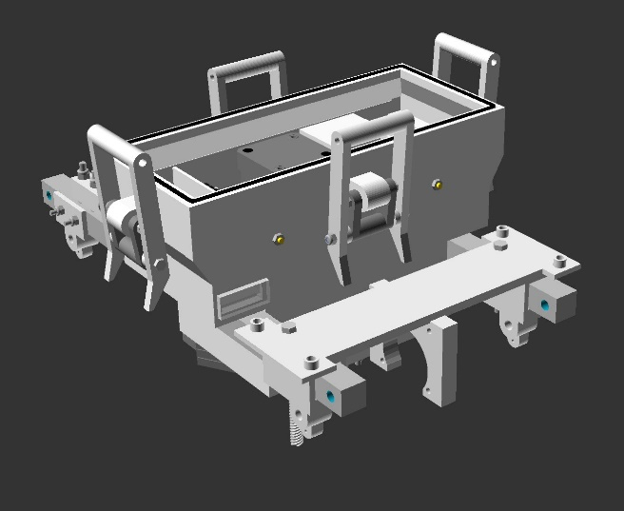

d.)

e.)

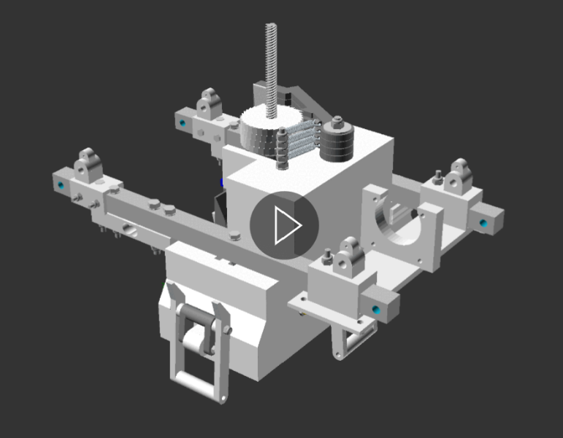

**Figure 83** Action diagrams (a, b, c and d) and animated

gif (e) illustrating step 5.5, installing Sensor platform V2

onto chamber brackets. View animation (e)

in file “step_5_5_animated.gif” available in the GitHub project

repository “openChamber/Chamber_1/Build_Guide/

Step 5_Construction_Manual_Animations/”.

This animation was modelled in openscad and compiled

into GIF format using ImageMagick.

Notes:

Parts required for this section - Subassembly unit resulting from step 5.4, 1 x part 8a or b or c (the sensor bracket, 2 x part 37 (M4 x 40mm bolt), 2 x part 39 (M4 lock nut).

Please note, although the shape of the sensor bracket (part 8) varies between versions, the attachment principles for each is the same.

Position part 8 so that the flat portion faces towards the lid of the motor unit and the coupling (the arch with a hole in it) faces the opposite direction. The coupling is closer to one side of part 8, with a hole in the top of the other side. Position the side with the hole towards the motor unit side. This is Illustrated in figure 83 a and e.

Slide part 8 onto the side of the chamber brackets (part 51), aligning the hole in part 8 with the hole in part 51 (figure 83 b and e).

Insert the 2x part 37 through parts 8 and 51. Lock these in place with the 2x part 39, tensioning so that the parts are held firmly in place on the chamber bracket, but not so tightly that the 3d parts are damaged. This is illustrated in figure 83 c, d and e.

5.6 Sensor pcb V2 installation

c.)

a.)

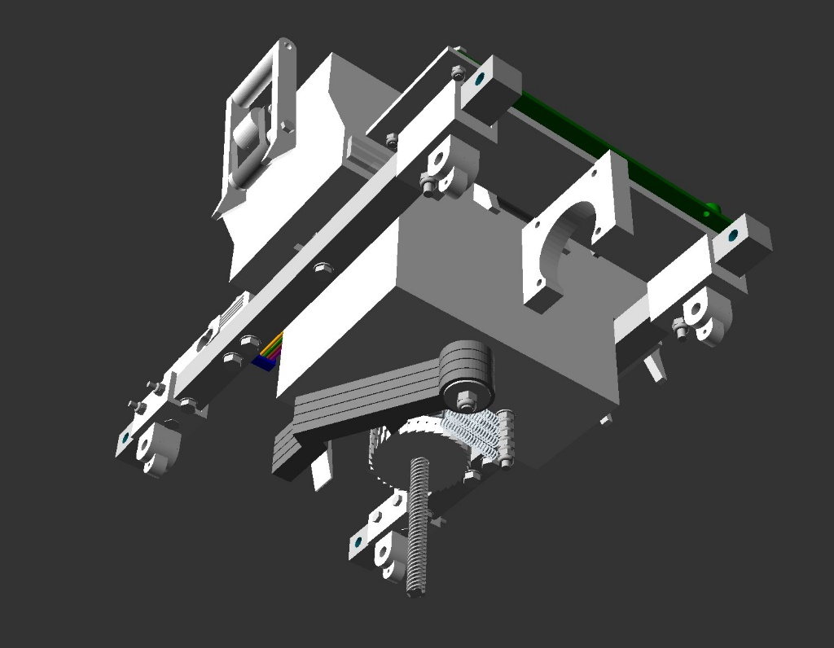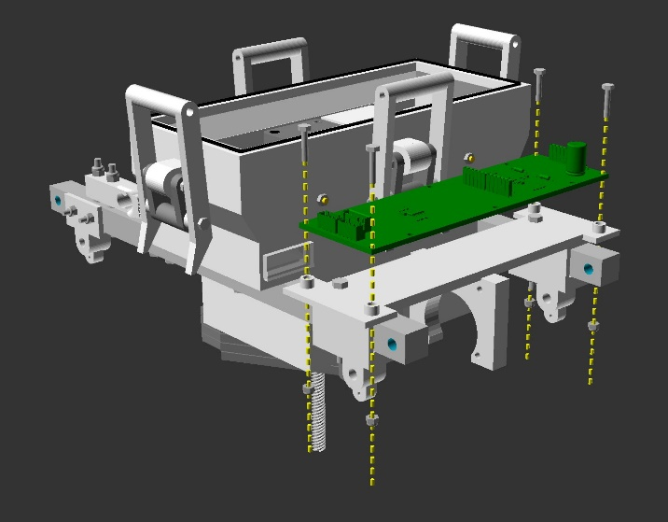

d.)

b.)

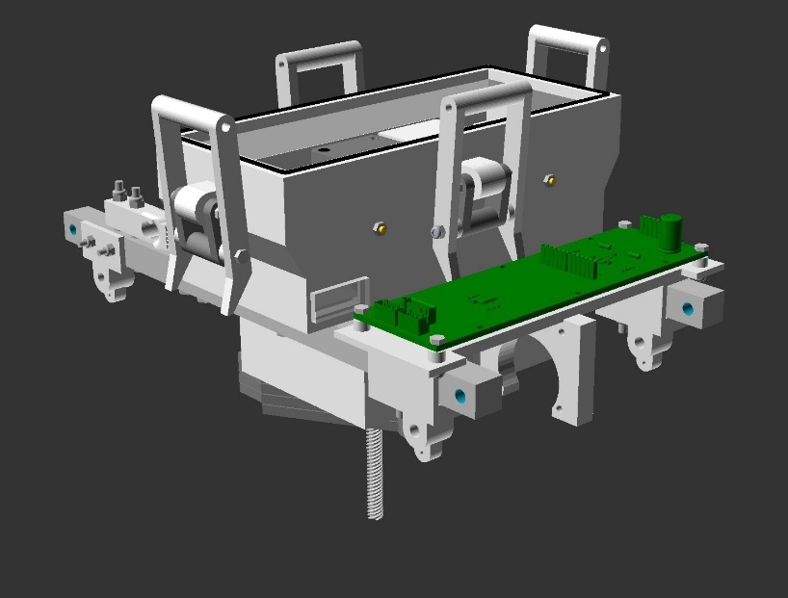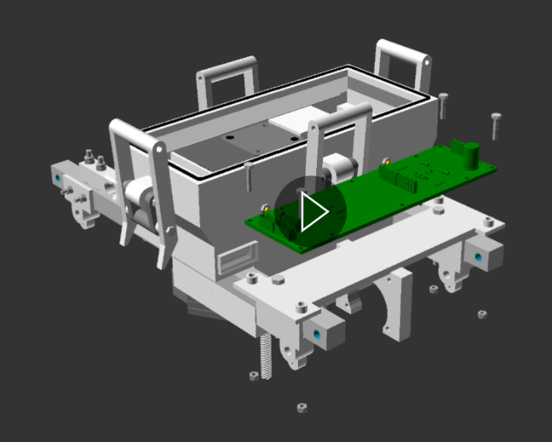

**Figure 84** Action diagrams (a, b, and c) and animated gif (d) illustrating step 5.6, installing the Sensor pcb V2 onto the chamber brackets. View animation (d) in file “step_5_6_animated.gif” available in the GitHub project repository “openChamber/Chamber_1/Build_Guide/Step 5_Construction_Manual_Animations/”. This animation was modelled in openscad and compiled into GIF format using ImageMagick.

Notes:

Parts required for this section - Subassembly unit resulting from step 5.5, 1 x part 75a or b or c (the sensor circuit board, 4 x part 43 (M3 x 20mm bolt), 4 x part 44 (M3 lock nut).

Please note, although the shape of the sensor circuit board (part 75) varies between versions, the attachment principles for each is the same when paired with the sensor bracket of the same version (i.e. Sensor bracket V1 with Sensor circuit board V1).

Position part 75 so that the JST cable connectors are on the same side as the cable hole of the motor unit. The HC-12 circuit should point in the opposite direction. The sensors should be facing the lid of the motor unit. This is illustrated in figure 84.

Line up the holes in the sensor circuit board (part 75) with the holes in the sensor bracket (part 8). Insert the 4x part 43 through the holes in part 75 and fix gently in place with the 4x part 44 (figure 84.). It is critical that these nuts and bolts are tensioned gently, so as not to damage the circuitry of part 75.

Additionally, rubber washers could be used between the circuit board and the nuts/ bolts for an added layer of protection. Though I have not found this necessary.

5.6 Fan installation

c.)

a.)

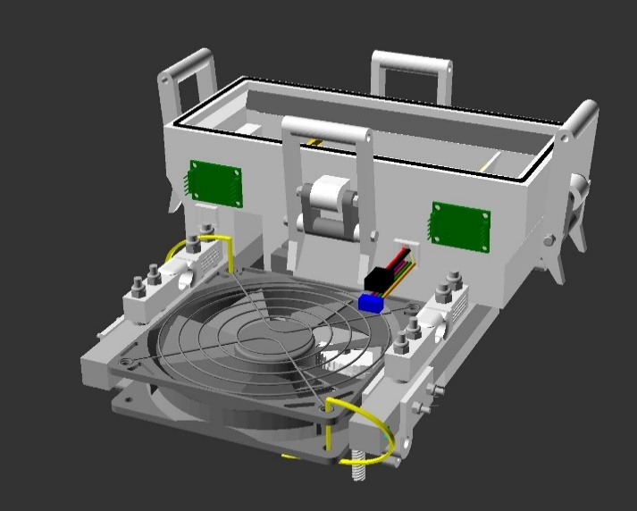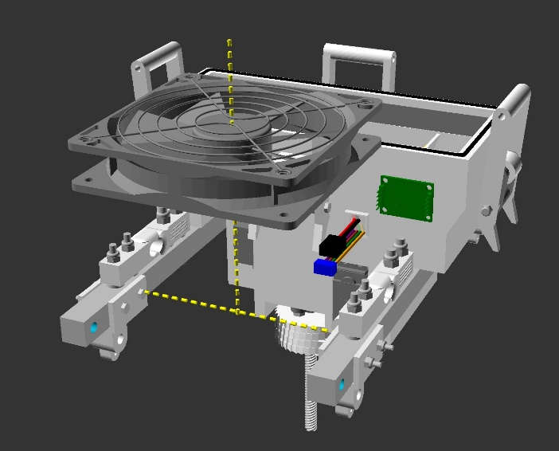

d.)

b.)

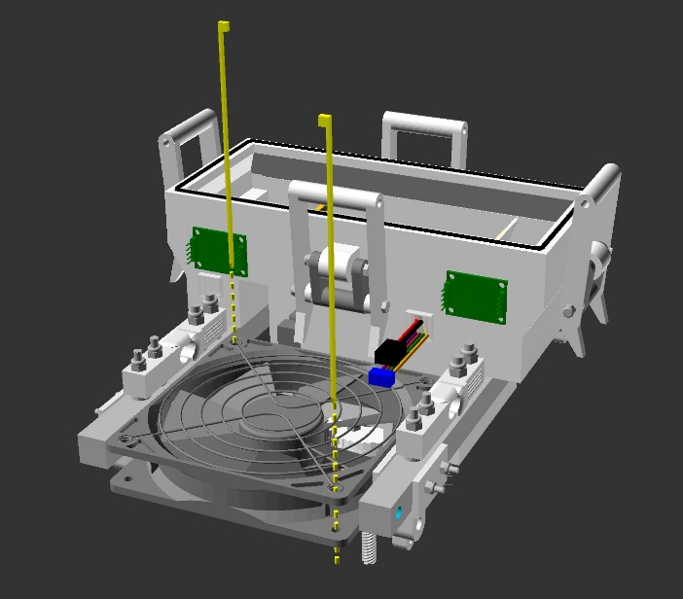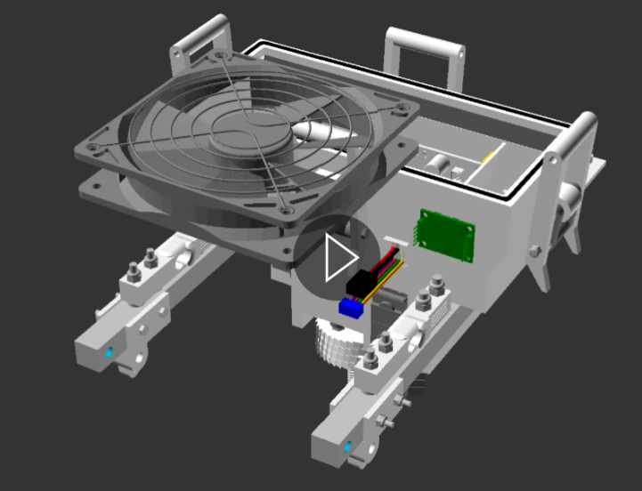

**Figure 85** Action diagrams (a, b, and c) and animated gif (d) illustrating step 5.7, installing the fan onto the chamber brackets. View animation (d) in file “step_5_7_animated.gif” available in the GitHub project repository “openChamber/Chamber_1/Build_Guide/Step 5_Construction_Manual_Animations/”. This animation was modelled in openscad and compiled into GIF format using ImageMagick.

Notes:

Parts required for this section - Subassembly unit resulting from step 5.6, 1 x part 79a (the pc fan), 2 x part 93 (zip ties)

Position part 79a (the fan) so that it blows air in the opposite direction to the motor unit lid (i.e. towards the chamber lid (part 2) and away from the water when all the chamber subunits are unified (step 6)). The cable of the fan should be close to the motor unit, to allow short and tidy cable connections.

In this orientation, move the fan between the 2 fan side brackets (part 6) as illustrated in figure 85.

Fix the fan onto the brackets using 2x part 93 (zip ties). Guide the zip ties through the bolt holes of the fan casing and around the chamber brackets (part 51), as illustrate in figure 85. Tension the zip ties so that the fan is held in place without fan case distortion, which can prevent the fan blades from moving.

Please note, that the fan must be removed inorder to mate the chamber brackets subunit with the other subunits in step 6.

In the future this step may be changed to allow for a mechanical binding of part 79a to the chamber brackets (part 51), without the need for single use cable ties (for example using nuts and bolts). But for the scope of this project as a part of my PhD, I do not have time to adjust this step at present.

With this, step 5 and the Chamber brackets subunit are completed. The Chamber brackets should look like figure 78.

### Step 6: Subunit unification

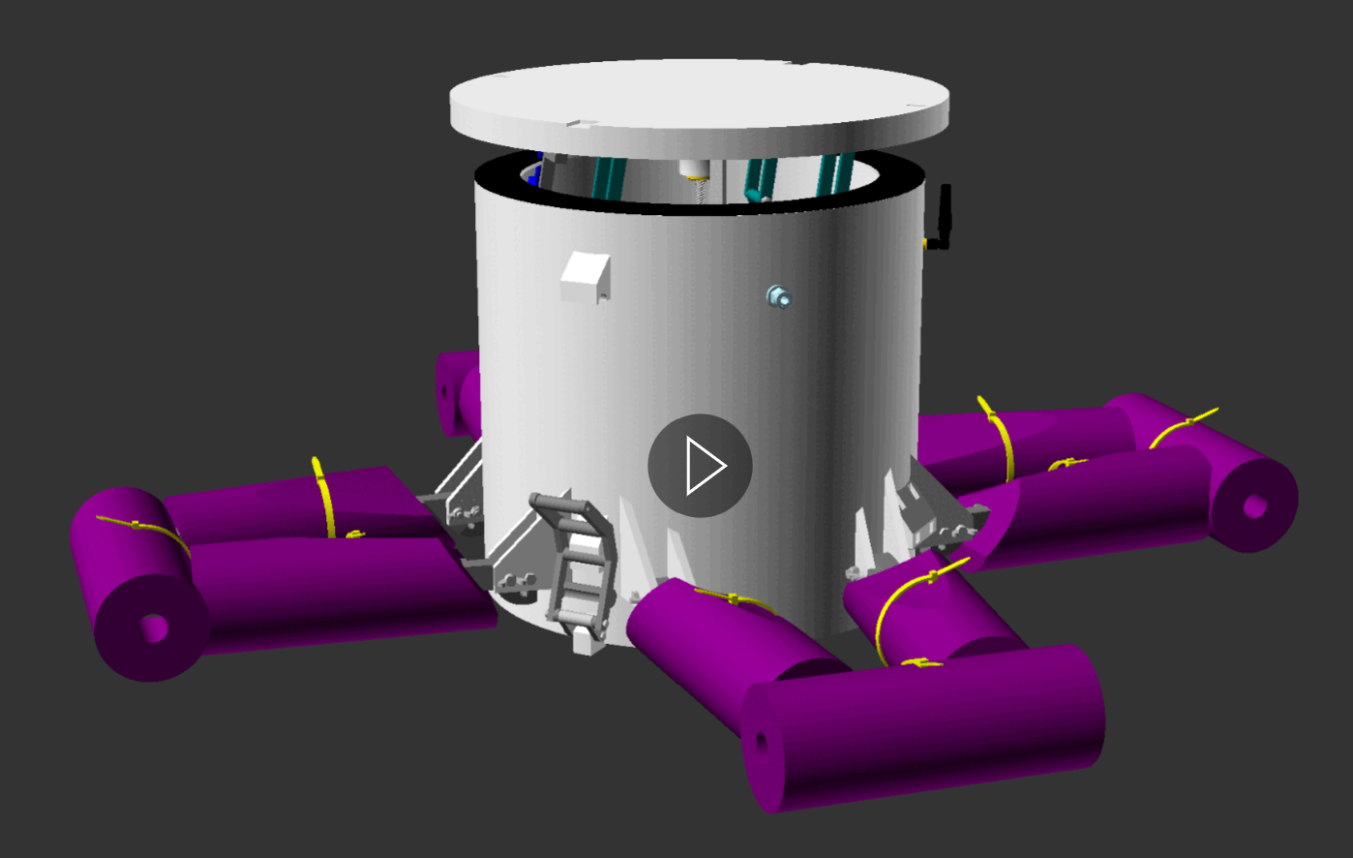

**Figure 86** 3d model illustrating the product of step 6. View this animation in file “step_6_end_product_animated.gif” available in the GitHub project repository “openChamber/Chamber_1/Build_Guide/Step 6_Construction_Manual_Animations/”. This animation was modelled in openscad and compiled into GIF format using ImageMagick.

Step 6 focuses upon the unification of the subunit assemblies. The end product of this step is the fully constructed chamber (figure 86).

6.1 Bracket subunit to lid subunit unification

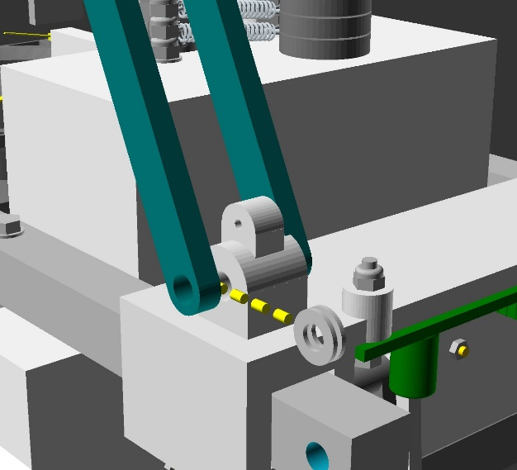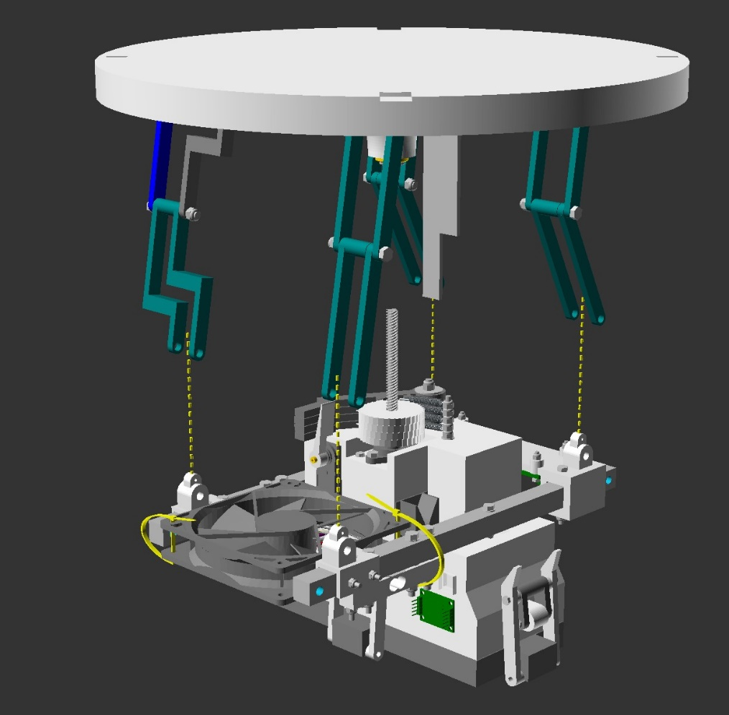

a.)

b.)

d.)

c.)

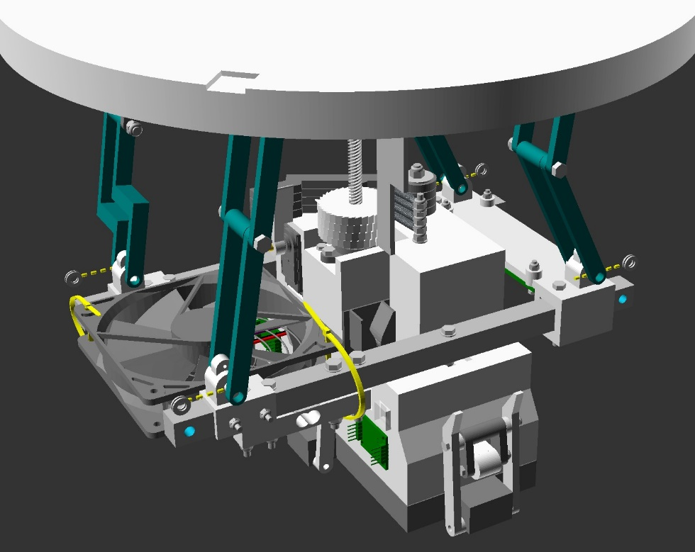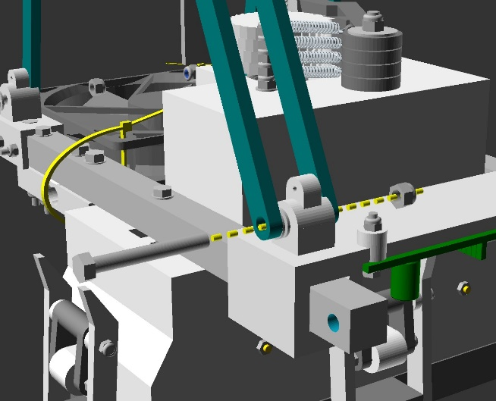

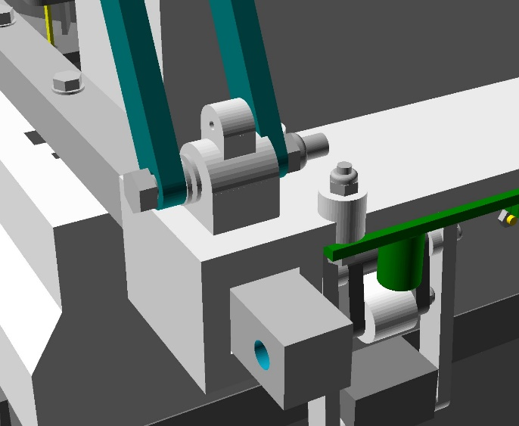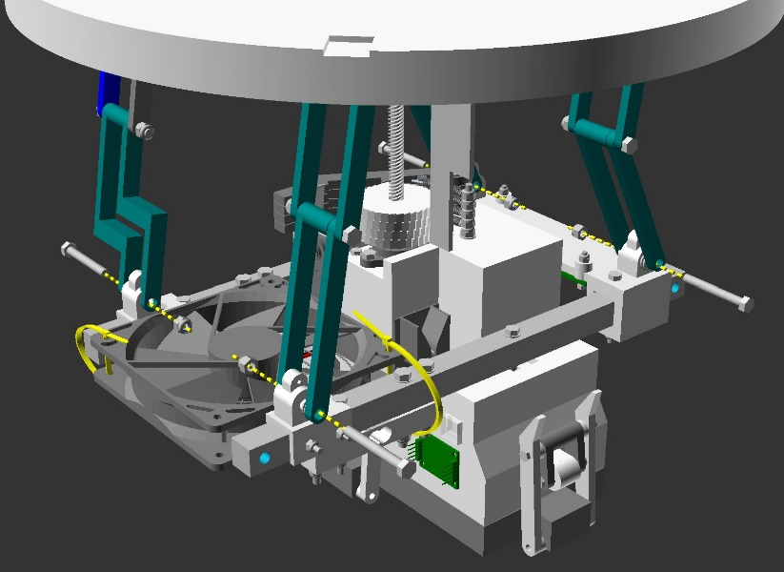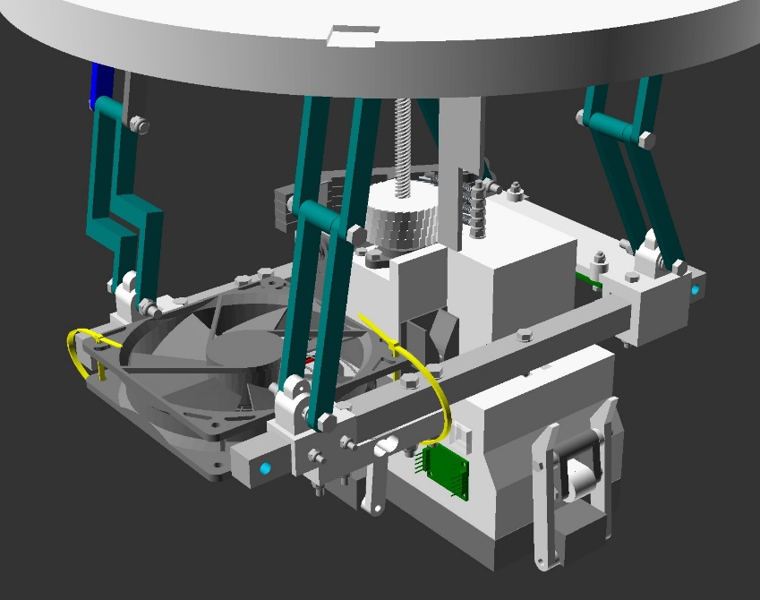

g.)

e.)

f.)

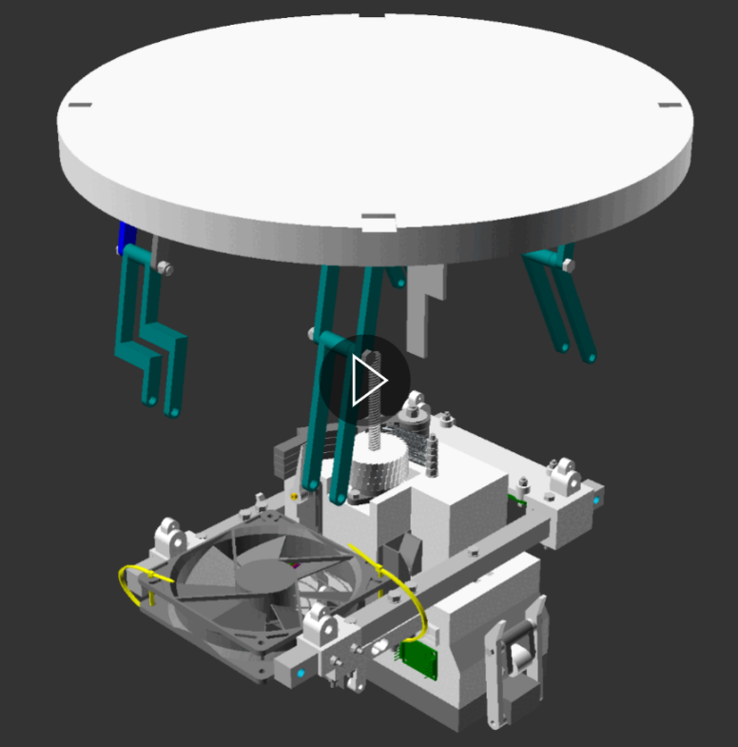

h.)

**Figure 87** Action diagrams (a, b, c, d, e, f and g) and animated gif (h) illustrating step 6.1 unification of the chamber brackets subunit to the chamber lid subunit. View animation (h) in file “step_6_1_animated.gif” available in the GitHub project repository “openChamber/Chamber_1/Build_Guide/Step 6_Construction_Manual_Animations/”. This animation was modelled in openscad and compiled into GIF format using ImageMagick.

Notes:

Parts required for this section – Chamber lid subassembly unit resulting from step 3.7, Chamber brackets subassembly unit resulting from step 5.6, 8 x part 35 (M5 washer), 4 x part 33 (M5 x 40mm bolts), 4 x part 34 (M5 lock nuts).

Position the chamber lid subassembly so that the chamber arms fit on either side of the bracket couplings, illustrated in figure 87 a and h. Part 56 (described in step 3.2) should be positioned between the guides of part 13 (described in step 4a.1 and 4a.2).

Between the outside chamber arm and the outside of the chamber couplings, insert 2 x part 35 (figure 87 b, c and h).

Next insert part 33 from the outside arm, through the bracket coupling, and through the inside arm. Fix this bolt in place with 1 x part 34. This should be repeated for each set of chamber arms / couplings (figure 87 d, e, f, g and h).

Fix the lock nuts (part 34) in place by tightening gently until resistance is met, then backing off by 1 turn in the loosening direction, to ensure that the pieces rotate freely without resistance. *

* Tip: This can be done using 2 size 8 spanners/ wrenches, or holding one side with a pair of pliers and using a spanner on the other side.

6.2 Bracket-Lid subunit to Chamber subunit unification

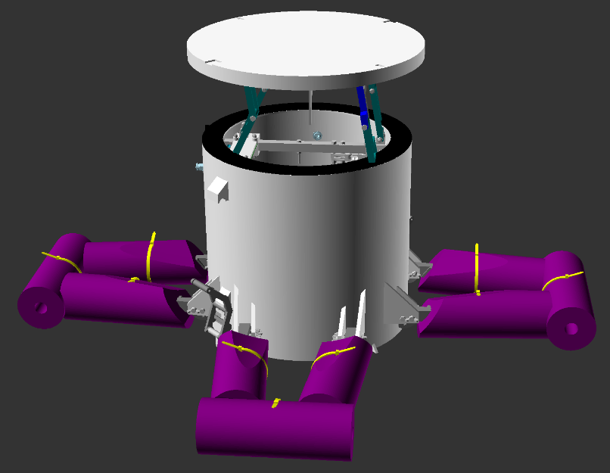

b.)

a.)

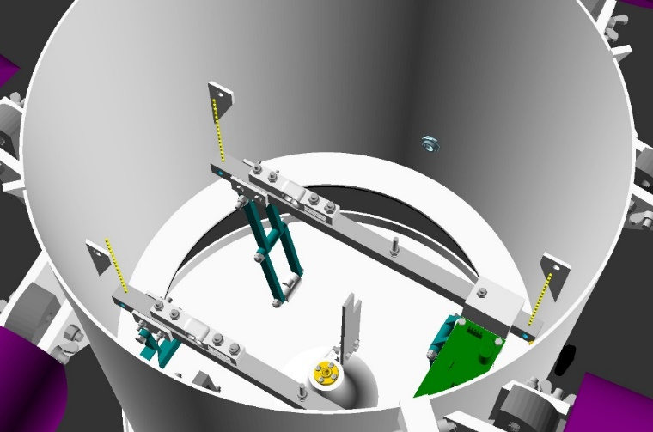

d.)

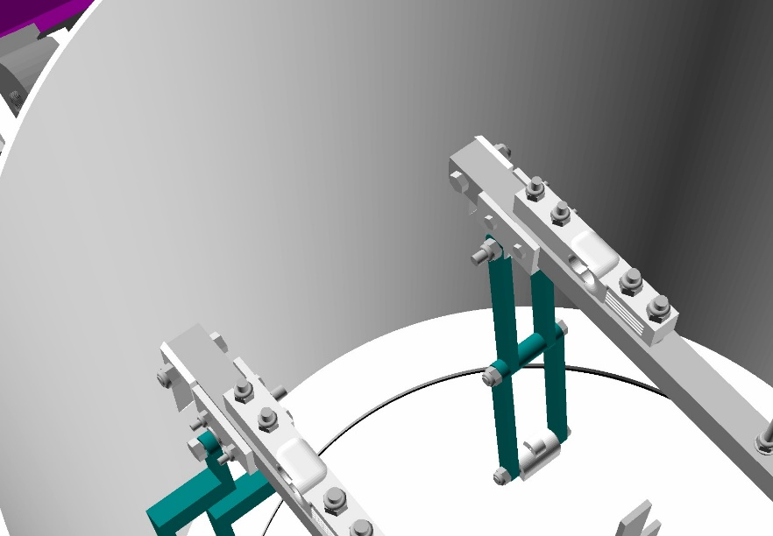

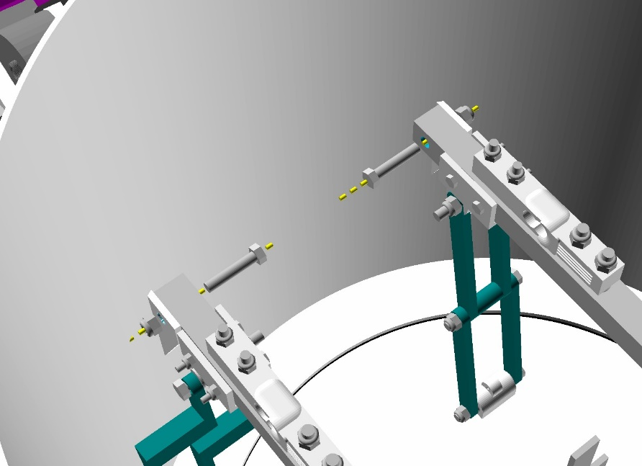

c.)

e.)

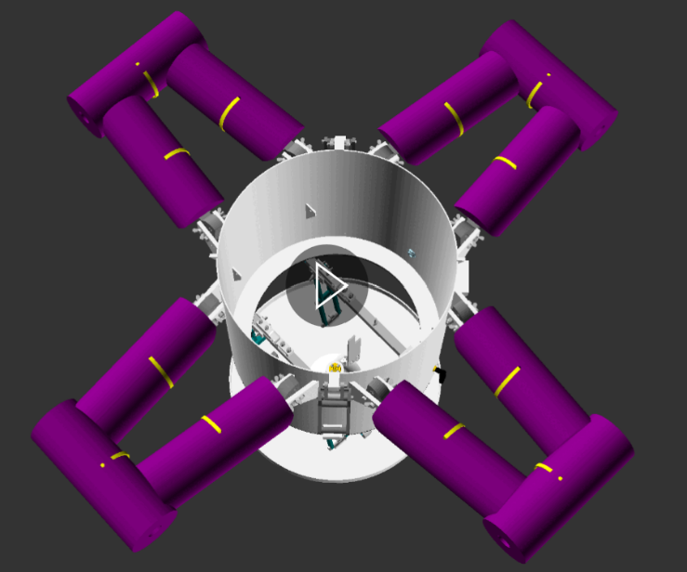

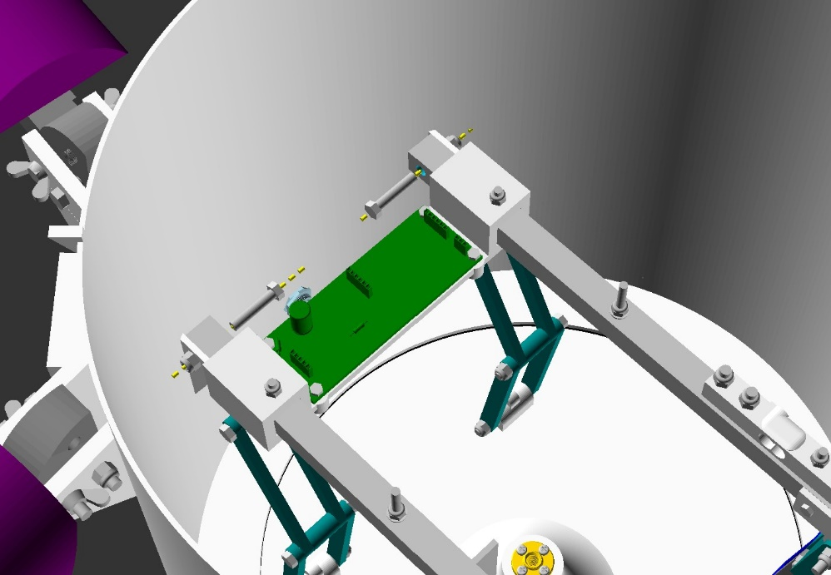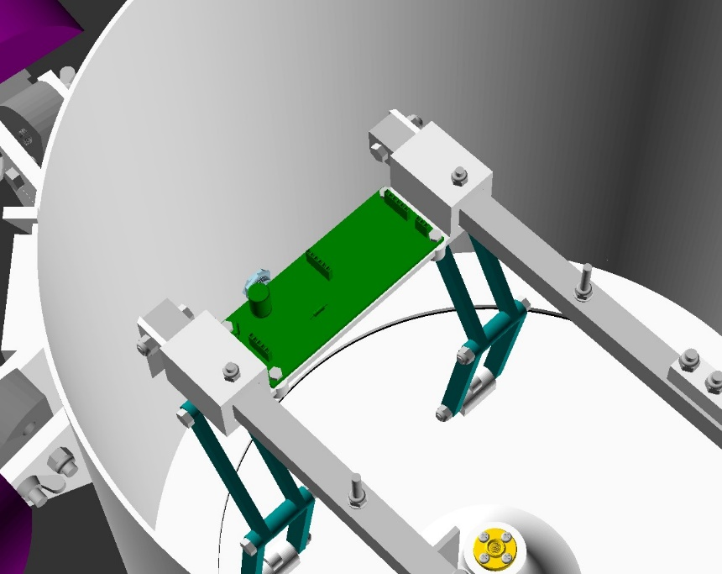

g.)

f.)

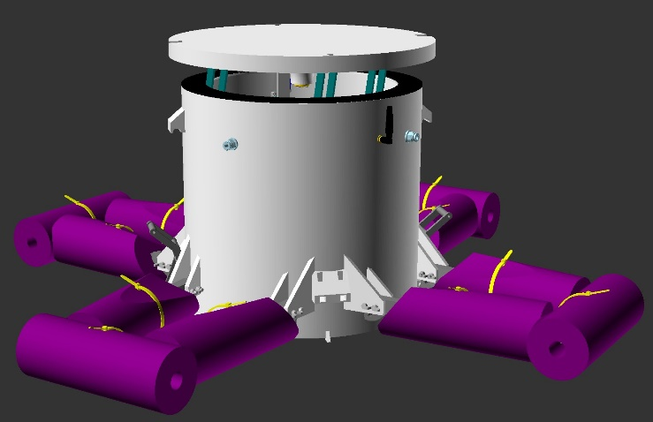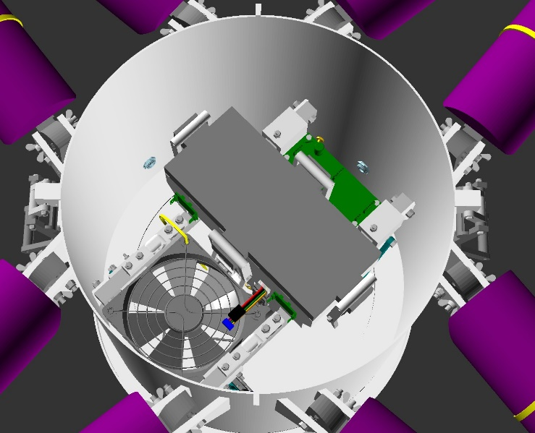

h.)

i.)

**Figure 88** Action diagrams (a, b, c, d, f, g, h and i) and animated gif (e) illustrating step 6.2 unification of the chamber subunit to the chamber bracket-id subunit. View animation (e) in file “step_6_2_animated.gif” available in the GitHub project repository “openChamber/Chamber_1/Build_Guide/Step 6_Construction_Manual_Animations/”. This animation was modelled in openscad and compiled into GIF format using ImageMagick.

Notes:

Parts required for this section – Lid-bracket subassembly unit resulting from step 6.1, Chamber body subassembly unit resulting from step 2.8a, 4 x part 33 or 33.b (M5 x 25 or 30mm bolts), 4 x part 34 or 34.c (M5 lock nuts or regular nuts).

Remove the motor unit and fan from the Chamber brackets subassembly, following the instructions described in step 5.2 and 5.6. Although the Lid-bracket subassembly can be installed without removing these items, it is easier to achieve safely by removing these parts.

Position the lid-bracket subassembly so that the sensor board (part 43) side is closest to the antenna (part 73 described in step 2.7) and the chamber brackets fit between the chamber body couplings (figure 88 a and b).

From the top of the chamber body subassembly, insert the lid-bracket subassembly into the chamber body subassembly.

Beginning with the side further away from the sensor board, line up the holes in the chamber brackets with the holes in the chamber body couplings. Following this, insert part 33 or part 33.b (whichever is a better fit) first through the chamber bracket hole and then through the chamber body coupling hole. Fix the bolt in place using part 34.c (however for deployment of the chamber on the water, using part 34 (locking nuts) is more likely to prevent problems associated with loosening). Do not tension the nuts/ bolts tightly at this point. This step is illustrated in figure 88 c, d and e.

Line up the sensor board side holes in the chamber brackets with the holes in the chamber body couplings. Following this, insert part 33 or part 33.b (whichever is a better fit) first through the chamber bracket hole and then through the chamber body coupling hole. Fix the bolt in place using part 34.c (however for deployment of the chamber on the water, using part 34 (locking nuts) is more likely to prevent problems associated with loosening). This step is illustrated in figure 88 e, f and g.

Now tension the 4 nut/bolts until the chamber brackets are held firmly in place, without damaging the 3d printed parts through over tightening.

Re-install the motor unit following the instructions described in step 5.2. With the pawls (parts 15, 16 and 17) disengaged from the ratchet(part 18 - the engaged position is illustrated in figure 70 b), thread the leadscrew of the motor case (part 48) into the lead screw nut of the chamber lid (part 49 installed in step 3.1). As you do this, ensure that the chamber arms fold towards the middles of the chamber and not outwards.

Once the chamber lid is flat against the chamber body gasket (part 52), re-install the fan to the chamber brackets subassembly, following the instructions described in step 5.6 (figure 88 e and h).

With this, step 6 and the Chamber construction is completed. The chamber should look like 86 and is ready for electrical setup and chamber testing (section 1.6) or chamber storage (section 1.7).

## 1.6 Electrical Setup and Chamber Testing

Motor Power:

5v 🡪 24v step up converter minimum 5 amps of current (e.g. LM2587S)

* Set this from 5v in to supply 24v out.

Motor driver:

Set the motor driver (TMC2208) reference voltage (vref) to ~1.5v. The vref is measured between the motor power ground (gnd) and the vref pin of the TMC2208 (figure …).

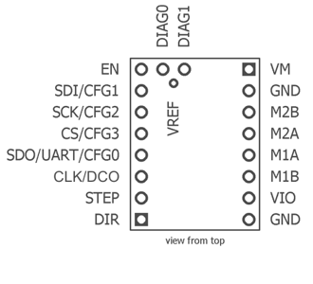

Figure … TMC2208 v2 pinout taken from https://learn.watterott.com/silentstepstick/pinconfig/

## 1.7 Chamber storage and transportation

## 1.8 Trouble shooting

### SD-card not detected

SD card problems:

Cause 1: The SD card is corrupted therefore will not read.

Solution = Exchange the old sd card to a fresh sd card that you know works on other devices.

Solution = Load the SD card onto a computer. The computer will sometimes fix the sd card. For example, if the power was removed while the SD card was in use, the sd card can get confused. Just like how on a computer you are asked to eject a USB stick before removing from the device, you sd card can be temporarily corrupted!

Power problems:

1. Power cable not a thick enough gauge therefore doesn’t allow the required current for the sd card to be detected.

Solution = change the usb cable to a thicker gauge

1. Power cable usb connector is not a high enough quality therefore doesn’t get a strong enough connection to the powerbank. This can be visualised as flickering LEDs. This disrupted power supply stops the sd card (which is very power sensitive) from loading up/ being read.

Solution = change the usb cable to one with high quality connectors, and ensure that the powerbank usb connector has not been damaged also.

Solution = Quick fix solution can be to use duct tape to hold the usb connector into the power bank to maintain the quality connection.

1. The power cable has broken somewhere inside the cable. This can sometimes occur through repeated use.

Solution = Change the power cable for a new one!

1. The power bank has broken. This means that the power is not providing a smooth power supply at the correct voltage and current requirements.

Solution = Replace the power bank for one that is fresh, or that you know is functional.

Circuit problems:

1. The ATMEGA328p chip is not seated correctly in the ZIF socket. Sometimes the connection with one of the pins can be loose causing the SD 🡪 ATMEGA328p communication to be faulty.

Solution = Remove the ATMEGA328p chip from the ZIF socket and carefully replace it again in the ZIF socket, making sure that the connections are clean and in contact.

1. The ATMEGA328p chip has broken. This can sometimes happen due to a short circuit, or damage to the specific bus of the chip that deals with the sd card.

Solution = Replace the ATMEGA328p chip for another ATMEGA328p chip that you know is functional on other circuits.

1. The SD card circuitry on the main circuit board has experienced damage and needs to be replaced.

Solution = Replace the circuit board for a new circuit board.

Solution = If you are confident in electronics, consult the circuit Gerber file and schematic. Replace the sd card components.

### Real Time Clock (RTC) not detected

Programming problems:

1. The time on the clock need resetting. This can be because of a power supply interruption, or because the RTC was never set in the first place. This is usually the case if the chip is detected, but cannot begin the programme.

Solution = Run the “set time” programme on the circuit board, to set the time to your computers time.

Circuit Problems:

1. There is a problem with one of the sensors running on the I2C bus of the ATMEGA328p. This can block the I2C line of the ATMEGA328p, for example by holding the data line high or low. This prevents the ATMEGA328p from communicating with the RTC, which also uses the I2C line for communication.

Solution = Unplug the “Sensors” JST connector. If the clock is now detected on start-up, check your sensor board wiring, or replace the sensor board for a new one.

1. The RTC circuitry on the main circuit board has experienced damage and needs to be replaced.

Solution = Replace the circuit board for a new circuit board.

Solution = If you are confident in electronics, consult the circuit Gerber file and schematic. Replace the sd card components.

### Stepper motor not running properly

Stepper motor runs in short bursts “on_off_on_off”

1. Check the cables connecting the motor to the boost converter / step-up voltage board. If the cables are not a thick enough gauge, not enough power will be able to pass through to the motor, causing a start-stop motion, as emergency protection circuits do their job.

Solution = Replace the cable running from the main circuit board to the boost converter/ step-up voltage board for a thicker gauge of cable.

### Uploading code to microcontroller

1. Serial port error

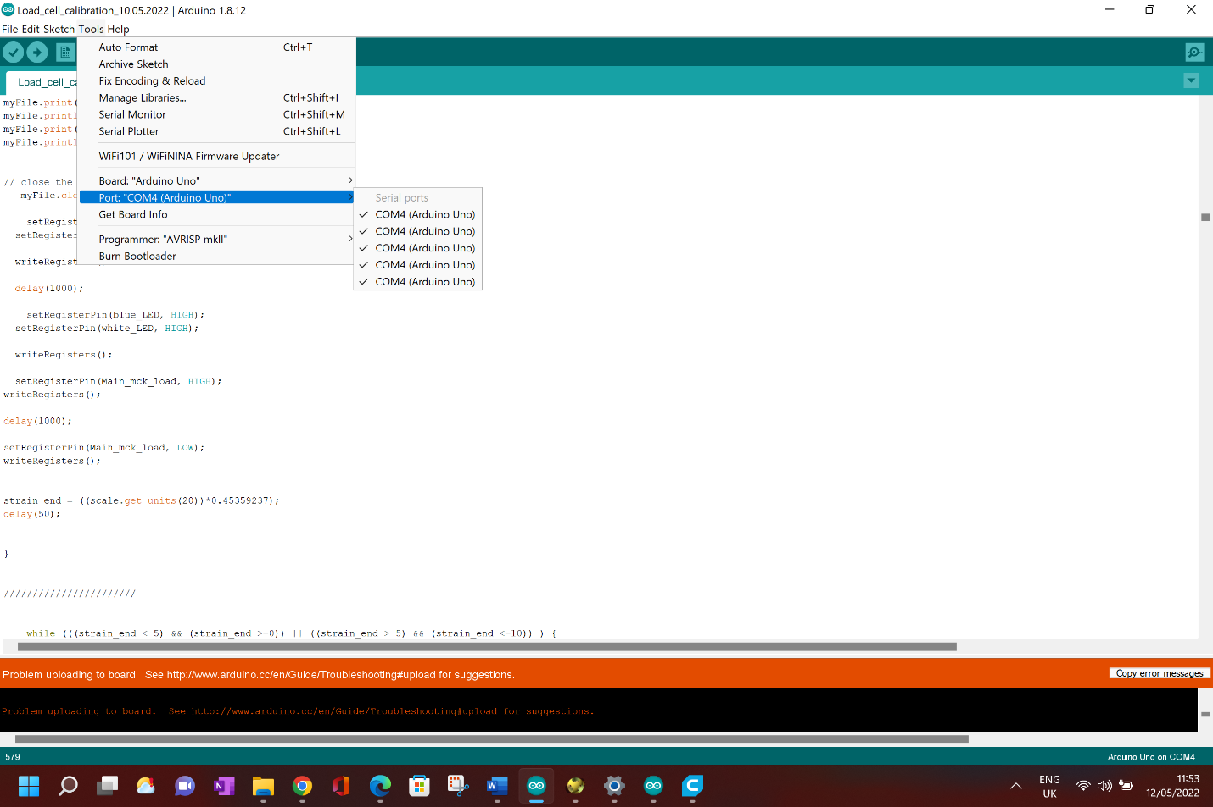

1. Wrong USB cable used – make sure USB is not just power but has data cables as well.

Solution = Use a new USB cable ensuring it has data transfere capabilities.

1. Corrupted ATMEGA328p chip

Solution = replace the chip for a new one.

1. Damaged DIP / zif socket on Arduino uno programmer

Solution = replace the DIP / ZIF socket on the Arduino uno, or buy a new Arduino uno using the DIP mount ATMEGA328p .

### Chamber lid doesn’t open when it should – Drumming noise when lid should be opening – 1, 0, error code.

1. Servo arm failiure - The pawl arms are not disengaging from the ratchet. This means that the stepper motor will try to move which is locked closed. The stalling of the motor causes a drumming noise.

Solution = Check the servo arm is not loose. If it is, reset the arm position and glue carefully in place. Now the pawls should disengage from the ratchet as intended.

Solution = If the servo arm is not loose, you may have set its position incorrectly. This would mean that the servo arm position does not match where it should be, to disengage the pawl arm from the ratchet. Reset the arm position or reset the pawl arm end position in the chamber code (only advised if the pawl arm is already glued in place and a quick solution is needed).

Solution = The servo arm does not respond to any command. Test with the “servo test” Arduino programme. If it still does not respond, check your wiring to the servo motor, and if this doesn’t change anything, replace the servo motor with a new one.

1. ATMEGA328p not seated correctly in ZIF socket – E.g. one of the pins on the chip is not making contact with the circuit board.

Solution = Take out the ATMEGA328p chip, check the pins are not bent or dirty (in which case carefully bend pins back or remove the dirt), check the chip orientation is correct and re-insert the chip.

1. Programming Failiure – Something has caused the ATMEGA328p chip to malfunction.

Solution = Reprogramme the chip and install back onto the board. This reset of the chip can often solve the issue, particularly if the system has been turned on and off again repeatedly during testing.

# Part 2 | Valve Changer Module

**Figure 6** - Illustration of the valve changer module for the Chamber.1 system. Image a shows the CAD model of the module, while image b shows the module deployed in the field under actual conditions.

## 2.1 Parts List

### 3d Printed Parts

### Non Printed Parts

## 2.2 3d Printing

## 2.3 3d printing post processing

## 2.4 Parts assembly

# Appendix

## 3.1 Chamber Module

### 3.11 Visualised Parts List

## 3.2 Valve Changer Module

### 3.21 Visualised Parts List

# References

Archer. (2022). Functionality explaination .

Archer, B. (2022). GIThub Chamber.1 project page 3d files folder.